# ICECAPS Weekly Report

January 11, 2016 – January 17, 2016

Mike Finnegan

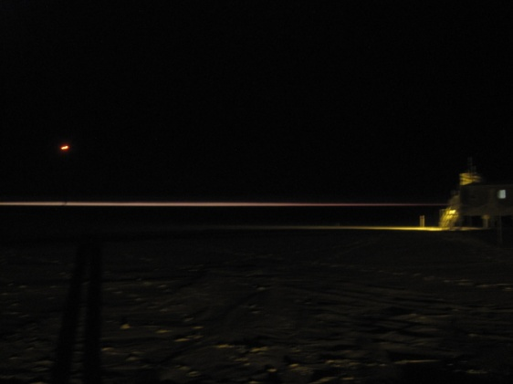

A Spotlight or the Horizon? - MOF, 1/13

**General:**

* Generator power swap – from 1303-1323z. – 1/13

**Significant Weather Observations:**

* 1/11: few altocumulus, 13.6kts, -50.4C
* 1/12: few altocumulus, 6.8kts, -43.3C
* 1/13: ovc stratus, 10.3kts, -34.5C
* 1/14: few altocumulus, 15.0kts, -43.6C
* 1/15: fzfg,0.0kts, -30.4C
* 1/16: few altocumulus, sct altostratus, bkn cirrostratus, 10.6kts, -39.6C
* 1/17: few altocumulus, sct cirrostratus, 10.0kts, -41.7C

**Dataman Account:**

* Operating normally.

**MWR:**

* HATPRO: Removed for repairs (1550-1915z on 1/11) to be sent to vendor. 150/90 back online at 1645z.
* 150-90: operating normally.
* Hatpro lowered from roof at 1400-1500z on 1/12.
* Hatpro moved into SOB at 1500z on 1/15.

**SODAR:**

* Operating normally.

**POSS:**

* Operating normally.

**MMCR:**

* Operating normally.
* Roll continues to be off by 5 degrees. May be a wiring issue since last time it was off this much, I check connectivity of the wires, found them all good, and the roll suddenly corrected itself. As it is off by the same amount this time suddenly, I don’t think the building shifted 5 degrees.
* Found Error 7: File Not Found error on 1/11 daily checks. Pressing “continue” allowed operation to resume. No errors found on 1/12.

**CAPABL:**

* Operating normally.

**MPL:**

* Operating normally.

**VCEIL:**

* Operating normally.

**Hotplate:**

* Operating normally.
* 1/13 – Sensor registering precipitation signal even though it was not precipitating out. Brushed and shifted wires, which solved the problem.

**IceCAM:**

* Operating normally.

**PAERI:**

* Operating normally.
* Caught PAERI LW/SW Responsivities going from yellow to red at 1430Z on 1/13. Cleared mirror of minimal snow, which brought it back to LW green and SW yellow. With the HATPRO removed, I think North winds will be more likely to blow snow into the hatch.
* PAERI fan #3 died on 1/14. Replacing the fuse did not fix this. I installed fan #1 on the enclosure and put it outside for operation. On 1/15, I noticed the new fan exhibited a “ticking” noise as had previously been found prior to having its bearings replaced. I replaced the bearings on fan #3, which caused it to work. I then replaced fan #1 (with the tick) with fan #3 (fan that has been operating all winter). Logs have all been updated.

**TSI:**

* Shutdown and removed from the roof for the winter.

**IcePIC:**

* No Photos Taken

**Radiosonde:**

* Twice daily sondes.
* 1/17 0Z launch successful, but not closed out in time.

**MASC:**

* Operating normally.
* Found three camera bus resets on 1/16 daily checks.