# ICECAPS Weekly Report

January 18, 2016 – January 24, 2016

Mike Finnegan

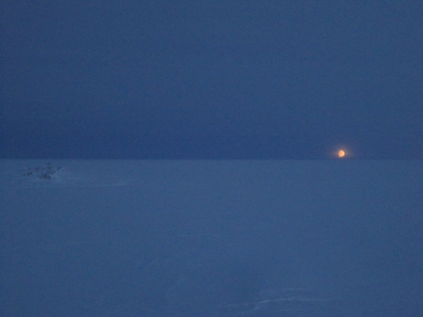

Moonrise Over the Icesheet - MOF, 1/18

**General:**

**Significant Weather Observations:**

* 1/18: sct altocumulus, bkn cirrostratus, 9.8kts, -35.2C
* 1/19: bkn stratocumulus, bkn cirrostratus, 9.8kts, -23.0C
* 1/20: blsn, ovc stratus, 23.2kts, -17.5C
* 1/21: fzfg, bkn stratus, bkn altocumulus, 8.8kts, -24.7C
* 1/22: ovc stratus, blsn, 15.0kts, -19.0C
* 1/23: ic, br, ovc030, 13.8kts, -25.2C
* 1/24: br, ovc, 10.5kts, -23.8C

**Dataman Account:**

* Operating normally.

**MWR:**

* HATPRO: Removed for repairs.
* 150-90: operating normally.
* Cleared rime from front of 150/90 on 1/21 at 1245Z.

**SODAR:**

* Operating normally.
* Cleared transmitter and receiver dishes of snow – 1408-1411z, 1/18
* Cleared receiver dish of snow – 1345z, 1/21
* JPG interval went to 1 hour at 0430Z, 1/24

**POSS:**

* Operating normally.

**MMCR:**

* Operating normally.
* Roll continues to be off by 5 degrees. May be a wiring issue since last time it was off this much, I check connectivity of the wires, found them all good, and the roll suddenly corrected itself. As it is off by the same amount this time suddenly, I don’t think the building shifted 5 degrees.

**CAPABL:**

* Operating normally.
* Cleared a few chunks of hard rime from the very edge of the window on 1/23.

**MPL:**

* Operating normally.
* Located MPL 107 computer under table to left of MPL.

**VCEIL:**

* Operating normally.

**Hotplate:**

* Operating normally.

**IceCAM:**

* Operating normally.

**PAERI:**

* Operating normally.
* Graphs not updating, but data still being read. – 1/23
* Encoder Scene Confirm oddly yellow at warm temp – 1/23-1/24

**TSI:**

* Shutdown and removed from the roof for the winter.

**IcePIC:**

* Photos taken from session on 1/23 from 1500-1700Z. Captured primarily small hexagonal plates and a couple larger hollow columns.

**Radiosonde:**

* Twice daily sondes.
* Sonde on 1/22 12z did not report data until 24 minutes after launch, nor did it initially prompt for initial conditions. It did gather temp and pressure data, but not humidity and was closed out successfully.

**MASC:**

* Operating normally.
* “# dropped images <bad frames>” count rose to 12 and “camera bus resets” to five. – 1/19
* Attempted to clear hard rime from flashes at 1257Z on 1/23, but was unsuccessful. Cleared successfully with isopropy alcohol and a soft, cotton cloth at 1323Z, but afterwards MASC was registering snowflakes continuously, which was unrealistic. I rebooted the MASC at 1345Z and it began to behave appropriately.