# ICECAPS Weekly Report

January 25, 2016 – January 31, 2016

Mike Finnegan

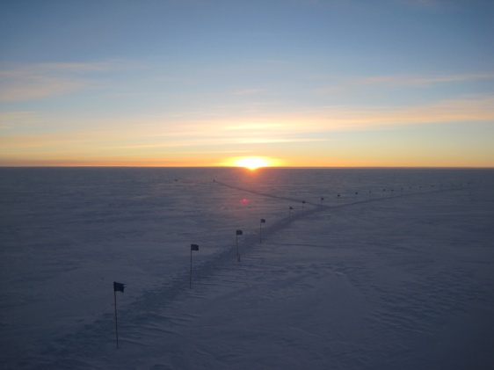

The Sun Came Back! - MOF, 1/28

**General:**

**Significant Weather Observations:**

* 1/25: blsn, bkn stratus, bkn altostratus, 19.2kts, -27.3C
* 1/26: bkn altostratus, bkn cirrostratus, 11.8kts, -38.7C
* 1/27: blsn, few cirrus, 25.2kts, -35.0C
* 1/28: few altocumulus, sct cirrostratus, 9.8kts, -51.0C
* 1/29: br, sct altostratus, 15.6kts, -42.5C
* 1/30: few altostratus, 4.0kts, -42.6C
* 1/31: skc, 10.0kts, -55.7C

**Dataman Account:**

* Operating normally.

**MWR:**

* HATPRO: Removed for repairs.
* 150-90: operating normally.

**SODAR:**

* Operating normally.
* JPG interval returned to one half hour on 1/25
* Cleared transmitter and receiver dishes of snow – 1516-1523z, 1/25
* Cleared transmitter and receiver dishes of snow – 1245-1304z, 1/27. Transmitter filled nearly to the cone.
* Cleared transmitter and receiver dishes of snow – 1344-1348z, 1/29

**POSS:**

* Operating normally.

**MMCR:**

* Operating normally.
* Roll continues to be off by 5 degrees. May be a wiring issue since last time it was off this much, I check connectivity of the wires, found them all good, and the roll suddenly corrected itself. As it is off by the same amount this time suddenly, I don’t think the building shifted 5 degrees.
* Found error “Could not read calibration table Net CDF File” on 1/31 daily checks.

**CAPABL:**

* Operating normally.
* Cleared minimal blowing snow from very edge of window at 1225Z, 1/27.

**MPL:**

* Operating normally.
* Performed AfterPulse Calibration on 1/26.

**VCEIL:**

* Operating normally.
* Received warning: “Receiver optical cross-talk compensation poor.” on 1/27. Removed snow from lens at 1220Z and this fixed the warning.

**Hotplate:**

* Operating normally.
* LED red, but no errors in software. Temp was -53.0C.

**IceCAM:**

* Operating normally.

**PAERI:**

* Operating normally.
* Encoder Scene Confirm oddly yellow at warm temp – 1/25-1/27
* LW/SW Responsivities Red during 1/27 daily checks and in the evening. Removed snow from mirror at 1215Z and 2230Z and both turned green.

**TSI:**

* Shutdown and removed from the roof for the winter.

**IcePIC:**

* No photos taken.

**Radiosonde:**

* Twice daily sondes.

**MASC:**

* Operating normally.
* Found a MASC socket error on 1/27. Relogged in through RDC and restarted the MASC software. It looks like it quit right after 0Z 1/27.