# ICECAPS Weekly Report

July 11, 2016 – July 17, 2016

Hannah James

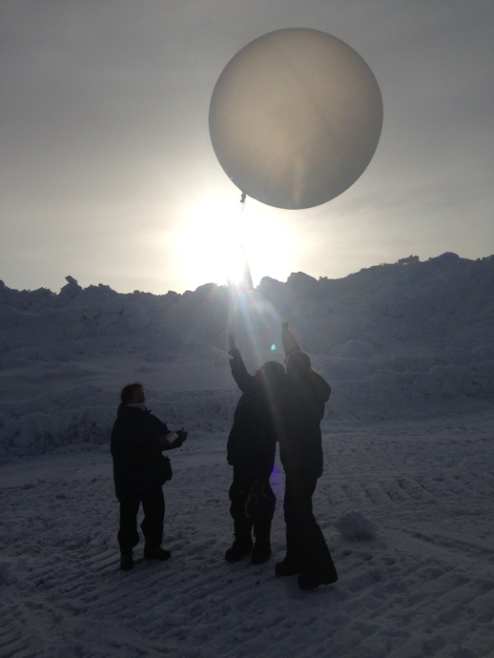

A group of JSEP students assist in launching an evening weather balloon. -HJ

**General:**

* A busy, busy week to start Flight Period 4. HATPRO is back on the MSF roof and collecting data, Albsolute Calibrations have been done daily since Saturday, July 15. The Veiegg group got the hardware they needed to fix their 182 Ghz Water Vapor Radiometer, and it is now housed on the MSF roof in the old ASIA-A location. The JSEP group was on station Wednesday through Sunday doing small science expierments and touring Summit. They especially loved helping out with Weather Balloon launches.

**Significant Weather Observations:**

* 7/11: Bkn altocumulus. -8C, 9kts. –Sn throughout the morning. 1800-1900z- upper tangent arc.
* 7/12: Bkn stratocumulus. -8C, 9 kts. –Sn throughout the morning- large dendritic clumps.
* 7/13: Sct cumulus. -11C, 6kts. –Sn and IC 1200-1300z.
* 7/14: Bkn nimbostratus. -11C, 9kts. –Sn 1030-1200z. Large, well-formed dendrites.
* 7/15: Bkn altostratus, sct cirrus. -11C, 6 kts. Thick fog in the morning, burned off by 1100z.
* 7/16: Few stratus, sct cirrus. -11C, 5 kts. IC and –Sn throughout morning.
* 7/17: Ovc nimbostratus. -7C, 16kts. –Sn throughout the morning.

**Dataman Account:**

* 7/11: Data transfer complete 1045z.
* 7/12: Data transfer complete 1149z.
* 7/13: Data transfer complete 1213z.
* 7/14: Data transfer complete 1254z.
* 7/15: Data transfer complete 1211z.
* 7/16: Data transfer complete 1237z.
* 7/17: Data transfer complete 1342z.

**MWR:**

* HATPRO returned on station 7/13! Installed on the roof on that evening.
* 7/14: 1555z- shut down 150-90 to attempt to connect with HATPRO. Unable to communicate with the computer. Swapped COM cables behind computer, tried different settings on the software, but the slave port reads “No data cable connected to serial port.” Program freezes after each attempt. Trouble shooting continues….
* 7/15: Trouble shooting complete! After skyping with Dave we were able to figure out that the communication ports are all sorts of backwards, but got it figured out so that both radiometers are communicating with the computer. In the computer communication port settings, COM4 is the 150-90 and COM2 is the HATPRO. In the physical cable connections to the computer server, 150-90 is cable port 2, and the HATPRO is cable port 1. Both radiometers were back online at 1345z.
* 7/16: Absolute calibrations performed on HATPRO and 150/90. 1657z: Terminated current batch. 1724-1727z: HATPRO calibrated. 1731-1751z: interenal_external_flop.mbf measurement sequence ran. 1823-1824z: 150/90 calibrated. 1853z: Both MWRs returned to VF11_scan measurements.
* 7/17: Absolute calibration performed on HATPRO. 1650z- Terminated current batch. 1657-1659z: calibration run. 1701-1703: second calibration run. 1704: internal_external_flop measurement. 1742z- VF_11scan measurement resumed.

**SODAR:**

* Operating normally.

**POSS:**

* Operating normally.

**MMCR:**

* Operating normally.
* Roll consistently reading 0.32 degrees.
* 7/11: Pitch bouncing between 0.00 and -0.10 degrees.
* 7/16: Roll bouncing between 0.32 and 0.43 degrees.

**CAPABL:**

* Operating normally.
* 7/15: Attempted to recover data from June 30 2015, but no data in folder. Robert is looking into this.

**MPL:**

* Operating normally.

**VCEIL:**

* Operating normally.

**Hotplate:**

* Off site for repairs since 6/9/2016.

**IceCAM:**

* Operating normally.
* Readjusted to include Harvard/University of Chicago’s WVR in the picture.

**PAERI:**

* Operating normally.

**TSI:**

* Operating normally.
* Due to decreasing angle of the sun, false low cloud coverage is reported in the early morning (0000z-0700z), and late in the evening (times not observed).

**IcePIC:**

* No IcePICs taken this week.

**Radiosonde:**

* Twice daily soundings.
* 7/13: No morning launch due to ANG’s early arrival on station.

**MASC:**

* Offsite for repairs since 5/3/2016.