# ICECAPS Weekly Report

July 18, 2016 – July 24, 2016

Hannah James

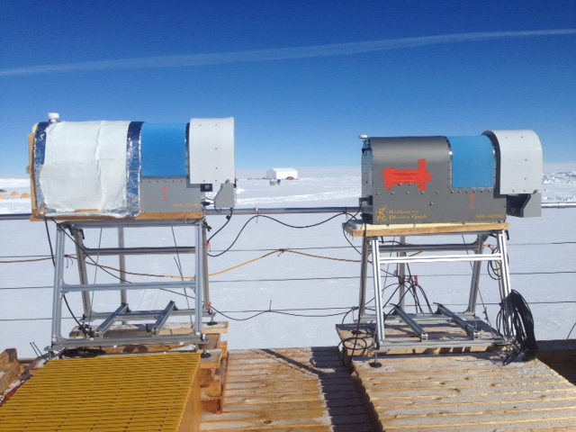

Reunited and it feels so good! -HJ

**General:**

* An unexpected power outage occurred on 7/18 from 2048-2054z. All instruments were on UPS power for the outage and faired the outage well. MWR calibrations were completed 7/18 and 7/19, and the remainder of the liquid nitrogen was used for ice cream making- all of station says thank you! The large dewar left station 7/22 with the southbound flight to close out Flight Period Four.

**Significant Weather Observations:**

* 7/18: Ovc nimbostratus. -10C, 8 kts. Visibility 5000m. –Sn throughout the morning.
* 7/19: Ovc nimbostratus, -10C, 3 kts. Visibility 5000m. –Sn all morning. Clearing in evening to sct cirrus.
* 7/20: Ovc nimbostratus. -5C, 16 kts. Visibility 1600m. –Sg and drsn all morning. Clearing to bkn stratocumulus at 1400z.
* 7/21: Bkn cumulus and altostratus. -3C, 10 kts. Visibility unlimited. Clearing to sct cirrus clouds in evening.
* 7/22: Sct cirrus clouds. -4C, 10 kts. Visibility unlimited. Fzfg in morning and late evening limited visibility to 400m, heavy overnight frost.
* 7/23: Sct cirrus. -8C, 6 kts. Visibility unlimited. Light fzfg in evening.
* 7/24: Few altostratus. -7C, 6 kts. Visibility unlimited. Fogbow 2250z.

**Dataman Account:**

* 7/18: Data transfer complete 1156z.
* 7/19: Data transfer complete 1138z.
* 7/20: Data transfer complete 1419z.
* 7/21: Data transfer complete 1353z.
* 7/22: Data transfer complete 1235z.
* 7/23: Data transfer complete 1053z.
* 7/24: Data transfer complete 0954z.

**MWR:**

* Operating normally.
* 7/18: HATPRO Absolute calibration performed. 1705z- stopped data acquisition. 1725- Started calibration, ran internal_external_flop measurement. 1752- Finished measurement. 1805- Radiometer collecting normal data.
* 7/19: HATPRO Absolute calibration performed. 1227z- stopped data acquisition. 1249- Started calibration. 1252- Calibration finished. 1253- Ran internal_external_flop measurement. 1312- Finished measurement. 1320- Radiometer collecting normal data.

**SODAR:**

* Operating normally.

**POSS:**

* Operating normally.
* 7/22: 0813z- DC offset flag

**MMCR:**

* Roll bouncing between 0.32 and 0.43 degrees, pitch bouncing between 0.00 and -0.10.
* 7/20: Starting at 0600z, error log has hourly entries stating “Level 2 – Net CDF_ Spec – Could not read calibration table NetCDF file” and “Data may be incorrect,” with the same two messages for NetCDF_Mom files. Persisted through the week- restart planned for Monday afternoon.

**CAPABL:**

* Operating normally.
* 7/18: 2051-2055z: Manually stopped data collection during the power outage in preparation for a longer outage.

**MPL:**

* Operating normally.

**VCEIL:**

* Operating normally.

**Hotplate:**

* Off site for repairs since 6/9/2016.

**IceCAM:**

* Operating normally.

**PAERI:**

* 7/18: Von emailed noting that the Stirling Cooler’s current has increased 0.2 amps over a few days without any significant temperature increases inside the MSF. I am keeping a watchful eye on flags’ status.

**TSI:**

* Operating normally.
* Due to decreasing angle of the sun, false low cloud coverage is reported during the early morning and late evening hours.

**IcePIC:**

* 7/18: Slides placed for collection 1205-1220z. Images photographed include rimed stellar dendrites, non-rimed stellar dendrites, rimed simple stars, non-rimed simple stars, hexagonal plates, rimed irregulars, and broken dendrite arms.
* 7/18: Second collection of the day. Slides placed for collection 1750z. Images photographed include stellar dendrites and fernlike dendrites.

**Radiosonde:**

* Twice daily soundings, with one exception:
* No morning launch 7/22 due to ANG morning flight.

**MASC:**

* Offsite for repairs since 5/3/2016.