# ICECAPS Weekly Report

July 25, 2016 – July 31, 2016

Hannah James

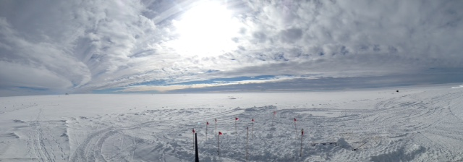

Interesting cloud formations above TAWO earlier in the week -HJ

**General:**

* Two unexpected power outages occurred on 7/26 at 1717z. These outages lasted only a few seconds each, and all MSF instruments were unaffected.

**Significant Weather Observations:**

* 7/25: Few cirrus. -10C, 7 kts. Visibility unlimited.
* 7/26: Few cirrus. -10C, 4 kts. Visibility unlimited.
* 7/27: Few altostratus. -10C, 5 kts. Visibility unlimited.
* 7/28: Bkn stratocumulus (liquid water), bkn cirrostratus. -8C, 3 kts. 1115-1215z: halo 0630-0730z- Parahelia (seen on IceCam). 1900z- verga in the distance
* 7/29: Bkn nimbostratus. -9C, 8 kts. Visibility 5000m. –Sn throughout the morning, large dendrites. Clearing to sct altocumulus in the afternoon. 2100z- Fzfg throughout the night. Fog bow 2130z.
* 7/30: Bkn stratocumulus. -15C, 9kts. Visibility unlimited. Fzfg limiting visibility to 800 m in morning (observed 0900-1000z). Fogbow 1050z.
* 7/31: Few altostratus and cirrus. -18C, 6 kts. Visibility unlimited. 0000-0100z: Fogbow. 1300z-IC.

**Dataman Account:**

* 7/25: Data transfer complete 1151z.
* 7/26: Data transfer complete 1034z.
* 7/27: Data transfer complete 1139z.
* 7/28: Data transfer complete 1148z.
* 7/29: Data transfer complete 1249z.
* 7/30: Data transfer complete 1059z.
* 7/31: Data transfer complete 1132z.

**MWR:**

* Operating normally.

**SODAR:**

* Operating normally.

**POSS:**

* Operating normally.

**MMCR:**

* Operating normally.
* Roll bouncing between 0.32 and 0.43 degrees, pitch bouncing between 0.00 and -0.10.
* 7/25: Rebooted to address the “Level 2 – Net CDF_ Spec – Could not read calibration table NetCDF file” and “Data may be incorrect,” errors seen last week. Multiple reboots were required due to Helix Overcurrent Fault. 1741z-1755z, 1813-1820, 1834-1859z, 2021-2035z. At 2035z, no fault lights, MMCR collecting data again, no errors on hourly error log.

**CAPABL:**

* Operating normally.

**MPL:**

* Operating normally.
* 7/26: 1715-1736z- Afterpulse calibration

**VCEIL:**

* Operating normally.
* 7/25: replaced insulation blanket.

**Hotplate:**

* Off site for repairs since 6/9/2016.

**IceCAM:**

* Operating normally.

**PAERI:**

* Operating normally.

**TSI:**

* Operating normally.
* Due to decreasing angle of the sun, false low cloud coverage is reported during the early morning and late evening hours.
* 7/25: 0427z and 0428z photos distorted as well as black and white.
* 7/26: 0900z- pink image.
* 7/29: No processed images early in the morning (0050-0430z due to low sun angle). Continued throughout the week.

**IcePIC:**

* 7/28 Slides placed for collection 1540-1620z. Images photographed include bullets, radiating plate, and irregular.

**Radiosonde:**

* Twice daily soundings.

**MASC:**

* Offsite for repairs since 5/3/2016.