# ICECAPS Weekly Report

July 4, 2016 – July 10, 2016

Hannah James

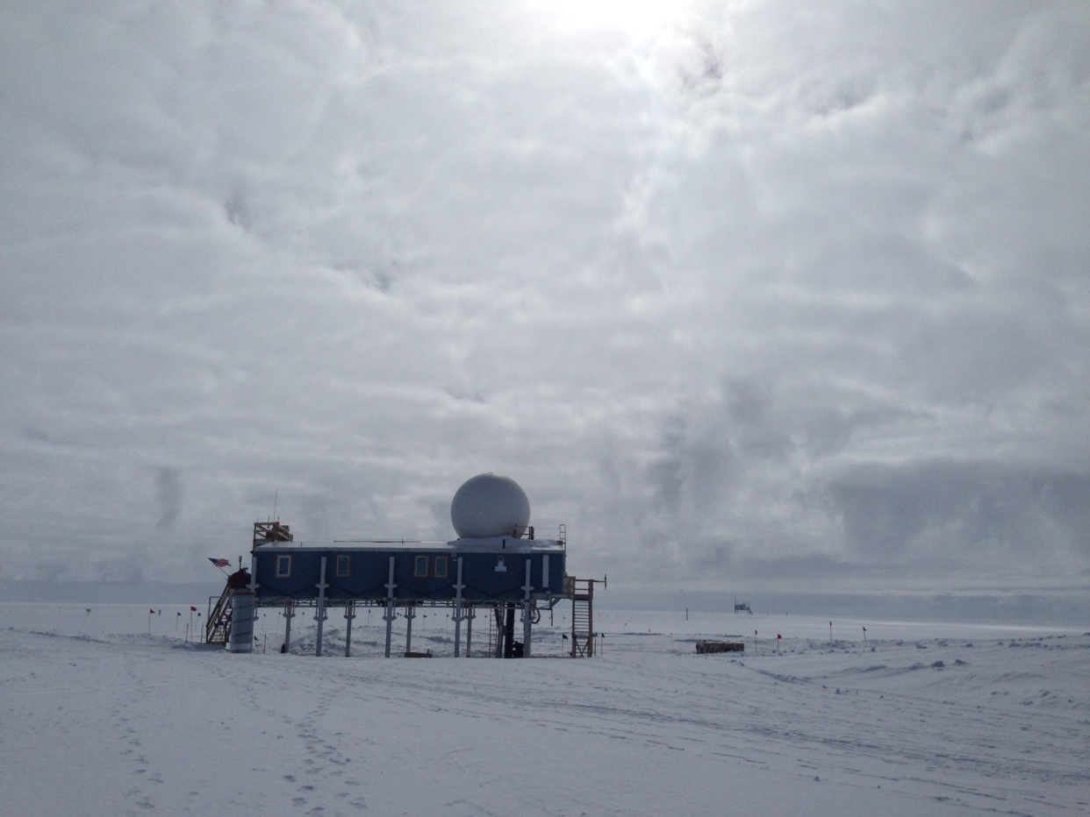

Low lying verga clouds around station -HJ

**General:**

* After running tests inside the MSF and on the porch outside the MSF, the Vieregg group installed their WVR on the roof on 7/7. Due to grounding issues however, their ethernet to USB convertors were fried. The instrument came back into the MSF on 7/8 for troubleshooting and more grounding connections. New ethernet to USB convertors are arriving on Wednesday’s flight, so they hope to have the radiometer up and running by Thursday of the coming week.

**Significant Weather Observations:**

* 7/4: Few stratus, sct altocumulus. -13C, 10kts. Visibility unlimited. IC throughout day. 1200z- corona. 1100-1215z: -Sn. 1500-1645z- iridescent clouds.
* 7/5: Ovc altostratus. -9C, 12 kts. Visibility 5000m. –Sn 1000z.
* 7/6: Bkn altocumulus, -7C, 7 kts. Visibility unlimited. Verga clouds witnessed 1400-1900z.
* 7/7: Bkn stratus, ovc cirrus. -9C, 11kts. Visibility 5000m.
* 7/8: Ovc nimbostratus, clearing to sct stratus, bkn altostratus. -10C, 12 kts. Visibility 5000m.
* 7/9: Bkn nimbostratus. -11C, 8 kts. Visibility 5000m.
* 7/10: Bkn nimbostratus. -7C, 13 kts. Visibility 5000m. –Sn throughout the morning.

**Dataman Account:**

* 7/4: Data transfer complete 1236z.
* 7/5: Data transfer complete 1228z.
* 7/6: Data transfer complete 1102z.
* 7/7: Data transfer complete 1220z.
* 7/8: Data transfer complete 1112z.
* 7/9: Data transfer complete 1159z.
* 7/10: Data transfer complete 1218z.

**MWR:**

* HATPRO removed for repairs.
* 7/8: Rec 1. And 2. Temp Stability alarmed red 1315z- most likely due to roof activity.
* 7/10: Rec 1. And 2. Temp Stability alarmed red 1415- went back to normal operation afterwards.

**SODAR:**

* Operating normally.

**POSS:**

* Operating normally.

**MMCR:**

* Operating normally.
* Roll bouncing between 0.22 and 0.32 degrees.
* 7/8: Pitch occasionally bouncing between 0.00 and -0.10 degrees. (Mostly at 0.00)

**CAPABL:**

* Operating normally.

**MPL:**

* Operating normally.

**VCEIL:**

* Operating normally.

**Hotplate:**

* Off site for repairs since 6/9/2016.

**IceCAM:**

* Operating normally.

**PAERI:**

* Operating normally. Detector Temp flag is turning yellow less frequently than previous weeks.
* 7/6: ABB Temp red. Contacted Von, he said not to worry.

**TSI:**

* Operating normally.
* Due to decreasing angle of the sun, a false low cloud coverage is reported in the early morning (0000z-0700z), and late in the evening (times not observed).

**IcePIC:**

* 7/4: Slides placed for collection 1200-1315z. Images photographed include stellar plates, sectored plates, simple stars, simple plates, split plates, split stars, and one dendrite.

**Radiosonde:**

* Twice daily soundings.
* GPS heights taken of different locations around station. Radiosonde antenna- 3265.52m. Radiosonde base station- 3260.470m. New NOAA pressure sensor on 50m Tower- 3257.145m. Launch sites: Directly outside SOB door: 3255.52 m, half way up SOB hill: 3257 m, and the top of SOB hill: 3260.47m.

**MASC:**

* Offsite for repairs since 5/3/2016.