# ICECAPS Weekly Report

June 13, 2016 – June 19, 2016

Hannah James

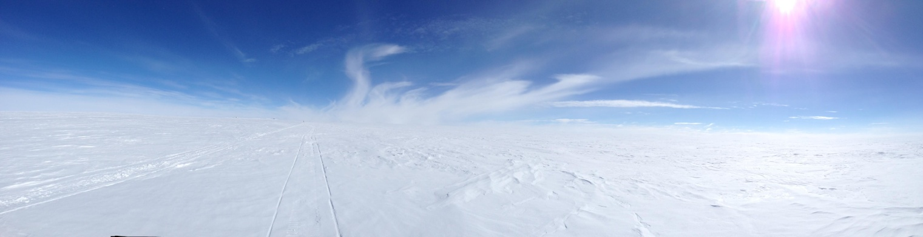

The ICESat traverse provides a humble reminder of our location -HJ

**General:**

* None to report

**Significant Weather Observations:**

* 6/13: Sct cumulus, bkn stratocumulus. -8C, 10kts. Unlimited visibility.
* 6/14: Bkn nimbostratus, bkn stratus. -9C, 9kts. Visibility 5000m. Snow on and off throughout morning, snowing heavily 1130-1200z.
* 6/15: Sct altostratus, sct cirrus. Visibility 1600m. -11C, 16 kts.
* 6/16: Few stratus, few cirrus. Br reducing visibility to 1600m. IC throughout morning. 0000z- sun dogs.
* 6/17: Sct altocumulus. -11C, 12kts. Unlimited visibility.
* 6/18: Few stratus, sct cirrocumulus, bkn cirrus. -11C, 13 kts. Unlimited visibility. IC throughout morning, halo 0900-1230z. Upper tangent arc in and out during that period.
* 6/19: Few stratus, few cirrus. -8C, 9kts. Unlimited visibility.

**Dataman Account:**

* 6/13: Data transfer complete 1045z.
* 6/14: Data transfer incomplete. 150 MB to go as of 1400z.
* 6/15: Trouble grabbing IcePICs from yesterday- “no such file or directory” error on Archive Boulder log- “ambiguous target” message. The txt file was misnamed; I renamed it to the proper format. Data transfer stopped 1028z, no POSS, SODAR, or IceCam files sent. 145 MB left in the Archive Boulder file.
* 6/16: Data transfer complete 1549z. CAPABL mount down at time of data grab. PAERI mount at 97% capacity.
* 6/17: Data transfer complete 1445z. PAERI mount at 98%.
* 6/18: Data transfer complete 1118z. CAPABL mount down overnight. PAERI mount at 77%.
* 6/19: Data transfer complete 1133z. CAPABL mount down at time of data grab. Remounted 1320, even though it showed it was up.

**MWR:**

* HATPRO removed for repairs.

**SODAR:**

* 6/13: 0330 jpg missing.
* 6/14: 1100 jpg missing.
* 6/15: 0130, 1200 jpg missing.
* 6/15: 0300, 0700 jpg missing.
* 6/17: 1500 jpg missing.
* 6/18: 0400, 0800 jpg missing.

**POSS:**

* Operating normally.

**MMCR:**

* Operating normally.
* 6/17: Roll bouncing between 0.11 and 0.22 degrees. Duane is aware of this.

**CAPABL:**

* Robert Stillwell on station.
* Operating normally.
* 6/13: Mount down overnight.
* 6/16: Mount down overnight.
* 6/17: Robert changed out flashlamps.
* 6/18: Mount down overnight.
* 6/19: Mount down overnight.

**MPL:**

* Operating normally.

**VCEIL:**

* Operating normally.

**Hotplate:**

* Off site for repairs since 6/9/2016.

**IceCAM:**

* Operating normally.

**PAERI:**

* Operating normally, though Detector Temp flag is turning yellow more frequently than normal. I am recording times I see this, and Von is remotely monitoring.

**TSI:**

* 6/18: Strange images from 0855-0900z and 0654z. Some black and white images, some distorted, and one green image. All other images normal.

**IcePIC:**

* 6/14: Slides placed for collection 1130-1230z. Images photographed include one 12-branched stellar plate, radiated dendrites, stellar dendrites, stellar plates, simple plates, split plates, irregular crystals.
* 6/16: Slides placed for collection 1230-1300z and 1920z. First sample provided photographs of needles and simple plates. Second collection included stellar dendrite, stellar plates, capped bullets, isolated bullets, bullet rosettes, radiating plates, simple prisms.

**Radiosonde:**

* Twice daily soundings.
* 6/18: Evening balloon did not transfer messages or provide GPS location throughout flight. It was discovered that the surface weather observations were never recorded, so I ran a simulated flight, adding the missing weather data. GPS points were given at the end of the simulation and recorded in the log.

**MASC:**

* Offsite for repairs since 5/3/2016.