# ICECAPS Weekly Report

June 20, 2016 – June 26, 2016

Hannah James

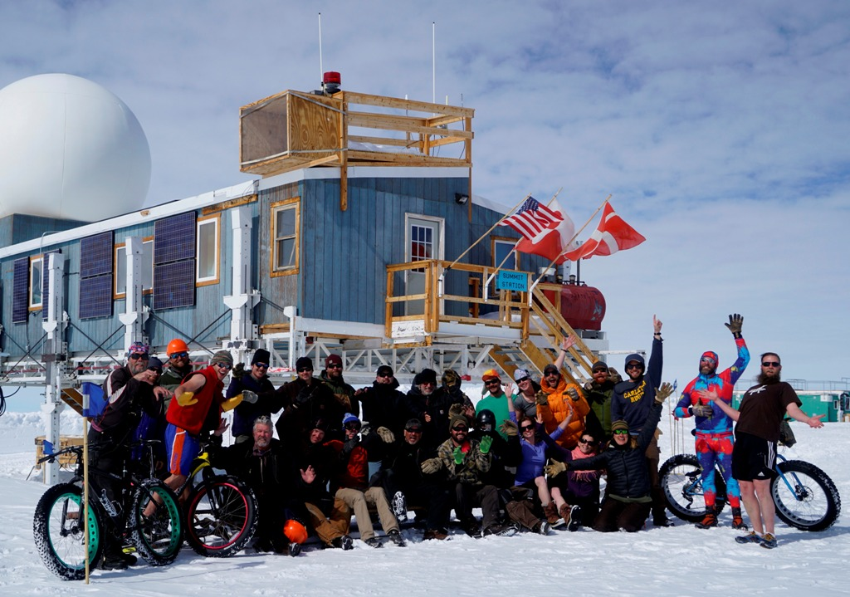

Solsitce greetings from the station!

**General:**

* A busy week with solsitce celebrations, lots of camp tasking, many IcePICs taken, a tour given to DVs from the Air National Guard, and the beginning of Flight Period 3.

**Significant Weather Observations:**

* 6/20: Bkn stratus. -10C, 16 kts. Visibility 5000m. –SN 1045-1215z.
* 6/21: Few cirrus. -14C, 13 kts. Visibility unlimited. 1750-1800z: halo
* 6/22: Bkn stratocumulus. -13C, 4 kts. Visibility 5000m. –SN 1000-1200z. 1120- corona
* 6/23: Fzfg throughout the morning, reducing visibility to 800 m at times. Bkn nimbostratus. -10C, 8 kts. 2015z: halo
* 6/24: Bkn nimbostratus, ovc stratus. -8C, 13 kts. Visibility 1600m. –Sn throughout entire day.
* 6/25: Bkn altocumulus. -8C, 12 kts. Visibility 5000m. –Sn throughout day (see IcePICs for description). 1400-1500z: halo.
* 6/26: Few cirrostratus, few cirrus. -10C, 12 kts. Unlimited visibility.

**Dataman Account:**

* 6/20: Data transfer incomplete. 152 MB to go as of 1303z. (3 days of missed CAPABL data added to transfer.)
* 6/21: Data transfer incomplete. 154 MB to go as of 1530z. (Lots of IcePICs to transfer)
* 6/22: Data transfer complete 1059z.
* 6/23: Data transfer complete 1341z.
* 6/24: Data transfer complete 1312z.
* 6/25: Data transfer complete 1425z.
* 6/46: Data transfer complete 1412z. CAPABL mount down- could not remount from Dataman computer. Notified Robert, CAPABL was remounted after it was restarted.

**MWR:**

* HATPRO removed for repairs.

**SODAR:**

* Operating normally.
* 6/20: 0300z, 2000z jpg missing.
* 6/21: 0400z jpg missing. On weekly call Matt said that these do not need to be recorded, as he can pull all the raw data still.

**POSS:**

* Operating normally.

**MMCR:**

* Operating normally.
* 6/17: Roll bouncing between 0.11 and 0.22 degrees. Duane is aware of this.

**CAPABL:**

* Robert Stillwell on station. Mike O’Neill sent up spare computer, Robert configured it to be plug-and-play if necessary.
* Operating normally.
* 6/24: Licel reading 952 volts, computer reading 950V. Robert informed me this is a grounding issue, and will come up occasionally.
* 6/26: Mount down overnight. Attempted remount on Dataman, but unable to connect. Robert power cycled CAPABL, which brought the mount back up. Realigned, ran alignment scan.

**MPL:**

* Operating normally.
* 6/25: 1626-1649z. Performed afterpulse calibration

**VCEIL:**

* Operating normally.

**Hotplate:**

* Off site for repairs since 6/9/2016.

**IceCAM:**

* Operating normally.

**PAERI:**

* Operating normally, though Detector Temp flag is turning yellow more frequently than normal. I am recording times I see this, and Von is remotely monitoring.

**TSI:**

* Operating normally.
* 6/21: 1207z-Pink-filtered looking image. Returned to normal afterwards.
* 6/22: 0218z- Green-filtered looking image. Returned to normal afterwards.
* 6/23: 0310z- Green filtered looking image. Returned to normal afterwards.

**IcePIC:**

* 6/20: Slides placed for collection 1140-1215z. Images photographed include rimed stellar dendrites, broken dendrite arms, simple plates, simple stars, split stars, and sectored plates. Slides placed for collection again 1405-1418z. Images photographed include rimed stellar dendrites, non-rimed stellar dendrites, broken dendrite arms, simple plates, simple stars, split stars, sectored plates.
* 6/23: Slides placed for collection 2220-2240z. Images photographed include one triangular crystal, hollow columns, capped bullets, isolated bullets, simple prisms, and simple plates.
* 6/24: Slides placed for collection 1145-1212z. Images photographed include radiating dendrites, radiating plates, rimed radiating dendrites, simple plates, and irregular crystals. Slides placed again 1735-1756z. Images photographed include rimed dendrites, rimed irregulars.
* 6/25: Slides placed for collection 1600-1652z. Images photographed include rimed dendrites, hexagonal plats, stellar plates, sectored plates, dendrites, split plates, split stars, radiating plates, irregulars, and rimed irregulars.

**Radiosonde:**

* Twice daily soundings.
* 6/25: No morning balloon launched due to ANG C-130 arrival at 0945 local.

**MASC:**

* Offsite for repairs since 5/3/2016.