# ICECAPS Weekly Report

June 6, 2016 – June 12, 2016

Hannah James

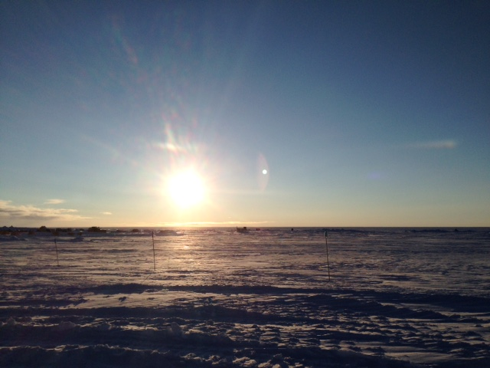

Midnight sun -HJ

**General:**

* A very busy but productive second half of flight period two. Matt Shupe and Duane Hazen departed station on the 9th after relocating the precipitation suite and releveling the MSF and MMCR. Matt took the Hotplate back to Boulder with him, as it was unable to communicate with the host computer. It will hopefully be returning this summer. Robert Stillwell remains on station to work on CAPABL. The new MW41 radiosonde software was installed and is being used. Controlled power outages occurred 6/7 from 1600-1607z and 1816-1823z, and 6/8 from 1301-1306z.

**Significant Weather Observations:**

* 6/6: Few cumulus and stratocumulus. -22C, 1kt. Visibility unlimited.
* 6/7: Sct stratocumulus, cirrostratus. Ground fog in morning, clearing to unlimited visibility late morning. -16C, 4kts. 0930z- 22 degree halo, upper and lower tangent arc. 1000-1130z: fogbow
* 6/8: Sct altocumulus, sct cirrus. -11C, 10kts. IC and –SN throughout the day. Fzfg in evening throughout midnight.
* 6/9: Few altocumulus and cirrocumulus. -10C, 11kts. Unlimited visibility.
* 6/10: Bkn nimbostratus. Blsn, -sn early morning until 1200z. Visibility 1200m. Cleared to sct at 1200z, visibility 5000m. –Sn throughout the afternoon and evening, large dendrites clumping together.
* 6/11: Few stratus, few stratocumulus far in the distance. -15C, 13 kts. Unlimited visibility.
* 6/12: Sct cumulus, bkn cirrus. –Sn and drsn. -4C, 20 kts. Visibility 1600m.

**Dataman Account:**

* 6/6: Data transfer completed 0710z.
* 6/7: Data transfer completed 0622z.
* 6/8: Data transfer incomplete. Manual transfer was started, but unsure if transfer is active. 784 MB to go as of 1339z (CAPABL and MMCR mounts back on).
* 6/9: Data transfer incomplete. 432.1 MB as of 1600z.
* 6/10: Data transfer completed 1402z.
* 6/11: Data transfer completed 1124z. CAPABL mount down during data grab. Remounted 1216z.
* 6/12: Data transfer incomplete. 151 MB to go as of 1400z.

**MWR:**

* HATPRO removed for repairs.
* 6/6: Strange temperatures seen for Receiver 1 and 2, red flag for Ambient Target Stability. Emailed Erik and Dave. Operating normally throughout the rest of the day.

**SODAR:**

* Operating normally.
* 6/6: Remains offline for snow removal after MSF move.
* 6/7: SODAR moved and connected in late afternoon.
* 6/8: Operating normally.
* 6/9: Operating normally. C-130 on the ground 1230-1334z.

**POSS:**

* Operating normally.
* 6/6: Remains offline after MSF move for relocation
* 6/7: Moved to new location, connected later in afternoon.
* 6/8: Operating normally.
* 6/10: Lots of 0’s in data read out, emailed Matt Shupe for an explanation- he will take a look at it when he is back in the Boulder office.

**MMCR:**

* Duane Hazen left station June 9.
* Operating normally after work done by Duane.
* 6/6: Remained offline for work by Duane.
* 6/7: Leveled and brought back online by Duane, pitch and roll back at 0.00, voltages read normally.

**CAPABL:**

* Robert Stillwell on station.
* Operating normally.
* 6/7: Mount down at 0100z, no data grabbed. Robert was made aware, and the data is ready to be grabbed for tonight’s transfer.
* 6/12: 1338-1430z- Shutdown to clear exterior window of water and snow.

**MPL:**

* Operating normally.

**VCEIL:**

* Operating normally.

**Hotplate:**

* 6/9: Remained offline after MSF move and was brought back to the states with Matt Shupe for troubleshooting with communication between instrument and computer.

**IceCAM:**

* Operating normally.

**PAERI:**

* Operating normally, though Detector Temp flag is turning yellow more frequently than normal. I am recording times I see this, and Von is remotely monitoring.

**TSI:**

* Operating normally.

**IcePIC:**

* 6/10: Slides placed 2210z. Images photographed include dendrites and rimed dendrites. Flakes melted quickly when inside IcePIC shed, so only a few photos were taken.
* 6/12: Slides place, but it was so warm (-4C) that flakes melted on the slides before I could capture any images.

**Radiosonde:**

* Twice daily soundings.
* New NOAA and PFS techs (Travis Guy and Elissa Barris) took over evening launches.
* 6/6: Matt Shupe continues upgrades and troubleshooting issues with data being sent out to GTS. Attempting to write bufr messages for GTS, with instructions from DMI not exactly working. Balloons are still being launched.
* 6/9: New MW41 radiosonde software is up and running! Very simplified prep process, and no need to shut the sonde down and send messages before 14000/02000z as the messages send automatically. New protocol is being written.

**MASC:**

* Offsite for repairs since 5/3/2016.