# ICECAPS Weekly Report

March 14, 2016 – March 20, 2016

Sam Dorsi

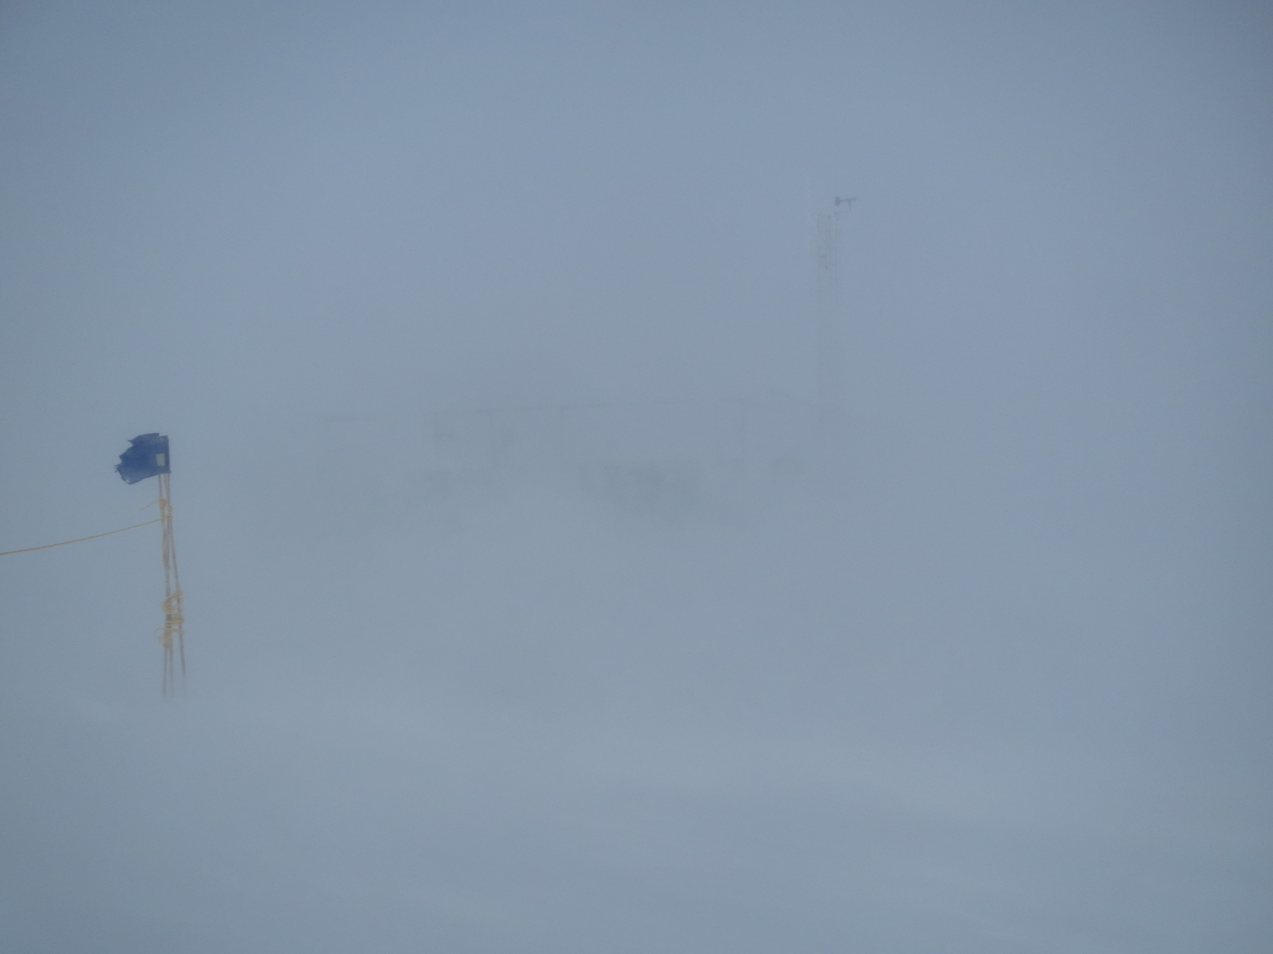

Typical mid-week view of the Green House. SWD.

**General:**

* 3/17: Identified unlabeled UPS-connected power strip behind MSF tech desktop. Labeled strip as UPS-only. Moved non-UPS-dependent items (computer speakers, battery chargers) to alternate non-UPS power strip (14:10z). This will extend UPS runtime and reduce risk of users tripping UPS breakers.
* 3/18: Updated ICECAPS passwords document.

**Significant Weather Observations:**

* 3/14: Overcast stratus, blowing snow, 17 kts, -27C
* 3/15: Few stratus, 10 kts, -49C
* 3/16: Overcast stratus, blowing snow, 20kts, -28C
* 3/17: Overcast stratus, blowing snow, 25kts, -18C
* 3/18: Broken altostratus, drifting snow, 16 kts, -18C
* 3/19: Broken stratocumulus, 10 kts, -18C
* 3/20: Overcast stratus, 12 kts, -25C

**Dataman Account:**

* Operating normally.
* 3/14: Transfer complete at 20:38z.
* 3/15: Transfer complete at 19:17z.
* 3/16: Transfer complete at 18:54z.
* 3/17: Transfer complete at 18:33z.
* 3/18: Transfer complete at 16:46z.
* 3/19: Transfer complete at 20:35z.
* 3/20: Transfer complete at 16:21z.

**MWR:**

* HATPRO removed for repairs.

**SODAR:**

* Operating normally.

**POSS:**

* Operating normally.

**MMCR:**

* Operating normally.
* Measurements of roll, pitch and outdoor temperature appear erroneous.
* 3/15: Errors associated with the calibration table (e.g., ‘Could not read calibration table NetCDF file’) appeared in the 04:00z log file. The MMCR is otherwise functional.
* 3/16: The calibration table errors reappeared. On the suggestion of Duane Hazen, the MMCR was rebooted to synchronize the actions of the MMCR-DM and MMCR-radar computers. This was successful in eliminating the calibration table errors.

**CAPABL:**

* Operating normally.

**MPL:**

* Operating normally.

**VCEIL:**

* Operating normally.

**Hotplate:**

* Operating normally.

**IceCAM:**

* Operating normally.

**PAERI:**

* Operating normally.
* 3/16: Cleaned scene mirror at 12:29z in response to red SW and LW Responsivity flags. The AERI Windows interface closed unexpectedly at ~12:35z, while I clicked the ‘<<’ and ‘>>’ navigation buttons to view the records from previous minutes. The PAERI mirror continued to accumulate snow, and was cleaned again at 15:23z.
* 3/17: Cleaned scene mirror at 12:30z, 13:19z, and 14:41z in response to red SW and LW Responsivity flags. These repeat errors were ultimately resolved by a shift in weather.

**TSI:**

* Stored in MSF and awaiting warmer temperatures for redeployment.

**IcePIC:**

* 3/18: Slides were placed for collection 5 m NW of MSF from 14:19 to 15:11z. Airborne particles appeared to be present, but were not captured on slides, likely due to 17 kt winds. Particles were instead collected in spindrift 2 meters to the NE of MSF. The collection of these building-influenced particles was successful, and images were made of sectored plates, hexagonal plates and triangular forms.

**Radiosonde:**

* Twice daily soundings.

**MASC:**

* Operating normally.