# ICECAPS Weekly Report

March 21, 2016 – March 27, 2016

Sam Dorsi

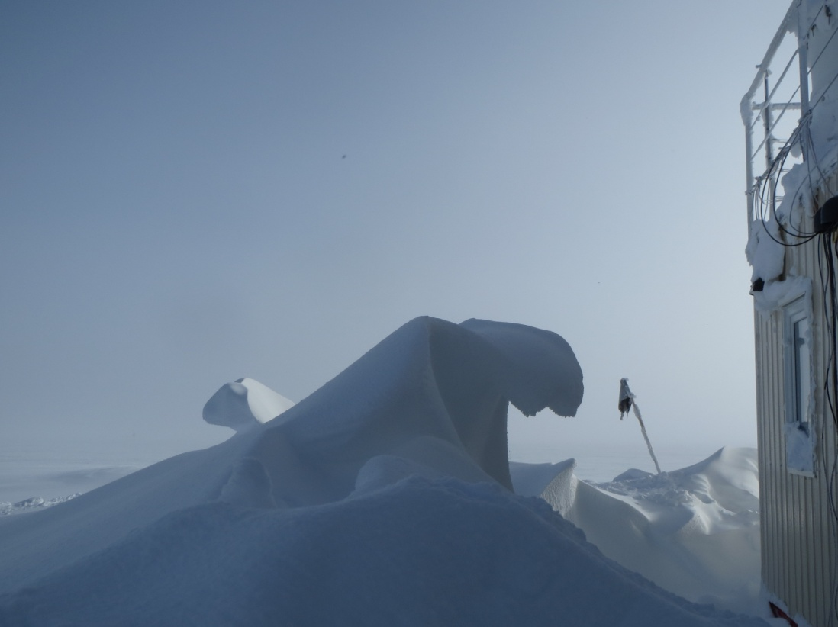

Sheltered by the MSF, two wave-like drift forms curl in opposite directions. SWD.

**General:**

* Cross-training with techs Jason and Marci continues.

**Significant Weather Observations:**

* 3/21: Few stratus, 12 kts, -35C
* 3/22: Scattered altocumulus, 7 kts, -31C
* 3/23: Few stratus, 8 kts, -35C
* 3/24: Freezing fog, 8 kts, -31C
* 3/25: Few stratus, mist, 7 kts, -36C
* 3/26: Scatted cirrostratus, 6 kts, -38C
* 3/27: Scatted cirrostratus, 0 kts, -29C

**Dataman Account:**

* Operating normally.
* 3/21: Data were queued normally, and transfer script executed, but no transfer took place. Errors in the style ‘No MMCRMom.nc.zip data to send’ were produced for all instruments. A full day’s backlog now exists.
* 3/22: A backlog of 830 MB existed at approximately 12:20z. ‘Lost connection’ errors appeared in ToBoulder log file after most of the day’s data was transferred.
* 3/23: A backlog of 560 MB existed at 13:15z. The ToBoulder log file shows that data was transferred until ~16:00z. After that point, an error appeared: ‘Read from remote host 140.172.38.113: Connection reset by peer’. This is followed by ‘lost connection’ errors and reports that the /home/summit/ path (representing the stateside destination directory) is inaccessible. This may be an NOAA outage related to the snowfall in Boulder.
* 3/24: A backlog of 1.2 GB existed at 13:00z. The ToBoulder log file shows that no data were transferred, as the /home/summit/ path was inaccessible. A check performed at approximately 20:00z showed that the transfer process had resumed for the last several hours of the day.
* 3/25: Data transfers proceeding normally. A backlog of 1 GB existed at 13:09z.
* 3/26: Transfer completed at 20:13z.
* 3/27: Transfer completed at 14:13z.

**MWR:**

* HATPRO removed for repairs.

**SODAR:**

* Operating normally.
* 3/26: The SodarPC application was restarted during tech training at 13:22z. The QSC gain for CH1 was increased to just below the clipping threshold at 13:25z.

**POSS:**

* Operating normally.

**MMCR:**

* Operating normally.
* Measurements of roll, pitch and outdoor temperature appear erroneous.
* 3/20: An error of ‘Dwell Control Calibration’ appeared on the MMCR LabView display at 21:00z, halting data collection.
* 3/21: The Dwell Control Calibration error was identified at 13:30z. The error was cleared, and data collection resumed at 13:32z.

**CAPABL:**

* Operating normally.
* 3/25: Deionized water added to both Big Sky laser units.

**MPL:**

* Operating normally.
* 3/23: Monthly afterpulse calibration performed from 14:11 to 14:40z. Task performed jointly with techs Jason and Marci for training purposes.

**VCEIL:**

* Operating normally.

**Hotplate:**

* Operating normally.
* 3/25: The ambient temperature measurement reported by the hotplate is consistently warmer   
  (-26C) than that reported by the NOAA meteorology equipment (-37C).

**IceCAM:**

* Operating normally.

**PAERI:**

* Operating normally.
* 3/25: The PAERI detector temperature had a brief out-of-spec (yellow flag) reading (00:45z) of 79.08 degC, which is just above the 79.00 deg C upper limit.

**TSI:**

* Stored in MSF and awaiting warmer temperatures for redeployment.

**IcePIC:**

* 3/22: Slides placed for collection from 16:14 to 17:02z. A small number of irregular particles were photographed.

**Radiosonde:**

* Twice daily soundings.

**MASC:**

* Operating normally.