# ICECAPS Weekly Report

March 7, 2016 – March 13, 2016

Sam Dorsi

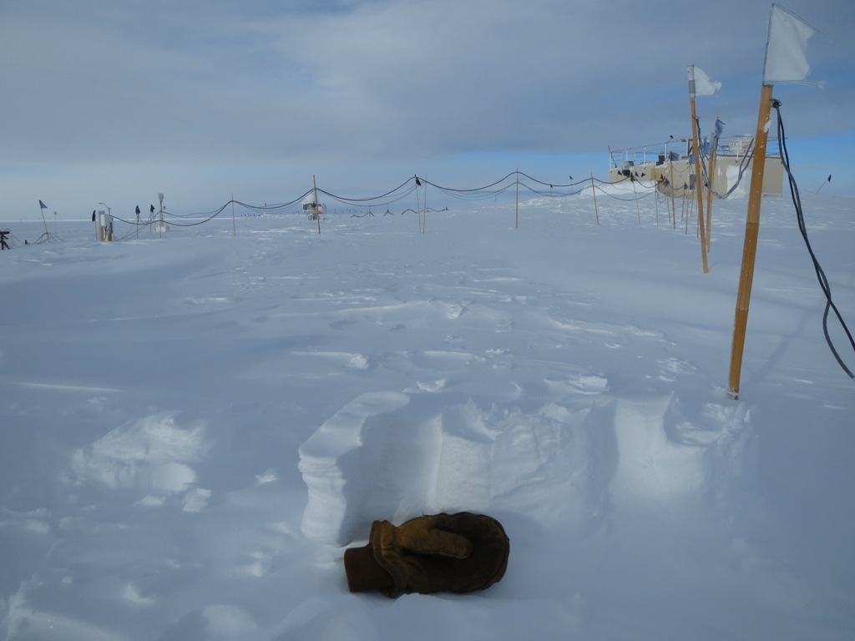

Scouring from the 10 March storm revealed these pedestrian pedestals. SWD.

**General:**

* 3/7: At approximately 11:01z, an unscheduled station-wide power outage occurred, lasting for 4 seconds. Neither the MSF science systems nor the in-preparation 12z radiosonde appeared to be affected.
* 3/9: Routine test of emergency generator was performed from 13:45 to 14:00z. All instruments remained in normal operation during the test.
* 3/10: MSF not visited by tech due to high winds and low visibility.
* 3/11: West side of MSF manually excavated from drifting after previous day’s storm.
* 3/12: Continued excavation of MSF west wall from drifts.
* 3/13: At 13:16z, a second unscheduled station-wide power outage occurred, lasting for 7 minutes and 41 seconds. The MSF science systems appeared to be unaffected.
* 3/13: Drift removal west of MSF using 933 loader.

**Significant Weather Observations:**

* 3/7: Broken stratus, drifting snow, freezing fog, 11 kts, -44C
* 3/8: Overcast stratus, blowing snow, 19 kts, -35C
* 3/9: Overcast stratus and altostratus, blowing snow, 17 kts, -29C
* 3/10: Blowing snow, 44 kts, -22C
* 3/11: Scattered stratus, 12 kts, -32C
* 3/12: Few stratus, 12 kts, -42C
* 3/13: Broken stratocumulus, 16 kts, -32C

**Dataman Account:**

* Operating normally.
* 3/7: Backlog 350 MB at 13:00z. Data transfer from 3/6 did not terminate overnight, but instead ran to completion at 10z on 3/7. ICECAPS data volume continues to be high (1 GB / day), though the backlog is decreasing only slowly (150 MB / day).
* 3/8: Backlog was completely cleared at 21:22z last night. Today’s upload completed at 10:40z!
* 3/9: Transfer was completed at 11:17z.
* 3/10: Transfer was completed at 11:21z.
* 3/11: Transfer was completed at 18:35z—later than usual due to presence of a large amount of traffic on the summitcamp.org host.
* 3/12: Backlog 677 MB at 13:00z. The ToBoulder archive process did not take place, as the Boulder servers were undergoing maintenance. This manifested as the unavailability of the directory /home/summit/ at the time the transfer script was executed.
* 3/13: Backlog ~900 MB at 14:00z.

**MWR:**

* HATPRO removed for repairs.

**SODAR:**

* Operating normally.

**POSS:**

* Operating normally.

**MMCR:**

* Operating normally.
* Measurements of roll, pitch and outdoor temperature appear erroneous.

**CAPABL:**

* Operating normally.

**MPL:**

* Operating normally.

**VCEIL:**

* Operating normally.

**Hotplate:**

* Operating normally.
* 3/10: The hotplate encountered an error “string not in expected format” at 10:41z. This error previously has been encountered when a transmitted message is truncated. The error occurred during the wind storm and so was not discovered until 3/11 at 14:10z.
* 3/11: The hotplate returned to operation. The instrument Ethernet cable was moved from port 12 to port 6 on the ICECAPS network switch. Data collection resumed at 15:38z.

**IceCAM:**

* Operating normally.
* 3/10: Some files appear to be corrupted and un-readable, or have file size of 0 bytes. Others show strange red or green coloration, as if color channels were intermittently failing. Other images are normal.
* 3/11: All images are 0 bytes. The IceCam is not accessible at 192.168.1.118. On inspecting the cable run from the IceCam to the PoE injector, a complete break in the cable jacket was discovered, approximately 4 meters from the camera unit. Issue was resolved when Ethernet cable was moved from port 11 to port 13 on the ICECAPS network switch. Port 11 continued to show activity on port 11 (flashing green), despite the absence of a connected device. Data collection resumed at 15:45z.
* 3/12: Damaged region of Ethernet cable protected using electrical tape (15:35z).

**PAERI:**

* Operating normally.
* 3/7: The scene mirror was cleaned at 14:10z; this resolved a yellow ‘SW responsivity’ flag.
* 3/12: Blue ‘data outage’ flags were found present on the PAERI (13:35z), with an estimated incident time of 09:30z.

**TSI:**

* Stored in MSF and awaiting warmer temperatures for redeployment.

**IcePIC:**

* 3/11: Particles were collected from 1620 to 1744z. Images showed bullet rosettes, sheaths, hollow columns, and a hexagonal plate.

**Radiosonde:**

* Twice daily sondes.
* 3/10: Radiosonde launch at 12z failed due to high winds. No data received after launch.
* 3/11: Radiosonde launch at 0z failed due to high winds. Sonde reported out-of-spec T and RH values, and self-terminated.

**MASC:**

* Operating normally.