# ICECAPS Weekly Report

May 16, 2016 – May 22, 2016

Hannah James

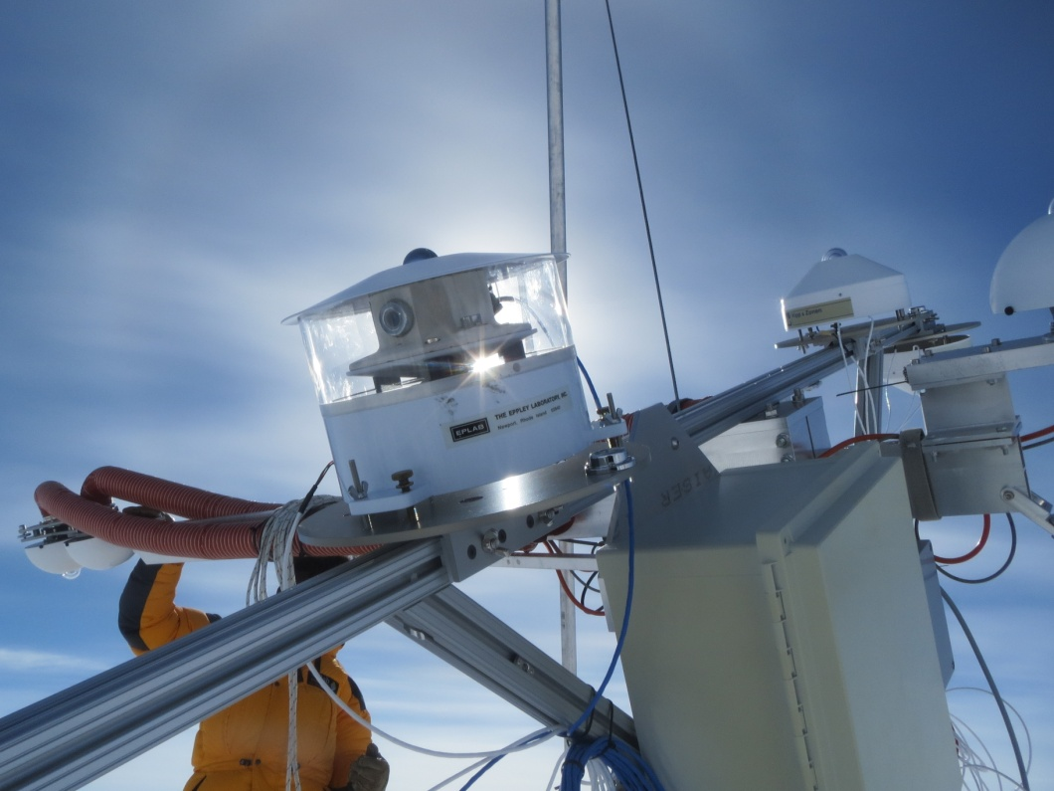

A halo around the NOAA downwelling pryranometer

during Koni Steffan’s solar instrument raise. -HJ.

**General:**

* 50 meter tower and NOAA radiometers had two power outages due to the installation of a shark meter. These occurred from 1116-1350z on 5/17, and 1754-1806z on 5/18. The Total Sky Imager is now installed on the MSF roof for the summer. Koni Steffen’s group arrived on 5/21 to service his AWS, raise instruments on the tower, and raise the solar trackers.

**Significant Weather Observations:**

* 5/16: Few stratus clouds on horizon, BR. Visibility 5000, -26C, 5kts. 1930z: halo
* 5/17: Few low stratus clouds, scattered altocumulus, and ovc cirrus. Drsn, -sn. Visibility 800m. -18C, 13kts. Winds climbing to 20 kts mid-morning through afternoon, calming to 10kts in evening. Visibility as low as 200m at times. Sun dogs 2000z.
* 5/18: Few altocumulus, sct cirrostratus clouds. Visibility 5000m, -14C, 12kts climbing throughout day. Halos and sundogs 1000-1200z. IC throughout the day.
* 5/19: Sct altostratus, bkn cirrus. Unlimited visibility, -16C, 5kts. IC on and off during the day. Kelvin Helmoltz clouds witnessed at 1800z (photos in weeklyphotos folder).
* 5/20: Sct cirrostratus clouds. Unlimited visibility. -18C, 3kts. Diamond dust throughout day. 11:30-1250z: sun corona. 1800z: slight halo/sun dogs
* 5/20: Started significant weather observations photo folder under /home/dataman/search/work/weeklyphotos
* 5/21: Few cirrus clouds. Unlimited visibility. -18C, 13kts. 2245: Fogbow
* 5/22: Few stratocumulus, bkn cirrus. Visibility 6000m. -18C, 10kts. Halo visible on and off 1300-1700z.

**Dataman Account:**

* 5/16: Data transfer completed 1211z.
* 5/17: Data transfer completed 1118z.
* 5/18: Data transfer completed 1304z. IcePIC and TSI files did not transfer.
* 5/19: Data transfer incomplete. 298 MB as of 1600z. IcePIC transfer is reason for backup.
* 5/20: Data transfer completed 1158z. TSI mount down. Remounted drive 1209z.
* 5/21: Data transfer completed 1240z.
* 5/22: Data transfer completed 1057z.

**MWR:**

* HATPRO removed for repairs.
* 5/18: Skype call with Erik regarding prep for reinstallation of HATPRO. Inventoried spare parts and tools in the MSF and inspected insulation for both instruments- most everything is in good shape, and all parts for LN2 calibration were located.

**SODAR:**

* Operating normally.
* The D6 has been operating near the SODAR for about 30 minutes each day. Noise has been noted in the log.

**POSS:**

* Operating normally.

**MMCR:**

* Operating normally.
* The +5 V (#1 and #2) interface buses are reported as out-of-spec in the Labview display since 4/29/16. However, the physical test points on the interface unit show these buses to be near the specified 5 V.
* Cable MPP8 disconnected (roll, pitch and outdoor temperature sensors) since 4/19.

**CAPABL:**

* Operating normally.
* 5/18: Shut down to clean water droplets off roof. Back online 1338z.

**MPL:**

* Operating normally.

**VCEIL:**

* Operating normally.

**Hotplate:**

* Operating normally.

**IceCAM:**

* Operating normally.
* 5/22: Frost covered lens overnight. Removed frost on daily rounds, 1300z photo clear.

**PAERI:**

* Operating normally.

**TSI:**

* 5/16: Mounted on roof, but not collecting photographs yet. Communication errors.
* 5/17: Communication errors solved, collecting data starting “1256z” (really 1306z- reset clock after realizing time was off). Faulty port #8 inside MSF causing break in line. TSI is currently in port #2 inside, and port #2 inside TSI box.
* 5/18: Started realignment of shadowband, but had to stop because the computer was going to die.
* 5/19: Instrument offline from 1156-1523 for shadow realignment. Lots of troubleshooting went into this due to cables and ports not working. I will make a better protocol for which cables to use.
* 5/20: Mount was not found on Dataman. Remounted drive on Dataman, reset IP address on TSI computer.
* 5/20: 1754-1809z. Offline for battery inspection.
* 5/21: TSI was very frosted overnight, but cleared itself as sun came up around 0500z.
* 5/22: TSI was very frosted overnight, but cleared itself around 0745z.

**IcePIC:**

* 5/18: Slides placed for collection 1156-1216z. Images photographed include simple prisms, bullets, radiating plates, irregulars, some rimed crystals, some broken plates, some needles.
* 5/20: Slides placed for diamond dust collection 1151-1310z. Images photographed include needle clusters and irregulars.

**Radiosonde:**

* Twice daily soundings.

**MASC:**

* Offsite for repairs since 5/3/2016.