# ICECAPS Weekly Report

May 2, 2016 – May 8, 2016

Hannah James

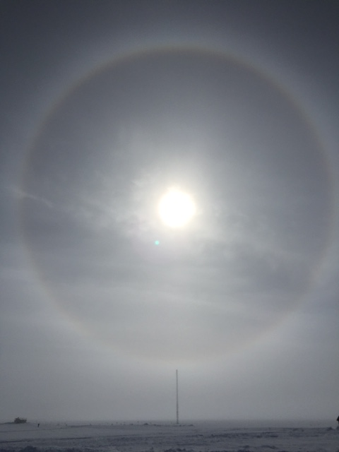.

A perfect halo above the Swiss Tower and MSF. -HJ.

**General:**

* A busy and productive week on station. Sam and a few of the early spring crew departed station on Tuesday. The sun is now above the horizon 24 hours a day, producing some fantastic halos throughout the week. Dataman is back online and nearly caught up with the backlog of data to be transferred.

**Significant Weather Observations:**

* 5/2: Few altocumulus and cirrus. 4kts, -31C
* 5/3: Few stratus and cirrus, unlimited visibility. 10kts, -27C.
* 5/4: Few cirrus clouds, unlimited visibility. 7kts, -26C. Fata morgana to the west witnessed at 0000z weather obs. Halo observed 1340z.
* 5/5: Scattered cirrostratus clouds, good visibility (5000m). 10kts, -25C. Fata morgana to the west witnessed at 0000z weather obs.
* 5/6: Few altocumulus and scattered cirrostratus. Fair visibility (1600m) at 1200z. 4 kts, -25C. FZFG 0900z. Sun dog present 1115-1215z. SG 0900-XXXXz. FZFG present throughout most of the morning and early afternoon. Fogbow at 2200z.
* 5/7: Mist on horizon reducing visibility to 5000m. Few to scattered cirrus clouds. 0 winds throughout morning, -29C.
* 5/8: Mist on horizon reducing visibility to 5000m. Low, fast moving stratus clouds. 7kts, -26C. Ice crystals at 1200z. Faint halo from 1800-1900z.

**Dataman Account:**

* 5/2: No data transfer to Boulder.
* 5/3: No data transfer to Boulder.
* 5/4: No data transfer to Boulder.
* 5/5: Data transfer issue resolved. While server work was done on station by SRI, the local IP address was changed without us being notified. Personal internet use is being limited on station to allow Dataman to catch up with six days’ worth of data transfer (3.2 GB as of 1200z).
* 5/6: Data successfully transferring, though still backlogged. 2.3 GB to go as of 1230z. RAID hard drive changed out due to errors found in daily checks.
* 5/7: Data successfully transferring, though still backlogged. 1.7 GB to go as of 1210z.
* 5/8: Data successfully transferring, though still backlogged. 1.0 GB to go as of 1300z.

**MWR:**

* HATPRO removed for repairs.

**SODAR:**

* Operating normally.

**POSS:**

* Operating normally.
* 5/3: Rebooted POSS for data transfer troubleshooting 1229-1315z.
* 5/6: Rebooted POSS for RAID hard drive replacement 1740-1913z.

**MMCR:**

* Operating normally.
* The +5 V (#1 and #2) interface buses are reported as out-of-spec in the Labview display since 4/29/16. However, the physical test points on the interface unit show these buses to be near the specified 5 V.
* Cable MPP8 disconnected (roll, pitch and outdoor temperature sensors) since 4/19.

**CAPABL:**

* Operating normally.
* 5/6: Replaced flashlamp on Laser 2. Offline 1856-2012z.

**MPL:**

* Operating normally.
* 5/5: Mount at 95%
* 5/7: Deleted data more than 1 year old. Mount still at 95%.
* 5/8: Continued to delete data more than one year old. Mount is still at 96%. It was discovered that the older data files are much larger than the files being created today. Awaiting permission to delete more files.

**VCEIL:**

* Operating normally.

**Hotplate:**

* Operating normally.

**IceCAM:**

* Operating normally.

**PAERI:**

* Operating normally.

**TSI:**

* Stored in MSF and awaiting warmer temperatures for redeployment.

**IcePIC:**

* 5/6: Slides placed for collection 1145-1330z. Images photographed include mostly irregulars with characteristics of stellar plates, hollow columns, and hexagonal plates. Some graupel and capped columns.
* 5/8: Slides placed for collection 14:17-1527z. Images photographed include mostly irregulars with some isolated bullets.

**Radiosonde:**

* Twice daily soundings.
* 5/4: Replaced plastic on balloon table.

**MASC:**

* MASC shipped back to Vanderbilt on 5/3/2016 via LC-130 for troubleshooting.