# ICECAPS Weekly Report

May 23, 2016 – May 29, 2016

Hannah James

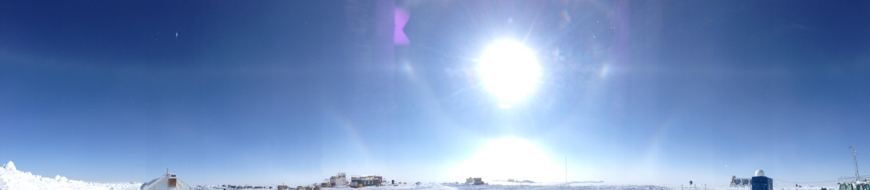

A clear parahelic circle along with infralateral arc, lower tangent arc, 22 degree halo, and parahelia. -HJ.

**General:**

* A majority of the snow removal around the MSF occurred 5/25, and continued throughout the end of the week.

**Significant Weather Observations:**

* 5/23: Sct stratocumulus, bkn cirrus. -19C, 4kts. 0930-1030z: halo
* 5/24: Sct altostratus, bkn cirrostratus. -22C, 10kts. 1115-1215z: halo, 2130z: sundogs
* 5/25: Sct altostratus, bkn cirrostratus, bkn cirrus. -16C, 15kts. 1130-1330z: halo, blsn. 1730z: IC, partial halo. 2030z: halo. 2330z: halo
* 5/26: Sct altostratus, bkn cirrus. Blsn, visibility 800m. -21C, 20 kts. 0930-1130z: lower tangent arc. 2120-2230: parahelic circle, upper and lower tangent arc, 22 degree halo, 46 degree halo, and superlateral arc all witnessed.
* 5/27: Blsn, fzfg, sct altocumulus. Visibility 800m. -22C, 20kts. IC and –SN throughout day. 0940: Lower tangent arc, halo. 1150z: corona. 1420: upper tangent arc, halo. 1800z: halo, sun dog, and slight upper and lower tangent arcs.
* 5/28: Few stratus. Drsn, br.-25C, 12kts. Visibility 1600m. IC in morning. 0930-1500z. Upper and lower tangent arc, sun dogs. 1109-1130: Parahelic circle, 46 degree halo, 22 degree halo, upper and lower tangent arc. 1208-1220z: parahelic circle, sundogs, 46 degree halo, upper and lower tangent arcs. (120800 TSI image captured this well). 1700z: halo.
* 5/29: Ovc stratus, blsn, sn. -16C, 25kt winds. Visibility 400-800m. 1841z- halo, slight upper tangent arc.

**Dataman Account:**

* 5/23: Data transfer completed 1109z.
* 5/24: Data transfer completed 1253z.
* 5/25: Data transfer completed 1203z.
* 5/26: Data transfer incomplete. 150.8MB to go as of 1241z.
* 5/27: Data transfer completed 1403z.
* 5/28: Data transfer completed 1223z.
* 5/28: Data transfer incomplete. 152.4 MB to go as of 1322z. (transferred by the end of the day)

**MWR:**

* HATPRO removed for repairs.

**SODAR:**

* Operating normally.
* Heavy equipment has been operating near the SODAR each day to build the ramp for the MSF’s new location and remove snow around MSF. Times have been noted in the log.
* 5/25: Heavy equipment operation around MSF to clear snow for a majority of the day. Noted in log.

**POSS:**

* Operating normally.

**MMCR:**

* Operating normally.
* The +5 V (#1 and #2) interface buses are reported as out-of-spec in the Labview display since 4/29/16. However, the physical test points on the interface unit show these buses to be near the specified 5 V.
* Cable MPP8 disconnected (roll, pitch and outdoor temperature sensors) since 4/19.

**CAPABL:**

* Operating normally.
* 5/23: Laser shut down 1300z-1323z for exterior window cleaning.

**MPL:**

* Operating normally.
* 5/23: 1341z: Reset PC time to match GPS server (off by 90 seconds)
* 5/27: 1732-1752z: Afterpulse calibration

**VCEIL:**

* Operating normally.

**Hotplate:**

* 5/25: “Error 85 LabVIEW: Scan failed. The input string does not contain data in the expected format” found during daily checks. Clicked ‘continue’ and the hotplate started collecting data as usual.
* 5/26: Same error found.
* 5/27: Same error found, red light found on and off during rounds. Clicked continue, started collecting data at 1213z. Error found a few minutes later. Rebooted entire system. Errors found again at 1306z.
* 5/28: Same error found. 1144z- started collecting data again. No red LEDs at hotplate. Data collection was errorless throughout the morning.
* 5/29: Same error found. 1342z- started collecting data again.
* These errors continued throughout the week, but on 5/30 (Monday morning) no errors were found.

**IceCAM:**

* Operating normally.

**PAERI:**

* Operating normally.

**TSI:**

* 5/23: TSI was covered in snow. Offline 1305-1323 to check status of heater. It was found off. I turned it on, tested by dropping snow on it. It immediately melted the snow.
* 5/25: Low percentage readout for high cloud coverage from 0000-0200z. Many clouds in images, but processed image did not read. Accurate readings once the sun got higher in the sky.
* 5/26: Same issues as yesterday. Noted that when the sun is below the TSI horizon there is lower cloud coverage reported…

**IcePIC:**

* Slides not placed due to heavy equipment moving snow around MSF throughout the week.

**Radiosonde:**

* Twice daily soundings.

**MASC:**

* Offsite for repairs since 5/3/2016.