# ICECAPS Weekly Report

May 30, 2016 – June 5, 2016

Hannah James

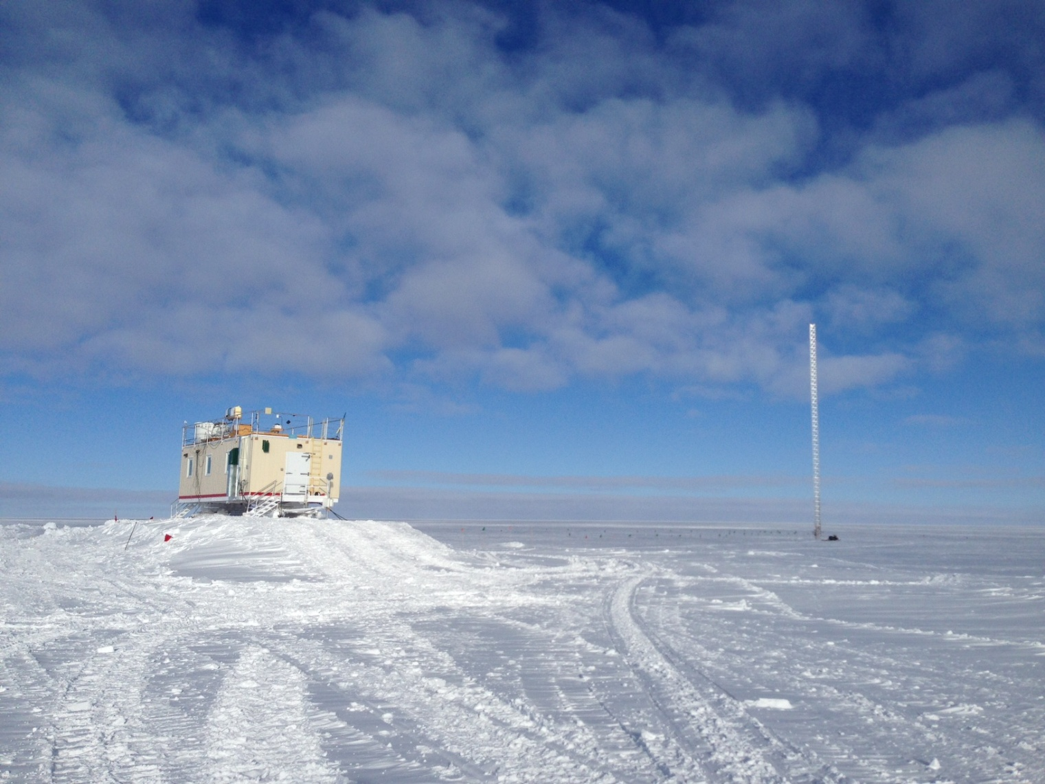

The new castle in the sky -HJ

**General:**

* Unexpected power outage on all UPS-based instruments due to a shorted circuit on the 50-meter tower breaker on June 5. This occurred from 2019-2045z, with power briefly restored at 2033 for diagnosis of the blown breaker. Inidivudual comments and times offline are noted below. The MSF was succesfully moved on June 5th! All instrument outages are noted below, and the precipitation suite remains offline until early next week due to heavy snow removal needed. Planned power outage on May 30 from 2130-2230z resulted in our interenet being shut down until 0100z May 31, not allowing data to be uploaded for the 30th. Individual times that instruments were powered down are detailed below. Matt Shupe, Duane Hazen, and Robert Stillwell arrived on station Friday, June 4th.

**Significant Weather Observations:**

* 5/30: Few stratus and cirrostratus. -19C, 10kts.
* 5/31: Few altocumulus and cirrus. -23C, 7kts. Visibility unlimited.
* 6/1: Bkn stratus, -16C, 20 kts. Visibility 1600m in morning, clearing to 5000m mid-day. 1400: winds up to 30kts, visibility limited to 400m. 0930: halo. 1340-1350z- parhelic circle, parahelia, upper tangent arc, 22degree halo. 1815:halo 1950-2020z: 22 degree halo, 46 degree halo, upper and lower tangent arc, Parry arc, circumzenithal arc, and parahelia.
* 6/2: Bkn cirrostratus, bkn cirrus. -19C, 19kts. 1315z: Halo.
* 6/3: Bkn stratus, stratocumulus. –Sn, blsn. -6C, 26 kts.
* 6/4: Bkn altocumulus. IC in early morning, -sn mid-morning. -12C, 10 kts. Visibility 5000m.Clearing later in the day to unlimited visibility and cumulus clouds.
* 6/5: Sct cumulus, drsn. -15.6C, 15kts. Visibility unlimited. –Sn 0000z.

**Dataman Account:**

* 5/30: Data transfer completed 1124z.
* 5/31: Data not uploaded or transferred due to internet outage.
* 6/1: Data transfer completed 1624z.
* 6/2: Data transfer completed 1318z. MMCR mount was down overnight, remounted 1338z.
* 6/3: Data transfer incomplete. 331.8 MB to go as of 1233z.
* 6/4: Data transfer complete 1300z.
* 6/5: Data transfer incomplete. 151.4 MB to go as of 2000z. Offline for MSF move. Offline 2019-2052 with unexpected power outage.

**MWR:**

* HATPRO removed for repairs.
* 5/30: Powered down 2017-2319 for scheduled power outage.
* 6/5: Powered down 1550-1831z for MSF move. Hard power down due to UPS short circuit 2019-2035. Controlled shut down 2035-2313z.

**SODAR:**

* Operating normally.
* 5/30: Left SODAR note file open above application overnight, resulting in no good JPGs.
* Heavy equipment has been operating near the SODAR each day to build the ramp for the MSF’s new location and remove snow around MSF. Times have been noted in the log.
* 5/30: Powered down 2008-2339z.
* 6/5: Powered down 1426 for MSF move. Remains offline due to heavy snow pack around it.

**POSS:**

* Operating normally.
* 5/30: Powered down 2004-2253z for scheduled power outage.
* 6/5: Powered down 1426 for MSF move. Remains offline with rest of precipitation suite until early next week.

**MMCR:**

* Duane Hazen arrived on station June 4.
* The +5 V (#1 and #2) interface buses are reported as out-of-spec in the Labview display since 4/29/16. However, the physical test points on the interface unit show these buses to be near the specified 5 V.
* Cable MPP8 disconnected (roll, pitch and outdoor temperature sensors) since 4/19.
* 5/30: Unable to bring back online after power outage. Unsure if it was able to shut down properly: UPS lights never turned off, so key was never turned. However, the instrument did not reboot itself. Receiver LCD reading out 50 and Interface reading 63. PIs notified. Exited out of programs 2108z.
* 6/1: Started rebooting process1526z. Had to reboot once, and system was back online by 1627z.
* 6/2: Mount down overnight, data did not transfer. Remounted drives 1338z.
* 6/5: Powered down for MSF move, leveling, and troubleshooting by Duane. Remains offline.

**CAPABL:**

* Robert Stillwell on station to realign and install an automatic steeling mount.
* Operating normally.
* 5/30: Powered down 2056-2309z for scheduled power outage.
* 6/3: Powered down 1250-1300z for window cleaning.
* 6/4: Powered down 1308-1320z for window cleaning.
* 6/5: Powered down 1538- 1929z for MSF move. Unexpected power outage 2019-2312 caused some software issues that were addressed by Robert immediately.

**MPL:**

* Operating normally.
* 5/30 & 5/31: Powered down 2000-0004z for scheduled power outage. LabView had to be started a few times upon powering up; it kept freezing.
* 5/31: VNC unable to access MPL computer.
* 6/1: 1557z: rebooted for VNC troubleshooting. Unresolved.
* 6/5: Powered down 1543-1831z for MSF move. Issue with VNC resolved.
* 6/5: Unexpected hard power down with UPS short circuit. Brought back online for a soft shutdown, back online 2251z.

**VCEIL:**

* Operating normally.
* 5/30: Powered down 1956-2354z for scheduled power outage.
* 6/5: Powered down 1541-1801z for MSF move. Unexpected hard power down with UPS short circuit. Brought back online 2244z.

**Hotplate:**

* 5/30: Hotplate application found running normally without errors.
* 5/30: Powered down 1954-2351z for scheduled power outage.
* 6/5: Error “1073807360 ‘Visa Hex0xBFFF0000: Unknown system error (miscellaneous error)’” found upon daily checks. Unable to reboot, so the MPL was shut down early at 1238z for the MSF move, and brought into the MSF for defrost and troubleshooting by Matt Shupe. Splits found in the communications cable.

**IceCAM:**

* Operating normally.
* 6/5: Photos on mount only after 1045z.

**PAERI:**

* Operating normally.
* 5/30: Powered down 2032-2250z, minus the Sterling Cooler, for scheduled power outage.
* 6/5: Powered down 1605-1712z, minus the Sterling Cooler, for MSF move.
* 6/5: Unexpected power outage to whole system 2019-2035. After brought back online things look good, but Von reported that the Sterling Cooler’s current is slightly higher (0.43 amps versus the previous 0.40) and working a bit harder. I am keeping a close eye on this.

**TSI:**

* Operating normally.
* 5/30: Powered down 2021-2304z for scheduled power outage.
* 6/5: Powered down 1534-1845 for MSF move. Powered down with unexpected power outage 2019-2317z.

**IcePIC:**

* Slides not placed due to heavy equipment moving snow around MSF throughout the week.

**Radiosonde:**

* Twice daily soundings.
* 6/4 & 6/5: Matt Shupe starting upgrades and troubleshooting issues with data being sent out to GTS. Attempting to write bufr messages for GTS, with instructions from DMI not exactly working. Balloons are still being launched.
* 6/4: No morning balloon launched due to incoming ANG C-130 flight.
* 6/5: No morning balloon launched due to incoming ANG C-130 flight.

**MASC:**

* Offsite for repairs since 5/3/2016.