# ICECAPS Weekly Report

November 14 – 20, 2016

Sam Dorsi

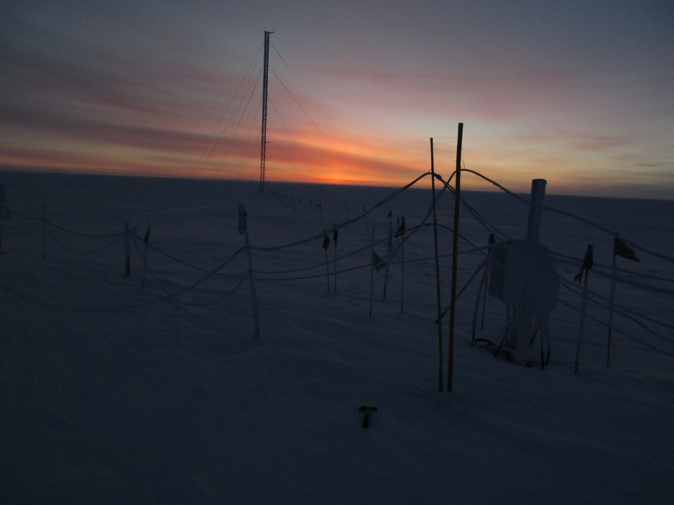

A dimly glowing sky provides the setting for raising instrument cables (11/19). SWD.

General:

* 11/19: Raised instrument cable runs in vicinity of the MSF (13:45-14:10z).

**Significant Weather Observations:**

* 11/14: Scattered altostratus, -45C, 7 kts.
* 11/15: Few altostratus, -46C, 6 kts.
* 11/16: Overcast stratus, freezing fog, -44C, 17 kts.
* 11/17: Few altostratus, -47C, 13 kts.
* 11/18: Freezing fog and drifting snow, -36C, 9 kts.
* 11/19: Broken altostratus, -39C, 6 kts.
* 11/20: Broken altostratus, -37C, 7 kts.

**ICECAPS Data Management:**

* 11/14: Data transfer complete at 15:40z.
* 11/15: Data transfer complete at 13:29z.
* 11/16: Data transfer did not complete. Very large LAN ping times 3:00-13:00z.
* 11/17: Data transfer did not complete until 10:55z the following morning. Lost connection errors and slow LAN connection. WLAN system reinitialized at 18:22z, and transfer rates appeared to normalize.
* 11/18: Data transfer complete at 19:17z.
* 11/19: Data transfer complete at 15:39z.
* 11/20: Data transfer complete at 17:23z.

**MWR:**

* Operating normally.

**SODAR:**

* Operating normally.

**POSS:**

* Operating normally.

**MMCR:**

* Operating normally.
* 11/17: Desiccant cartridges swapped at 19:12z. Next swap will be at turnover in February.
* Pitch 0.22, roll -0.22 as of 11/19.

**CAPABL:**

* Operating normally.

**MPL:**

* Operating normally.

**VCEIL:**

* Operating normally.

**Hotplate:**

* Offsite for repairs since 6/9/2016.

**IceCAM:**

* Operating normally.

**PAERI:**

* Operating normally.

**TSI:**

* Stored in MSF for winter.

**IcePIC:**

* 11/18: Slides placed for collection 13:19 – 13:22z in drifting snow. Particles photographed are irregulars.

**Radiosonde:**

* Twice daily soundings.

**MASC:**

* Offsite for repairs since 5/3/2016.