# ICECAPS Weekly Report

November 21 – 27, 2016

Sam Dorsi

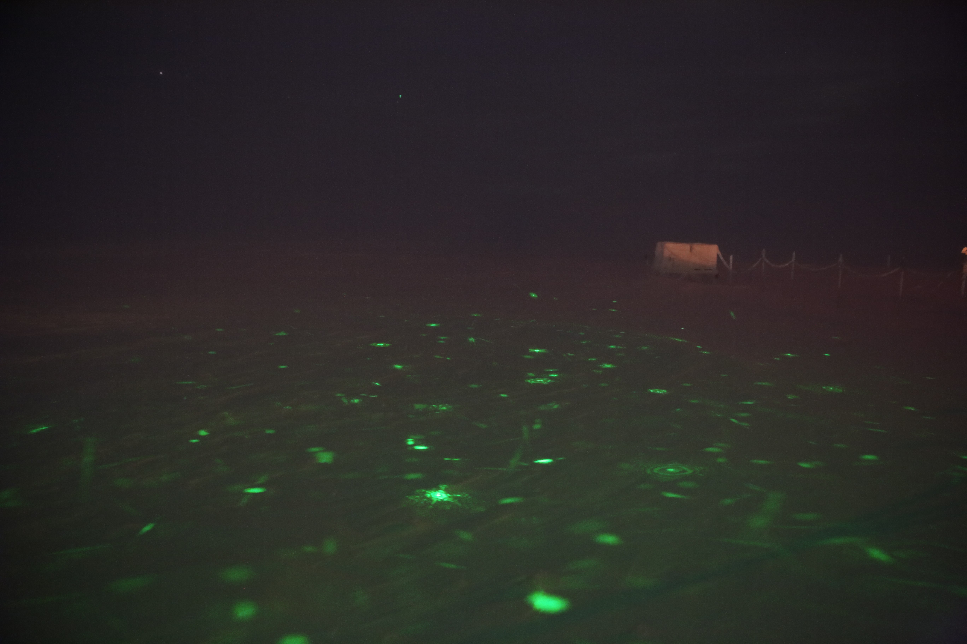

Artifacts of particles, caught in the CAPABL beam, cast on snow surface east of the MSF. MG.

General:

* 11/21: Remarkable reflections (refracted projections?) of laser light by airborne particles onto snow surface east of MSF, spanning at least period 20:00 to 20:40z. Shapes on snow surface included solid spots, abundant dim stripes, and very interesting concentric rings and other diffraction patterns. Quite a light show.

**Significant Weather Observations:**

* 11/21: Few stratus, -43C, 6 kts.
* 11/22: Few stratus, -43C, 7 kts.
* 11/23: Broken stratus, -46C, 15 kts.
* 11/24: Few stratus, -52C, 13 kts.
* 11/25: Scattered stratus, -45C, 14 kts.
* 11/26: Broken stratocumulus, -42C, 14 kts.
* 12/27: Broken stratocumulus, -25, 15 kts.

**ICECAPS Data Management:**

* 11/21: Data transfer complete at 15:22z.
* 11/22: Data transfer complete at 18:47z.
* 11/23: Data transfer complete at 16:51z.
* 11/24: Data transfer complete at 17:17z.
* 11/25: Network issues during the night appear to have interfered with nightly aggregation of data: mounts were down. Network restored shortly after 25 Nov 02:00z, several lost connection errors occurred before this time. Partial transfer completed at 15:30z. Archiving and transmission to Boulder manually initialized at 19:48z and 20:26z, respectively.
* 11/26: Data transfer complete at 17:49z.
* 11/27: Data transfer complete at 17:18z.

**MWR:**

* Operating normally.
* 11/27: The HATPRO blower fan was found motionless at 12:42z. The heater was unplugged to prevent heat damage at 12:46z, and the entire blower unit will be brought inside for fan replacement.

**SODAR:**

* Operating normally.

**POSS:**

* Operating normally.

**MMCR:**

* Operating normally.
* Pitch 0.22, roll -0.22 as of 11/19.

**CAPABL:**

* Operating normally.
* 11/25: Found in an error state (13:02z), with laser firing, but Licel ‘run’, ‘i/o’, and ‘clip’ status lights all off, and LabView displaying block diagram in place of user interface. Process reinitialized by Robert, and normal functioning was confirmed (daily checks) at 16:41z.

**MPL:**

* Operating normally.

**VCEIL:**

* Operating normally.

**Hotplate:**

* Offsite for repairs since 6/9/2016.

**IceCAM:**

* Operating normally.

**PAERI:**

* Operating normally.

**TSI:**

* Stored in MSF for winter.

**IcePIC:**

* 11/21: Slides placed for collection 20:15 – 20:22z, during period of snowfall and lidar beam reflections. Particles photographed include hollow columns and radiating plates.

**Radiosonde:**

* Twice daily soundings.

**MASC:**

* Offsite for repairs since 5/3/2016.