# ICECAPS Weekly Report

November 28 – December 4, 2016

Sam Dorsi

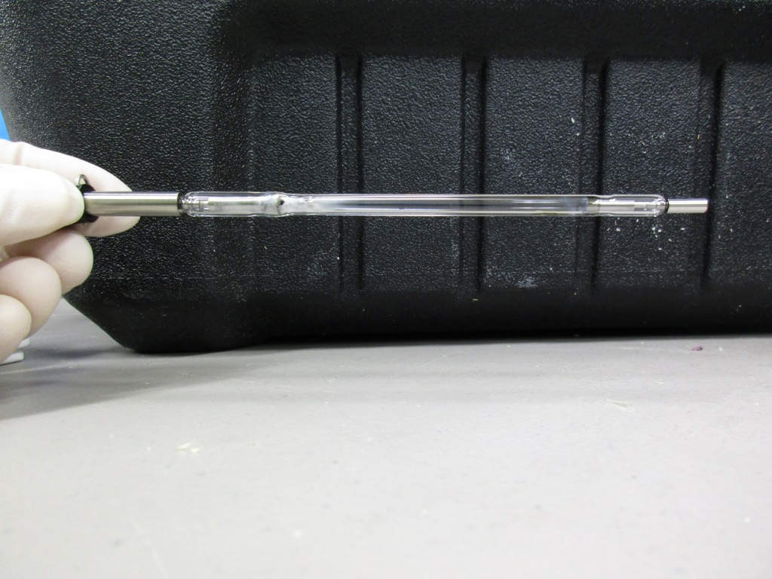

The used Laser 1 flash lamp, displays white and tan glass smoking   
from a productive lifetime pumping the CAPABL laser. SWD.

General:

* 12/4: MSF tech workstation CPU clock was 8 minutes fast at 11:49z, despite having synchronized with time server 24 hours prior.

**Significant Weather Observations:**

* 11/28: Overcast stratus, ice particles, -36C, 9 kts.
* 11/29: Few stratus, -51C, 5 kts.
* 11/30: Few stratus, -45C, 12 kts.
* 12/1: Clear, -48C, 15 kts.
* 12/2: Scattered stratus, -43C, 6 kts.
* 12/3: Clear, -44C, 6 kts.
* 12/4: Clear, -47C, 5 kts.

**ICECAPS Data Management:**

* 11/28: Data transfer complete at 16:49z.
* 11/29: Data transfer complete at 22:18z.
* 11/30: Data transfer complete at 17:22z.
* 12/1: Data transfer complete at 12:11z. Reduced MMCR data on this day.
* 12/2: Data transfer complete at 16:05z.
* 12/3: Data transfer complete at 12:33zt.
* 12/4: Data transfer complete at 14:47z.

**MWR:**

* Operating normally.
* 11/28: The HATPRO blower was removed from the roof at 12:48z, and brought inside to warm on the lab bench. The fan was replaced with an on-site spare, and the blower unit reinstalled at 19:45z. The blower heater was powered up and the system is working normally.

**SODAR:**

* Operating normally.
* 11/28: Transmitter and receiver dishes cleaned of snow 14:47 – 14:56z.

**POSS:**

* Operating normally.
* 11/30: POSS found to be reporting a set of unfamiliar errors, and data packets are truncated or missing (12:52z). POSS Telebyte communications device reports no issues at the time of observation.
* 12/4: POSS data dropout 11:46-11:56z. Traced to electrical issue at TeleByte terminal block. Matt Shupe has approved stabilization of this connection to prevent a reoccurrence.

**MMCR:**

* Operating normally.
* Pitch 0.29, roll -0.22 as of 12/4.
* 11/30: Resistors added to J1 terminal block to improve the resolution of the pitch and roll measurements. MMCR was powered down at 13:25z, and remained powered down through day while waiting for information on a disconnected cable.
* 12/1: MMCR was powered up at 12:31z. The MMCR resumed full operation on the first attempt, but exhibits zero values for roll and Interface 5v #1.
* 12/2: Resistor values changed on J1 terminal block. MMCR powered down at 13:33z and restored to operation at 14:14z. Monitoring values are again operational but initial resolution issues remain unresolved.
* 12/3: MMCR reports calibration table errors (13:20z). Duane Hazen reports this indicates some change in the radar—could be environmental or internal.

**CAPABL:**

* Operating normally.
* 12/1: Flash lamp was replaced in Laser 1 (17:14z) using lamp labeled ‘NEW 6-17-2016’. During the first minute of Laser 1 operation, tech noted a steady decrease in peak detector counts, and a visible dimming of the CAPABL beam. Out of concern for the system, tech stopped the laser and contacted PIs. This degradation in power was repeated during diagnostics with Robert. He concluded that thermal transients were causing poor pump/conversion efficiency-- the first time this effect had been identified in this particular system. As the system continued to warm in test operations, the laser power increased to normal levels. CAPABL resumed full operation on Laser 1 at 19:10z.
* 12/2: After testing on both Laser 1 and Laser 2, Robert confirms that system is operating normally. Laser 1, which has the greater output power, will remain in active use.

**MPL:**

* Operating normally.
* 11/29: Afterpulse calibration performed 14:27 – 14:46z.

**VCEIL:**

* Operating normally.

**Hotplate:**

* Offsite for repairs since 6/9/2016.

**IceCAM:**

* Operating normally.

**PAERI:**

* Operating normally.

**TSI:**

* Stored in MSF for winter.

**IcePIC:**

* 11/28: Slides placed for collection 12:37 – 13:02 UTC. Particles photographed include hollow columns, hexagonal plates, simple needles, isolated bullets and rimed isolated bullets.

**Radiosonde:**

* Twice daily soundings.

**MASC:**

* Offsite for repairs since 5/3/2016.