# ICECAPS Weekly Report

November 6, 2016 – November 13, 2016

Sam Dorsi

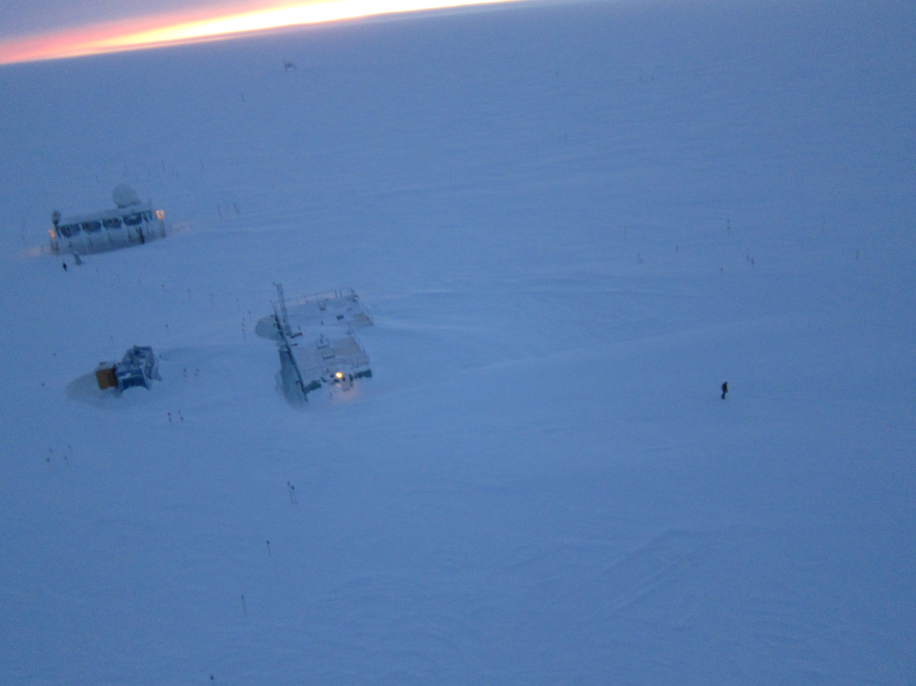

The last sunset of the year appears above camp, as seen from a kite. SWD.

General:

* 11/13: The sun has set for the winter at 14:40z.

**Significant Weather Observations:**

* 11/7: Overcast stratus, freezing fog -36C, 13 kts.
* 11/8: Overcast stratus, freezing fog, -38C, 16 kts.
* 11/9: Overcast stratus, freezing fog, -33C, 15 kts.
* 11/10: Overcast stratus, blowing snow, -31C, 22 kts.
* 11/11: Blowing snow, -22C, 38 kts
* 11/12: Blowing snow, -24C, 35 kts
* 11/13: Few altostratus, -33C, 6 kts.

**ICECAPS Data Management:**

* 11/7: Data transfer complete at 13:09z.
* 11/8: Data transfer complete at 12:46z.
* 11/9: Data transfer complete at 12:05z.
* 11/10: Data transfer complete at 11:08z.
* 11/11: Data transfer complete at 12:14z.
* 11/12: Data transfer complete at 17:43z.
* 11/13: Data transfer complete at 14:01z.

**MWR:**

* Operating normally.

**SODAR:**

* Operating normally.

**POSS:**

* Operating normally.

**MMCR:**

* Operating normally.
* Pitch 0.21, roll -0.21 as of 11/13.

**CAPABL:**

* Operating normally.
* 11/9: CAPABL discovered in a non-operating mode at 12:25z, and performed diagnostics with Robert Stillwell. A dead flashlamp is suspected. After swapping to Laser 2, operation was restored at 13:45z.

**MPL:**

* Operating normally.

**VCEIL:**

* Operating normally.

**Hotplate:**

* Offsite for repairs since 6/9/2016.

**IceCAM:**

* Operating normally.

**PAERI:**

* Operating normally.

**TSI:**

* Stored in MSF for winter.

**IcePIC:**

* 11/7: Slides placed for collection 14:12 – 14:56z. Particles photographed include isolated bullets, bullet rosettes, and needles.

**Radiosonde:**

* Twice daily soundings.
* 11/9: Stabilized balloon-fill test mass for long-term use. Using a precision balance, the mass was re-weighed at 706.6 +/- .3 g, both before and after the stabilization.

**MASC:**

* Offsite for repairs since 5/3/2016.