# ICECAPS Weekly Report

October 10, 2016 – October 16, 2016

Elissa Barris, Travis Guy

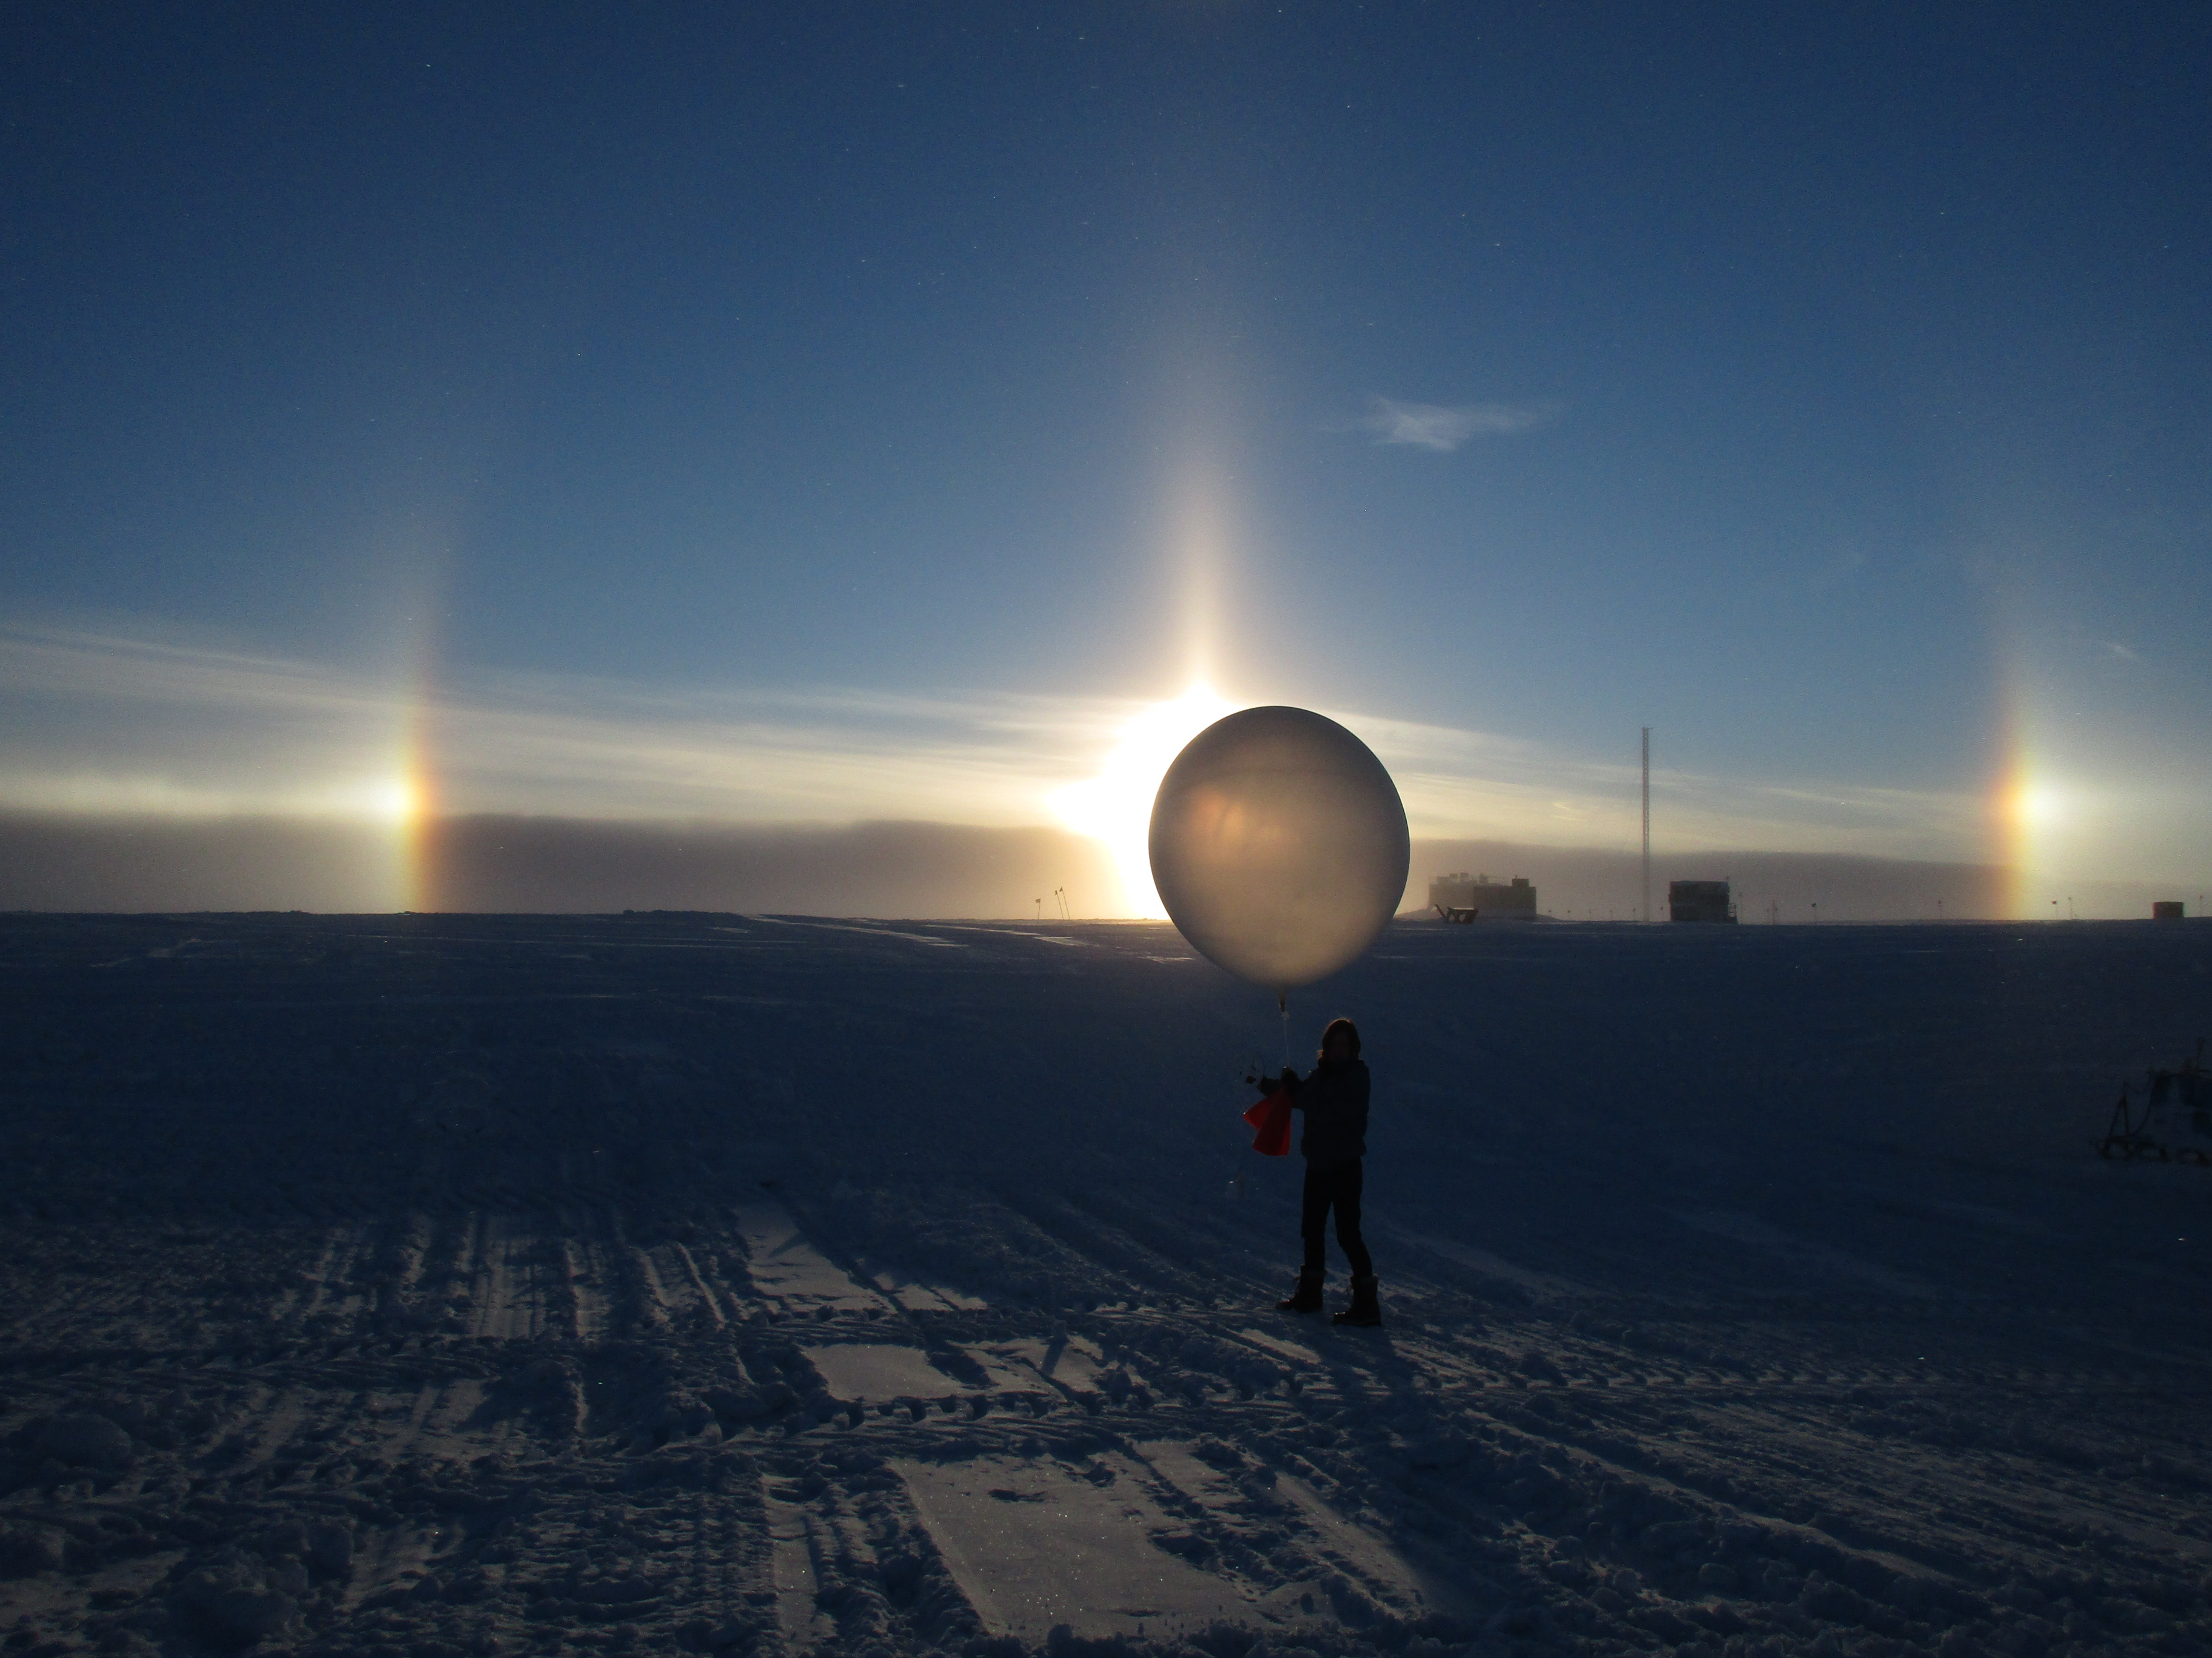

Cool backdrop for a balloon launch, and a welcome change from blowing snow. –Travis, 10/17

**General:**

* Brief daily internet interruptions at ~1300z due to solar interference.

**Significant Weather Observations:**

* 10/10: Bkn altostratus, DRSN, -27C, 13kn, Visibility 800m. Halo 1333z
* 10/11: Sct cirrus giving way to Ovc stratus, -22C, 7kn, 1600m. Parhelia 1105z. Fogbow 1308z.
* 10/12: Ovc stratus, -18C, 25kn, BLSN, Visibility 400m.
* 10/13: Ovc stratus, -18C, 22kn, BLSN, Visibility 300m. Slight clearing in the afternoon. Parhelia 1606z.
* 10/14: Bkn, stratus and altocumulus, -20C, 27kn, BLSN, Visibility 200m, dropping down to less than 100m in the afternoon.
* 10/15: Bkn stratus, -15C, 24kn, BLSN, Visibility 200m. Paraselene 0234z and 2244z.
* 10/16: Few stratus, Sct Altostratus, Bkn cirrus, -22C, 15kn, DRSN, FZFG, Visibility 1600m dropping to 600m. Halo ~1200z and lasting throughout most of the afternoon.

**Dataman Account:**

* 10/10: Data transfer complete at 1114z.
* 10/11: Data transfer complete at 1215z.
* 10/12: Data transfer complete at 1103z.
* 10/13: Data transfer complete at 1542z.
* 10/14: Data transfer complete at 1536z.
* 10/15: Data transfer complete at ????z. Had to initiate manual transfer at ~1400z to restart upload after internet interruption. Transfer was close to complete at this time.
* 10/16: Data transfer complete at 1115z.

**MWR:**

* Operating normally.

**SODAR:**

* Operating normally.

**POSS:**

* Operating normally.

**MMCR:**

* Operating normally.
* TWTA Cathode Voltage out of range throughout week.
* The following errors were seen in the elog throughout the week:

Level 2 – NetCDF_Spec – Could not read calibration table NetCDF file.

Level 2 – NetCDF_Spec – Data may be incorrect.

Level 2 – NetCDF_Mom – Could not read calibration table NetCDF file.

Level 2 – NetCDF_Mom – Data may be incorrect.

* Pitch 0.11, roll -0.11 as of 10/15.

**CAPABL:**

* Operating normally.

**MPL:**

* Operating normally.

**VCEIL:**

* Operating normally.

**Hotplate:**

* Off site for repairs since 6/9/2016.

**IceCAM:**

* Operating normally.

**PAERI:**

* Operating normally.

**TSI:**

* Operating normally.

**IcePIC:**

* 8/XX Slides placed for collection XXXXXz. Images photographed include XXXXXXXX.

**Radiosonde:**

* Twice daily soundings.
* 11/14: Night sonde lost satellite reception either right before or immediately after launch. We had trouble getting satellites while doing the conditioning as well. A 2nd launch was successful.

**MASC:**

* Offsite for repairs since 5/3/2016.