# ICECAPS Weekly Report

October 17, 2016 – October 23, 2016

Elissa Barris, Travis Guy, Sam Dorsi

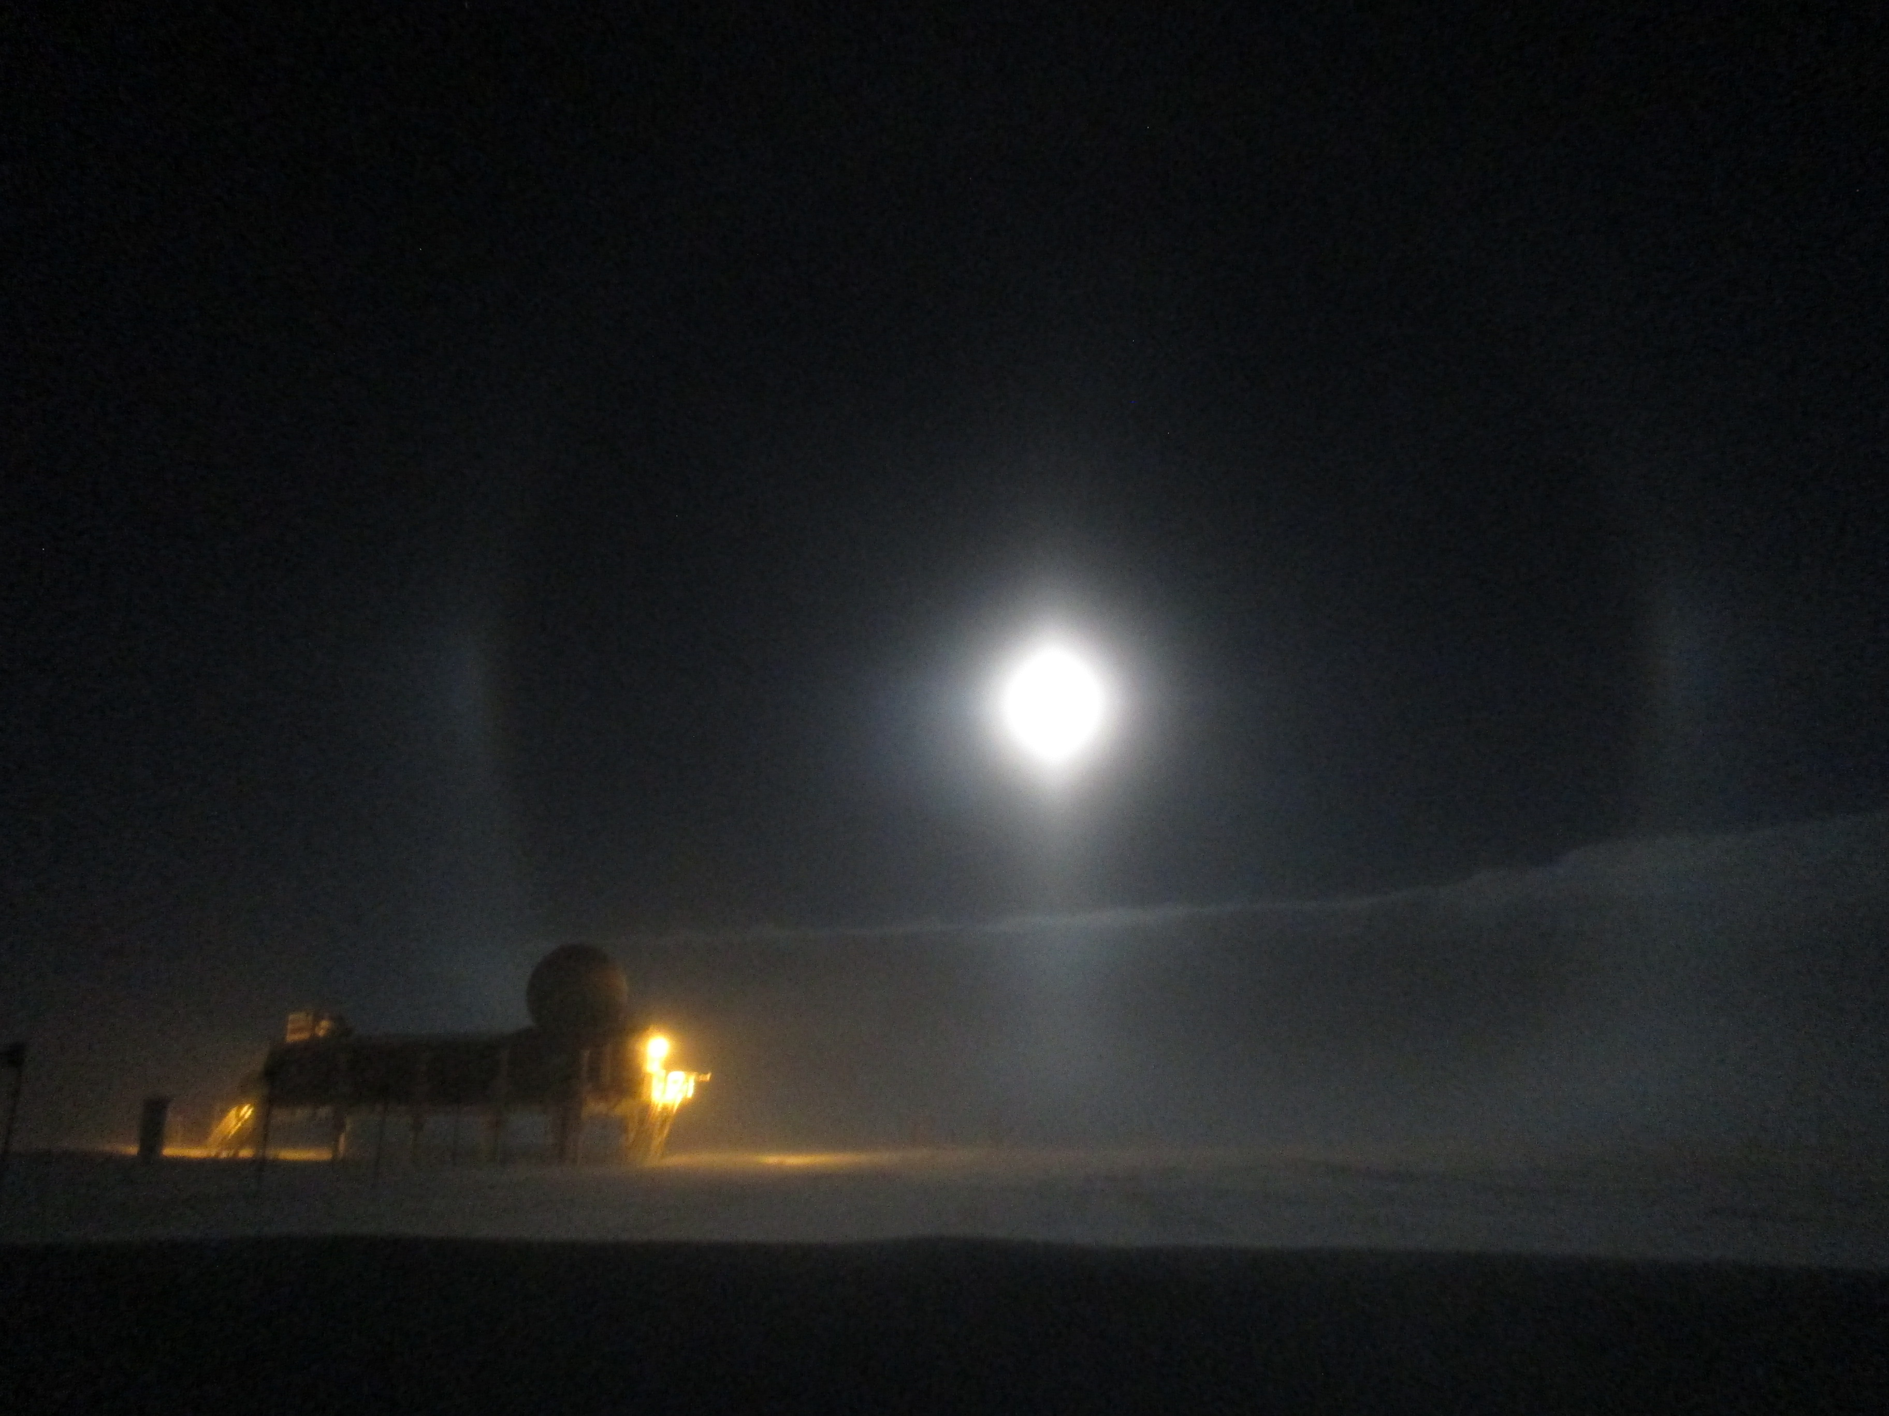

Paraselenae appear alongside the Big House. –Travis, 10/15

**General:**

* Brief daily internet interruptions at ~1300z due to solar interference. (Until 10/18)
* 10/19-10/20: Significant wind even with sustained winds up to 58 knots.
* 10/20: Shoveled out considerable drifted snow from vestibule

**Significant Weather Observations:**

* 10/17: Sct cirrus giving way to Bkn stratus. -25C, 9kn, visibility 1600m. Parhelia 1100z.
* 10/18: Bkn stratus, -24C, 14kn, visibility 700m.
* 10/19: Ovc stratus, BLSN, IC, -20C, 21kn, visibility 400m. Sustained winds up to 58.6kn.
* 10/20: Sct altocumulus, Sct cirrus, BLSN, -22C, 34kn, visibility 100m.
* 10/21: Bkn stratocumulus, Vis 1600m, -24C, 15kn. Halo 1302z.
* 10/22: Ovc, stratus, BLSN, -25C, 28kn, visibility 200m
* 10/23: Sct stratocumulus, sct cirrus. -22C, 12kn, visibility 1600m.

**Dataman Account:**

* 10/17: Data transfer complete at 1253z.
* 10/18: Data transfer complete at 1201z.
* 10/19: Data transfer complete at 1320z.
* 10/20: Data transfer complete at 1251z.
* 10/21: Data transfer complete at 1723z.
* 10/22: Data transfer complete at 1353z.
* 10/23: Data transfer complete at 1520z.

**MWR:**

* Operating normally.
* 10/20: Snow found in the RPG-150 window, and foil was peeled back. I did nothing other than fold the foil back over as I know the window area is sensitive. I sent Dave Turner and Erik Olson photos and an email to see what our next move should be.

**SODAR:**

* Operating normally.
* 10/17: Cleared substantial snow off at around 1700z.

**POSS:**

* Operating normally.
* 10/20: First time seeing fault: “max noise limit”

**MMCR:**

* Operating normally.
* TWTA Cathode Voltage out of range throughout week.
* Pitch 0.11, roll -0.14 as of 10/23.

**CAPABL:**

* Operating normally.

**MPL:**

* Operating normally.

**VCEIL:**

* Operating normally.

**Hotplate:**

* Off site for repairs since 6/9/2016.

**IceCAM:**

* Operating normally.
* 10/20: Camera blown out of position by high winds: Repositioned.

**PAERI:**

* Operating normally.
* 10/20: First time seeing Atmos Pressure warning
* 10/22: Briefly had LW/SW Responsivity errors (~1426z), but they cleared themselves

**TSI:**

* Operating normally.

**IcePIC:**

* 8/XX Slides placed for collection XXXXXz. Images photographed include XXXXXXXX.

**Radiosonde:**

* Twice daily soundings.
* 10/19 night flight: First conditioned sonde was reading wacky RH (ex. -140.7, then eventually not giving a value), temperature (ex. -3281.14), and pressure (ex. 49,478.26) values. We tried a different sonde that worked. The launch was late; however, because during the launch we lost a balloon due to a snapped parachute cord in 31kn winds. 2nd attempted launch was successful.
* 10/20 night flight: We launched in high winds. The sonde slammed into the snow when the balloon was pushed downwards, which resulted in a loss of communication. We decided to not launch another sonde that night due to the high probability of another failed flight.

**MASC:**

* Offsite for repairs since 5/3/2016.