# ICECAPS Weekly Report

October 24, 2016 – October 30, 2016

Sam Dorsi

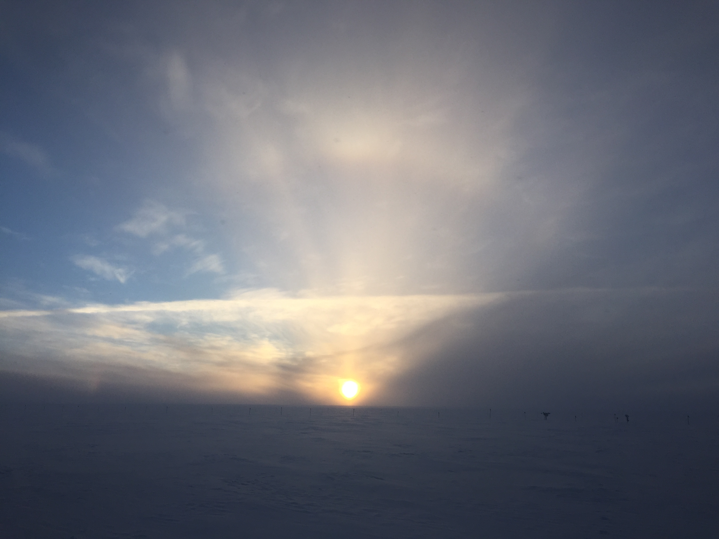

In the low October sunlight, a contrail cuts across a solar halo. SWD

General:

* None.

**Significant Weather Observations:**

* 10/24: Overcast stratus, -25C, 8 kts.
* 10/25: Broken altocumulus, distinct liquid layer on MPL 12:30z, -36C, 12 kts.
* 10/26: Broken altostratus, -33C, 12kts.
* 10/27: Scattered altostratus, weak solar pillar and parhelia at 11:55-12:15z, -32C, 8 kts.
* 10/28: Overcast stratus, blowing snow after ~20:00z, -35C, 12 kts.
* 10/29: Overcast stratus, blowing snow, -24C, 20 kts.
* 10/30: Overcast stratus, drifting snow, -25C, 17 kts.

**Dataman Account:**

* 10/24: Data transfer complete at 11:52z.
* 10/25: Data transfer complete at 14:25z.
* 10/26: Data transfer complete at 14:59z.
* 10/27: Data transfer complete at 15:21z.
* 10/27: USB disk ICECAPS #1 was swapped in for ICECAPS #4 (at a very efficient 96% utilization). The full disk will be hand carried to Boulder by Matt Okraszewski.
* 10/27: ICECAPS computer was rebooted at 15:50z. Following Matt’s edit of the /etc/fstab table, the OS is no longer trying to mount the missing TSI data directory.
* 10/28: Data transfer complete at 15:02z.
* 10/29: Data transfer complete at 16:20z.
* 10/30: Data transfer complete at 13:09z.

**MWR:**

* Operating normally.

**SODAR:**

* Operating normally.

**POSS:**

* Operating normally.
* 10/27: POSS acquisition was briefly halted (starting 15:49z) while the ICECAPS computer was rebooted. Data collection resumed at 15:56z.

**MMCR:**

* Operating normally.
* Pitch 0.22, roll -0.15 as of 10/31.
* 10/25: MMCR showed an error: “Error 7 occurred at Open File+.vi: Open File”. After clearing the error, data collection resumed at 12:58z.
* 10/30: Same MMCR error: “Error 7 occurred at Open File+.vi: Open File”. Error was cleared and data collection resumed at 12:19z.
* 10/30:‘Open File’ error discovered again at 16:57z.

**CAPABL:**

* Operating normally.

**MPL:**

* Operating normally.
* 10/25: Afterpulse calibration performed from 13:38 to 13:59z.

**VCEIL:**

* Operating normally.

**Hotplate:**

* Off site for repairs since 6/9/2016.

**IceCAM:**

* Operating normally.
* 10/26: Noticed that the files produced by IceCAM had size 0 bytes. Attempts to connect to 192.168.1.118 failed. At 14:03, power-cycled the PoE unit, with no change. Noticed that the IceCAM Ethernet cable had been connected to port 13 on the network switch, which I had identified and labeled as unreliable in March 2016. Moved the IceCAM cable to port 12, and immediately saw a response from the port traffic LED. This change restored the connection to 192.168.1.118.

**PAERI:**

* Operating normally.
* 10/28: The hatch cover controller shows rapidly updating garbage characters; PAERI otherwise is functioning normally.

**TSI:**

* Stored in MSF for winter.

**IcePIC:**

* 10/27: Slides placed for collection 1755-1820z. Particles photographed include isolated bullets and bullet rosettes.

**Radiosonde:**

* Twice daily soundings.
* 10/26 0z: Final RS-92 launched.
* 10/26 12z: First normal-operation RS-41 launched. With a test mass of 705g, average rise rate is 4.5 m/s.
* 10/27 12z: Test mass changed to 720g; resulting average rise rate for individual flights since this change ranges from 4.6 – 5.0 m/s.

**MASC:**

* Offsite for repairs since 5/3/2016.