# ICECAPS Weekly Report

October 3, 2016 – October 9, 2016

Elissa Barris, Travis Guy

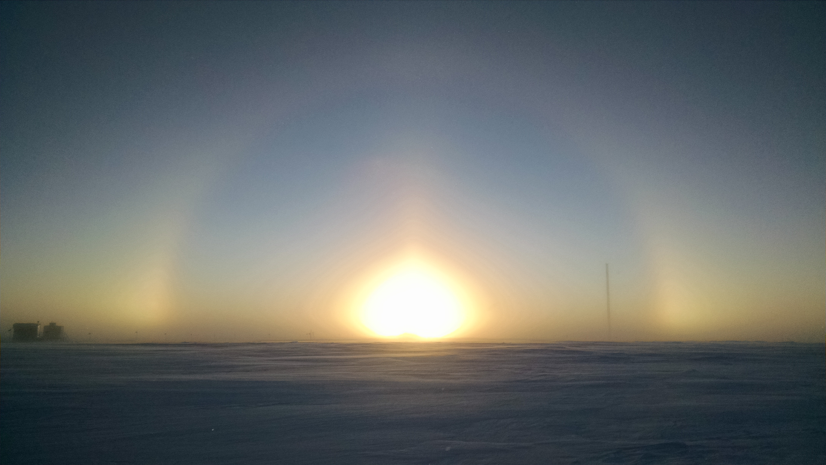

Find the MSF! –Elissa, 10/07

**General:**

* Nothing to report

**Significant Weather Observations:**

* 10/03: Bkn stratus, Sct cirrus and cirrocumulus. -24C, 7kn, Visibility 3200m. Halo and parhelia 1300z.
* 10/04: Bkn stratocumulus. -17C, 11kn, Visibility 3200m.
* 10/05: Ovc stratus, BLSN. -20C, 13kn, Visibility 400m. Halo 1243z and 1501z
* 10/06: Ovc stratus, BLSN, -18C, 20kn, Visibility 800m. Clearing to Sct stratocumulus in early afternoon with 8kn winds. Parhelia 1834z.
* 10/07: Sct stratus, Sct cirrostratus, BLSN, IC, -25C, 15kn, Visibility 600m. Solar halo, parhelia, fogbow from 1000z throughout morning.
* 10/08: Ovc stratus. BLSN. -16C, 19kn, Visibility 800m. Clearing slightly to Sct altostratus and Bkn cirrus. Winds increasing up to 30kn.
* 10/09: Ovc stratus, BR, BLSN. -22C, 18kn, Visibility 600m. Halo and parhelia 1331z and 1814z.

**Dataman Account:**

* 10/03: Data transfer complete at 1230z.
* 10/04: Data transfer complete at ??? Still going at 2042z. Currently on IceCam jpgs (2016-10-03_12.15.01.jpg)
* 10/05: Data transfer complete at 1403z.
* 10/06: Data transfer complete at 1238z.
* 10/07: Data transfer complete at 1105z.
* 10/08: Data transfer complete at ???z. Finished sometime before beginning of next transfer.
* 10/09: Data transfer complete at 1323z.

**MWR:**

* Operating normally.

**SODAR:**

* Operating normally.
* Snow cleaned off SODAR 10/03.

**POSS:**

* Operating normally.

**MMCR:**

* Operating normally.
* TWTA Cathode Voltage out of range throughout week.
* 10/4: Starting at 0800z, the following errors were seen in the elog:

Level 2 – NetCDF_Spec – Could not read calibration table NetCDF file.

Level 2 – NetCDF_Spec – Data may be incorrect.

Level 2 – NetCDF_Mom – Could not read calibration table NetCDF file.

Level 2 – NetCDF_Mom – Data may be incorrect.

* Pitch 0.11, roll -0.11 as of 10/09.

**CAPABL:**

* Operating normally.

**MPL:**

* Operating normally.
* VantageVue communication error (15:57) remains on log.
* “Missing calibration files: Overlap, Dead Time Correction” messages also present throughout week.

**VCEIL:**

* Operating normally.

**Hotplate:**

* Off site for repairs since 6/9/2016.

**IceCAM:**

* Operating normally.

**PAERI:**

* Operating normally.
* 10/8: The right time series spectra graph is blank. As I scrolled back through the day, it appeared it was blank at the beginning and throughout the entire day.
* Von mentioned this happens from time to time and that the data display should be fine again after the 00:00 reboot. He said data acquisition looked fine on his end. Display reappeared 10/9.

**TSI:**

* Operating normally.

**IcePIC:**

* 8/XX Slides placed for collection XXXXXz. Images photographed include XXXXXXXX.

**Radiosonde:**

* Twice daily soundings.
* 10/5: High winds launch. During 1st attempt, the string attaching the balloon to the parachute snapped due to high winds. Balloon was lost but not the sonde. 2nd attempt was successful (sonde barely cleared the berm).

**MASC:**

* Offsite for repairs since 5/3/2016.