# ICECAPS Weekly Report

October 31, 2016 – November 6, 2016

Sam Dorsi

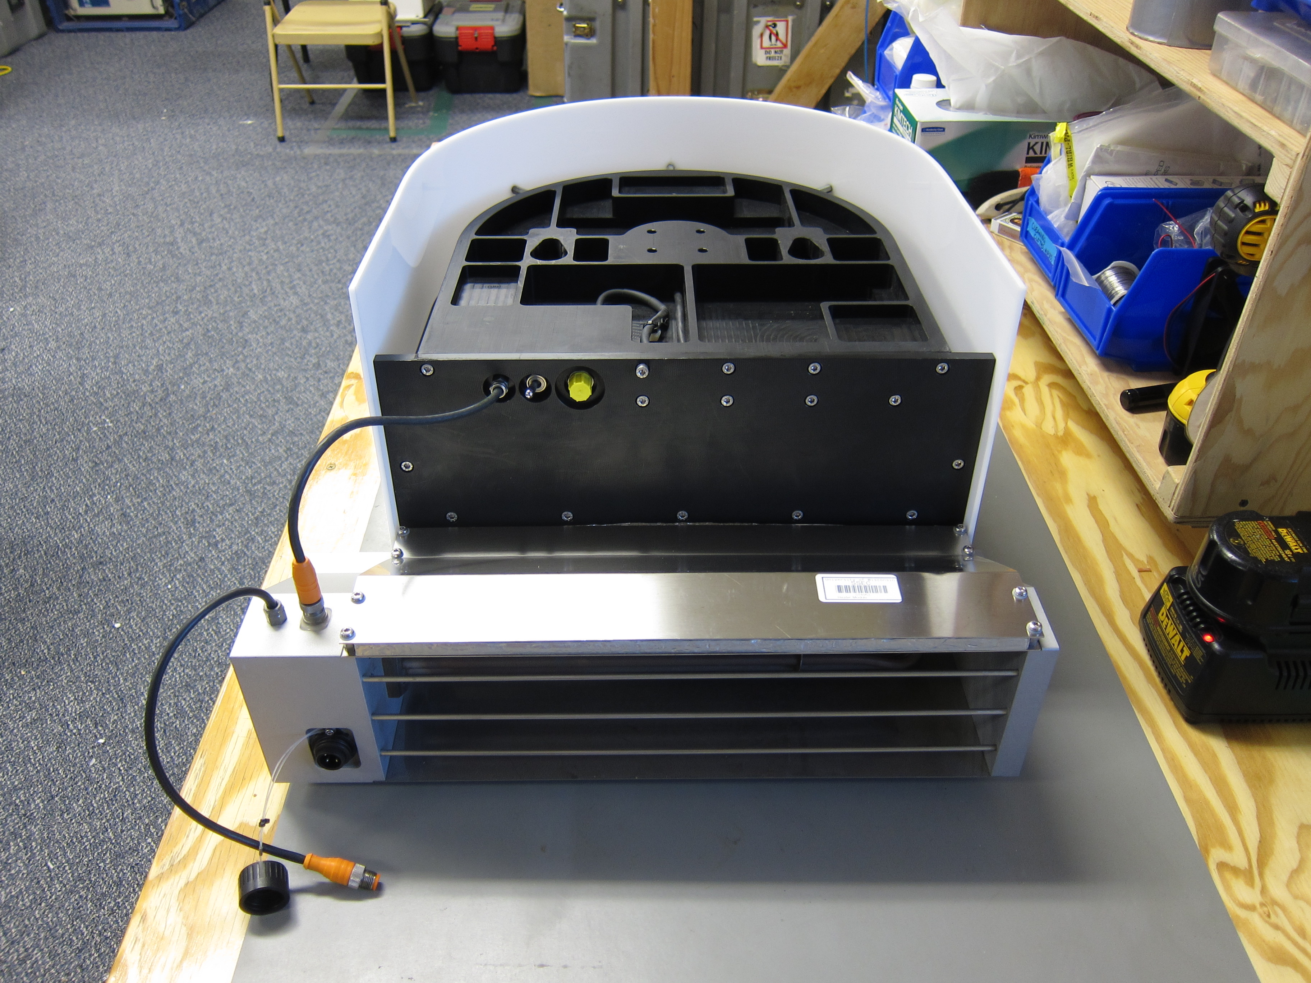

In anticipation of fan replacement, the MWR blower unit warms on the MSF bench. SWD.

General:

* 11/2: Network outage due to stateside issues with ISP, roughly 18:00-22:00z.

**Significant Weather Observations:**

* 10/31: Overcast stratus, freezing fog -33C, 10 kts.
* 11/1: Overcast stratus, blowing snow, -20C, 18 kts.
* 11/2: Overcast stratus, falling ice crystals (12:40-14:00z), -37C, 8 kts.
* 11/3: Few altostratus, -42C, 12 kts.
* 11/4: Few altostratus, freezing fog, -40C, 6 kts.
* 11/5: Overcast stratus, freezing fog, blowing snow, -18C, 18 kts.
* 11/6: Overcast stratus, blowing snow, -17C, 18 kts.

**ICECAPS Data Management:**

* 10/31: Data transfer complete at 15:35z.
* 11/1: Data transfer complete at 17:16z.
* 11/2: Data transfer complete at 11:51z.
* 11/3: Data did not transfer. This resulted from an issue with the NOAA server.
* 11/4: Data transfer complete at 23:48z. The backlog from yesterday’s issue was successfully transferred.
* 11/5: Data transfer complete at 13:33z.
* 11/6: Data transfer complete at 13:53z.

**MWR:**

* Operating normally.
* 11/1: The HATPRO heater fan was found inoperative at 12:57z. To reduce the chance of the unventilated heater causing damage, the heater was unplugged at 15:53z. Replacement fans have been located and will be swapped out.
* 11/2: The MWR blower was removed at 12:52z, and moved into the MSF for warming. The blower unit was disassembled, a new fan installed, connections soldered and heat-shrunk, and the unit reassembled. The fan was restored to service at 18:25z and the heater power restored at 18:27z. It sounds normal and appears to be drawing error well.
* 11/3: Using photos from previous day’s job, a step-by-step protocol for the fan replacement was written and placed in the /ICECAPS/MWR/resources/ directory.

**SODAR:**

* Operating normally.

**POSS:**

* Operating normally.

**MMCR:**

* Operating normally.
* Pitch 0.20, roll -0.15 as of 11/6.

**CAPABL:**

* Operating normally.

**MPL:**

* Operating normally.

**VCEIL:**

* Operating normally.

**Hotplate:**

* Offsite for repairs since 6/9/2016.

**IceCAM:**

* Operating normally.

**PAERI:**

* Operating normally.
* 11/3-4: Yellow alert flags related to lower indoor temperatures in the MSF.

**TSI:**

* Stored in MSF for winter.

**IcePIC:**

* 11/2: Slides placed for collection 12:48 – 14:18z. Particles photographed include sheaths, hexagonal plates and bullet rosettes.

**Radiosonde:**

* Twice daily soundings.

**MASC:**

* Offsite for repairs since 5/3/2016.