# ICECAPS Weekly Report

September 19, 2016 – September 25, 2016

Elissa Barris, Travis Guy

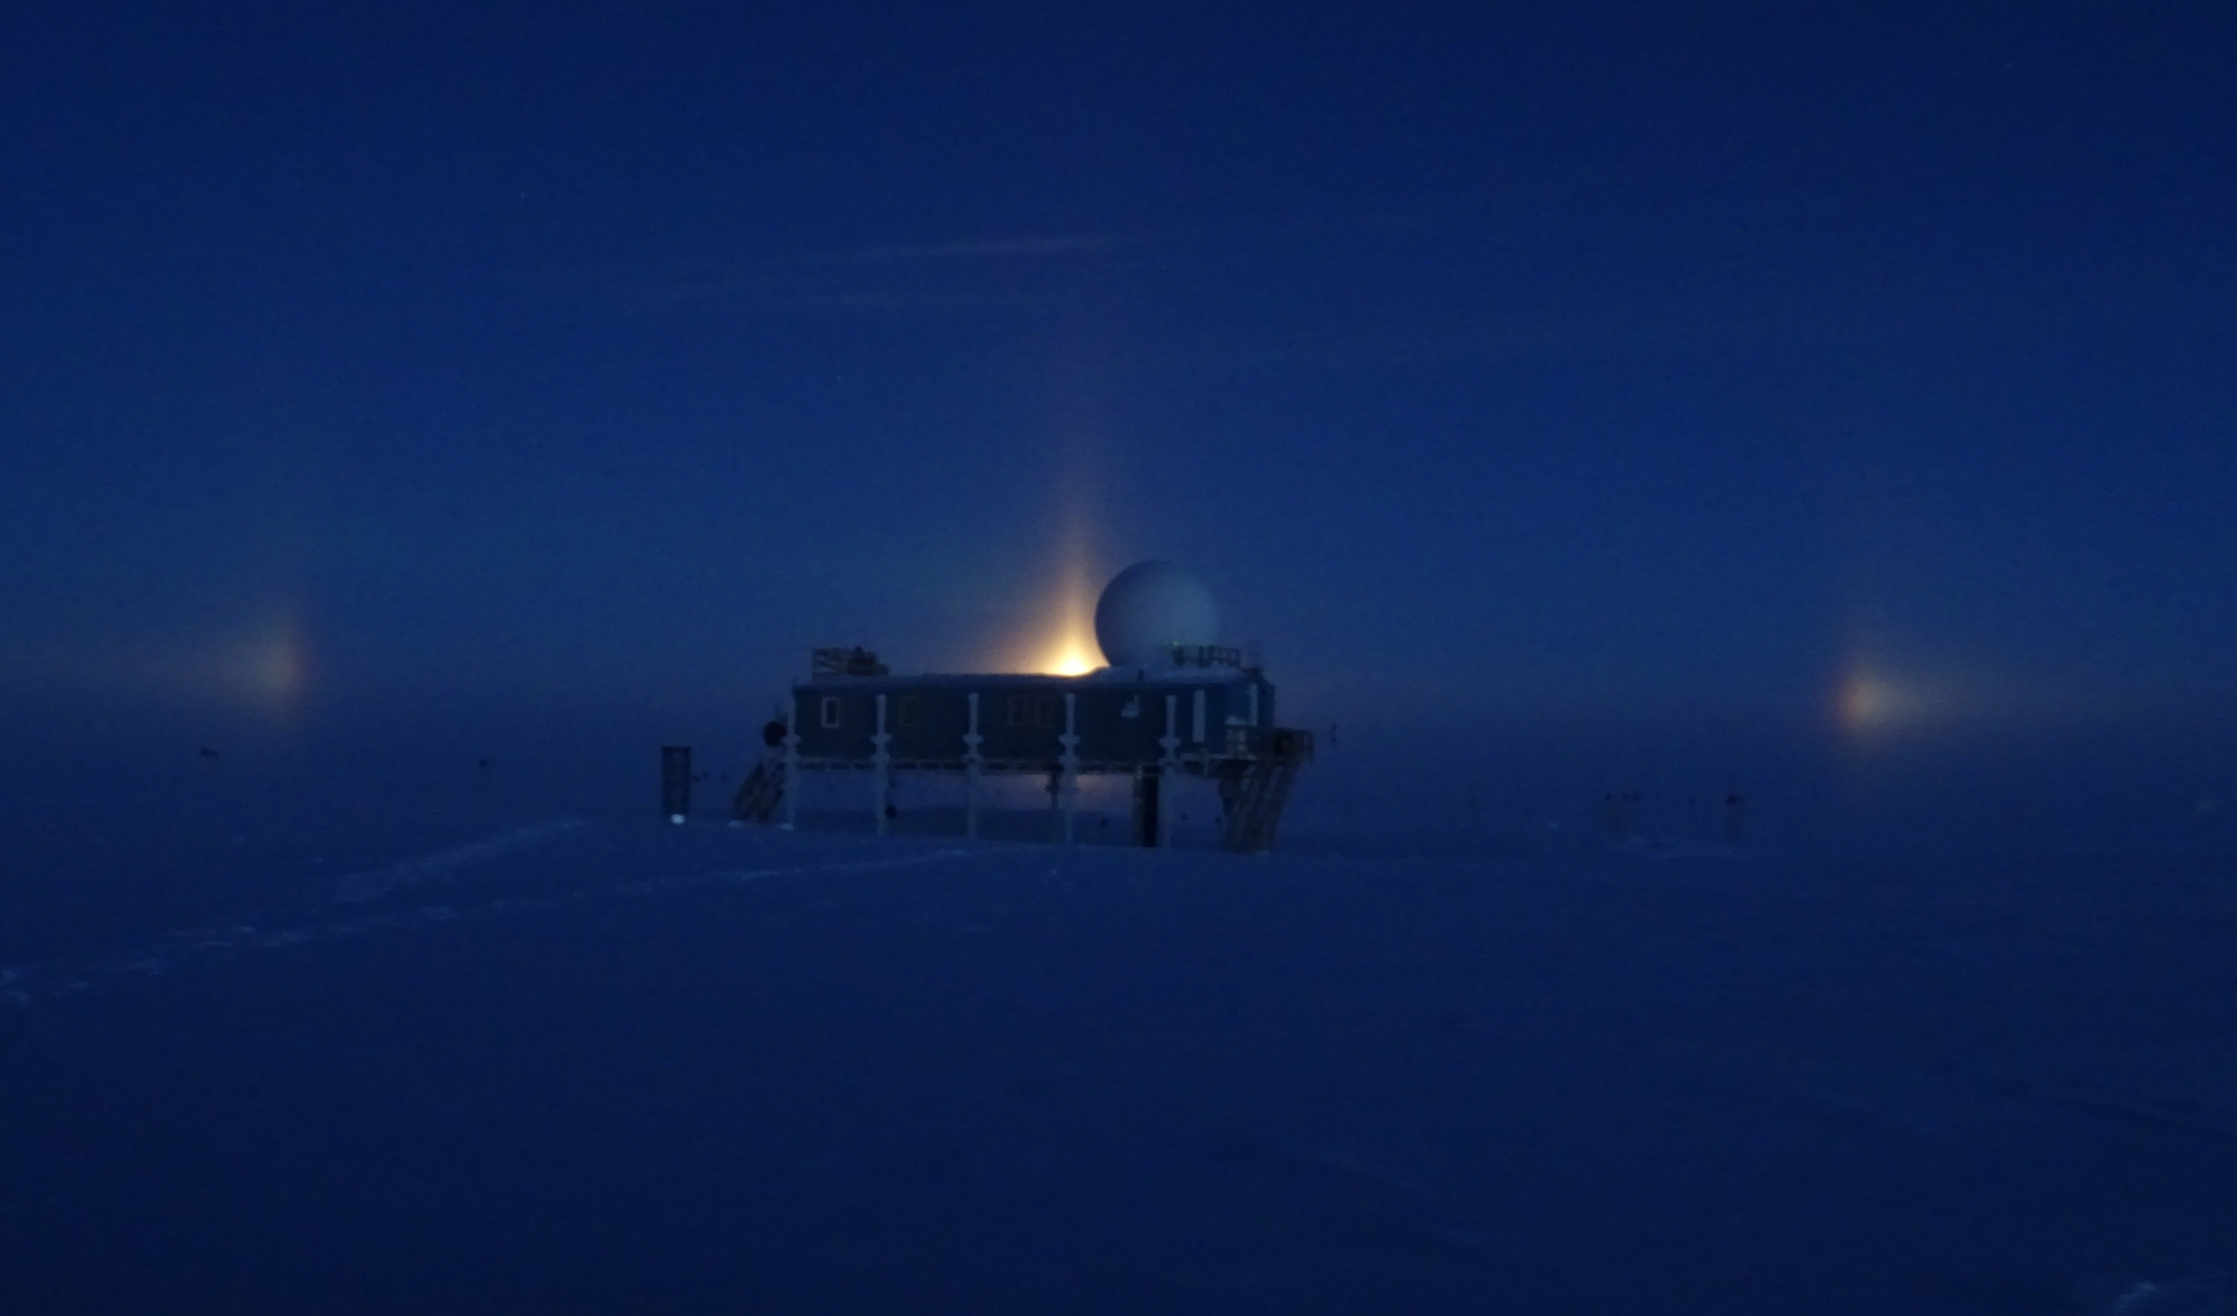

Paraselenae behind the Big House. –Travis, 9/13

**General:**

* Nothing to report.

**Significant Weather Observations:**

* 9/19: Sct Altocumulus, -29C, 6kn, Visibility unlimited.
* 9/13:
* 9/14:
* 9/15:
* 9/16:
* 9/17:
* 9/18:

**Dataman Account:**

* 9/12: Data transfer complete at 0610z.
* 8/13: Data transfer complete at 0559z.
* 8/14: Data transfer complete at 0606z.
* 9/15: Data transfer complete at 0606z.
* 9/16: Data transfer complete at 06010z. One file not sent to Boulder: “LCVR_NotOn.zip 35 bytes link (broken)”
* 9/17: Data transfer complete at 0609z.
* 9/18: Data transfer complete at 0609z

**MWR:**

* Operating normally.

**SODAR:**

* Operating normally.
* Heavy equipment operating daily for berm construction.

**POSS:**

* Operating normally.

**MMCR:**

* Operating normally.
* TWTA Cathode Voltage out of range throughout week.
* Pitch 0.12, roll -0.08 as of 9/18.

**CAPABL:**

* Operating normally.
* 9/15: Shut down for window clearing at 1230z. Zeroing procedure accidentally initiated upon restart, and laser shut down. Began laser alignment at 2028z with help from Robert. Laser was aligned as well as possible considering the cloudy conditions and resumed logging at 2050z. A better alignment will be attempted with Robert as soon as clear skies allow.

**MPL:**

* Operating normally.
* VantageVue communication error (15:57) remains on log.
* “Missing calibration files: Overlap, Dead Time Correction” messages also present throughout week.

**VCEIL:**

* Operating normally.

**Hotplate:**

* Off site for repairs since 6/9/2016.

**IceCAM:**

* Operating normally.

**PAERI:**

* Operating normally.

**TSI:**

* Operating normally.
* Due to decreasing angle of the sun, false low cloud coverage is reported during the early morning and late evening hours, and there are no raw or processed photos from ~0803z-2036z as of 9/18 (time increasing each day). TSI will be taken down later this week due to decreasing temperatures.

**IcePIC:**

* 8/XX Slides placed for collection XXXXXz. Images photographed include XXXXXXXX.

**Radiosonde:**

* Twice daily soundings.
* 9/17: During the morning launch, the computer was receiving a signal from the sondes, but no data was being transmitted. A reboot of the computer fixed this. The morning sonde was launched late because of this issue.

**MASC:**

* Offsite for repairs since 5/3/2016.