# ICECAPS Weekly Report

September 19, 2016 – September 25, 2016

Elissa Barris, Travis Guy

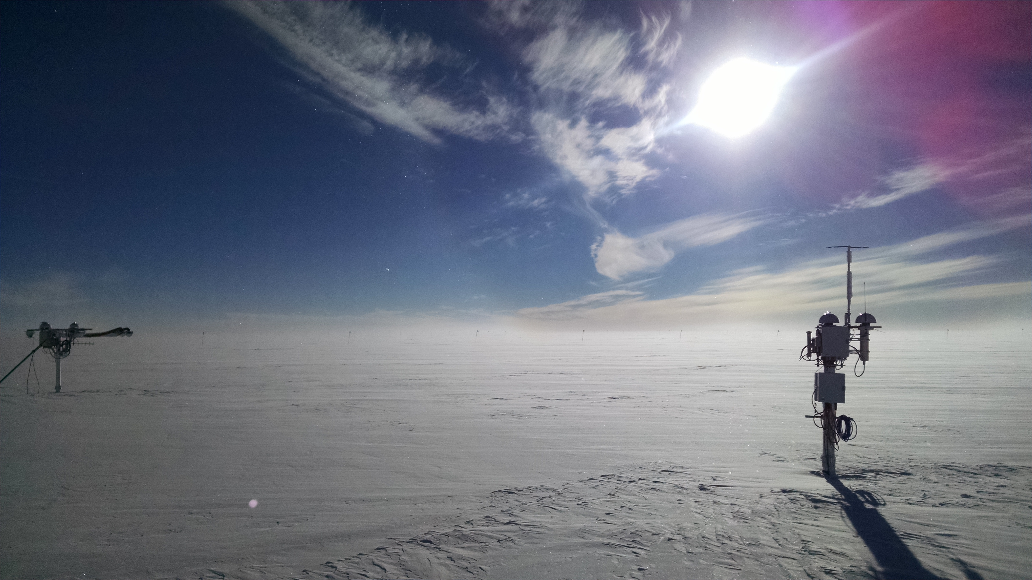

Faint halo and some cirrus backdrop the solar instruments. –Elissa, 9/25

**General:**

* 9/20: Unexpected power outage 1156z-1206z
* 9/20: Adjusted air handler fan fins so that they are no longer pointed at the PAERI but pointed towards the tech desk.

**Significant Weather Observations:**

* 9/19: Sct Altocumulus, -29C, 6kn, Visibility unlimited. Pahrelia at 1332z.
* 9/20: Bkn Stratus, FZFG, -31C, 11kn, 800m visibility.
* 9/21: Sct Stratus, FZFG, -31C, 0kn, 700m visibility, clearing in the afternoon. Corona at 1400z.
* 9/22: Few Stratus, Bkn altostratus, Bkn cirrus, BR, -27C, 9kn, 4800 visibility.
* 9/23: Bkn Cumulus, Few Stratus, clearing mid-day. -29C, 10kn, 3200 visibility.
* 9/24: Ovc Stratus., -SN, -18C, 12kn, 4800m visibility,
* 9/25: Bkn Stratocumuls clearing to Sct Cirrus, -24C, 14kn, vis 1600-3200m. 1303z Parhelia.

**Dataman Account:**

* 9/19: Data transfer complete at 0605z.
* 9/20: Data transfer complete at 0601z.
* 9/21: Data transfer complete at 0601z.
* 9/22: Data transfer complete at 0613z.
* 9/23: Data transfer complete at 0600z.
* 9/24: Data transfer complete at 0611z.
* 9/25: Data transfer complete at 0557z.

**MWR:**

* Operating normally.

**SODAR:**

* Operating normally.
* Heavy equipment operating daily for berm construction.

**POSS:**

* Operating normally.

**MMCR:**

* Operating normally.
* TWTA Cathode Voltage out of range throughout week.
* 9/22: Duane expressed concern about a temperature drop from 22 to 19C. It appears to coincide with the change in air handler direction that we made in order to keep direct air off of the PAERI.
* Pitch -0.12, roll 0.04 as of 9/25.

**CAPABL:**

* Operating normally.
* 9/19: Real-time data examined with Robert in clear conditions, determined re-alignment unnecessary at this time.

**MPL:**

* Operating normally.
* 9/20: Reset clock at 1316z.
* VantageVue communication error (15:57) remains on log.
* “Missing calibration files: Overlap, Dead Time Correction” messages also present throughout week.

**VCEIL:**

* Operating normally.

**Hotplate:**

* Off site for repairs since 6/9/2016.

**IceCAM:**

* Operating normally.

**PAERI:**

* Operating normally.
* 9/19: Insulation added around wall penetration to try to control temperature stability within the exterior casing.
* 9/20: HBB Max Temp Diff warning has been on for longer than 15 straight hours. Contacted Von. He said this is normal with dipping temperatures

**TSI:**

* Operating normally.
* 9/20: TSI shut down and brought inside due to decreasing temperatures ~1707z.  
  Farewell TSI!!

**IcePIC:**

* 8/XX Slides placed for collection XXXXXz. Images photographed include XXXXXXXX.

**Radiosonde:**

* Twice daily soundings.

**MASC:**

* Offsite for repairs since 5/3/2016.