# ICECAPS Weekly Report

September 26, 2016 – October 2, 2016

Elissa Barris, Travis Guy

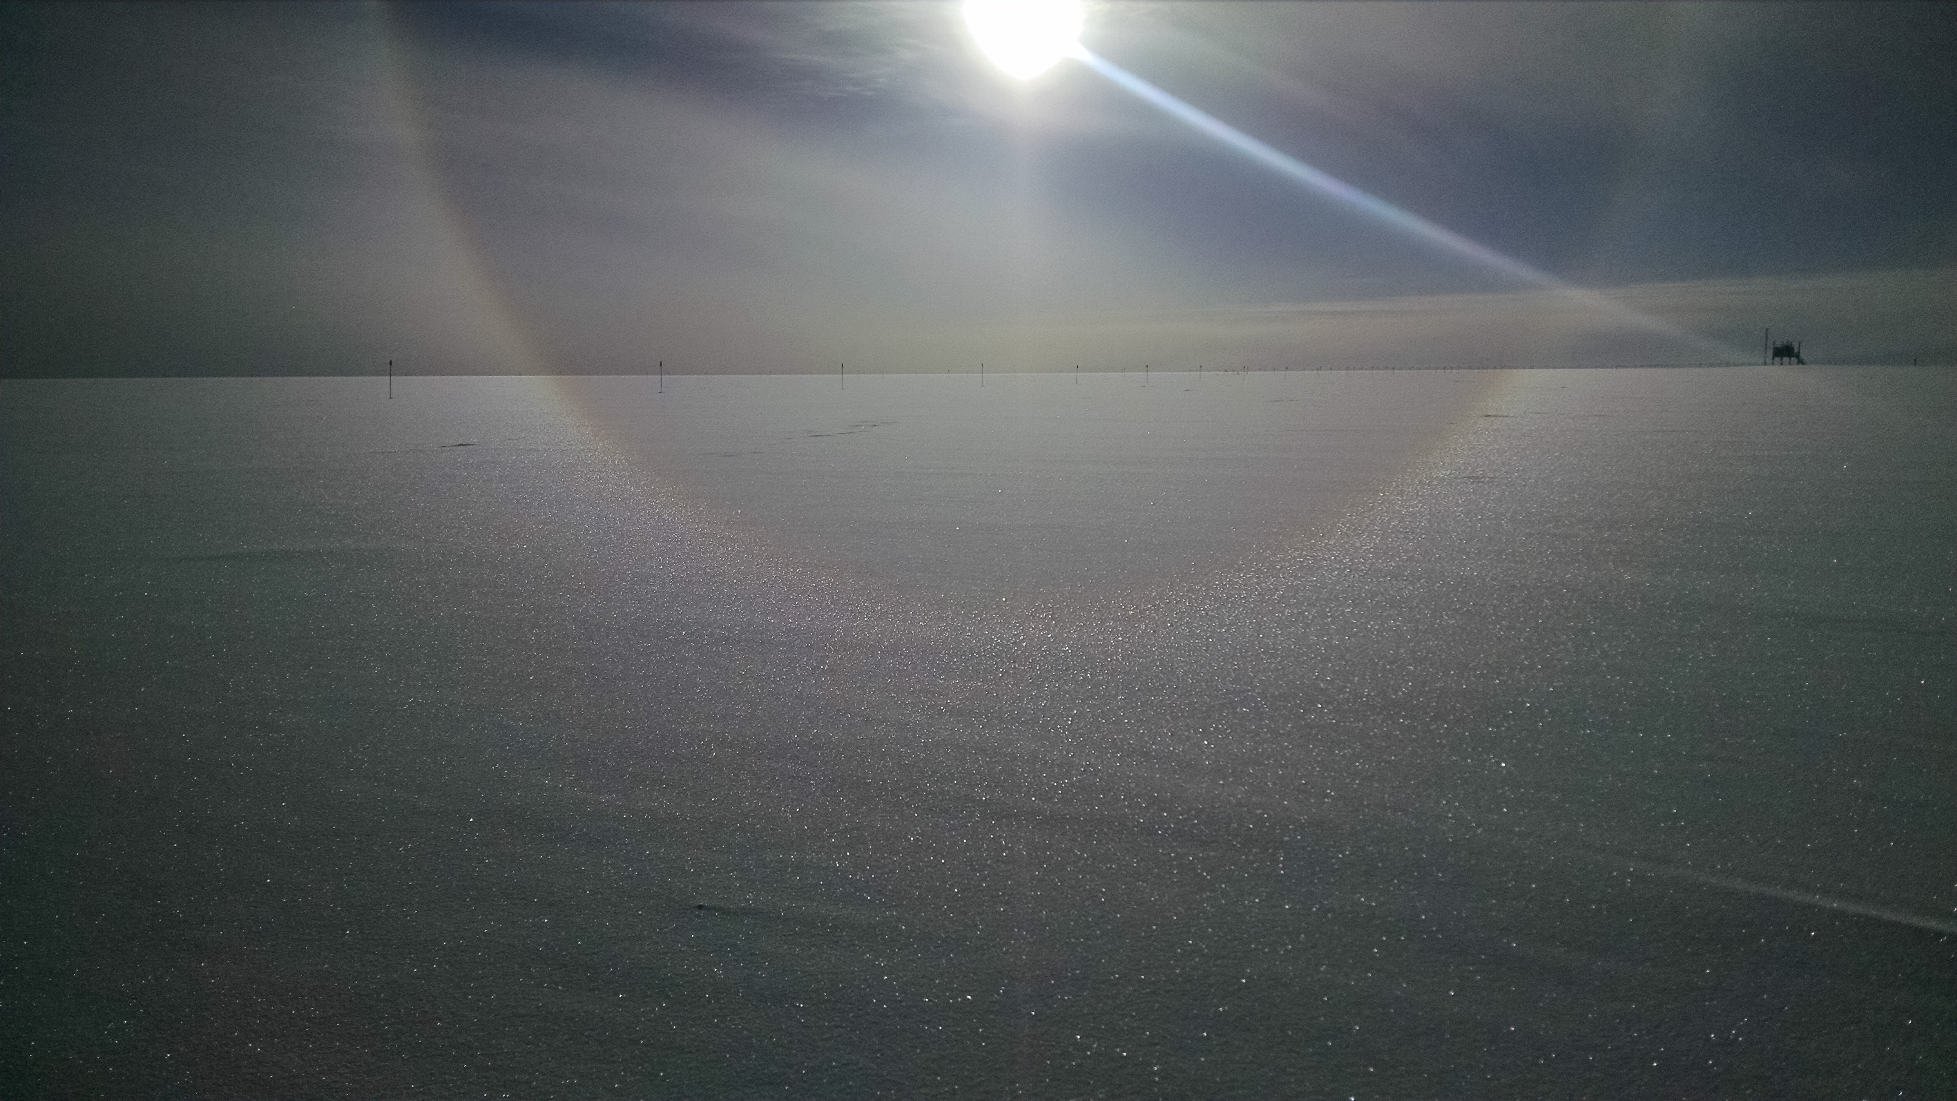

Reflected halo. –Elissa, 9/29

**General:**

* 9/26: Internet set to winter bandwidth

**Significant Weather Observations:**

* 9/26: Few Stratus, BR, -30C, 8kn, Visibility 1600m. Fog bow 1817z.
* 9/27: Ovc Stratus, BR, -18C, 8kn, Visibility 1600m. Parhelia 0954z. Halo 1815z.
* 9/28: Few Stratus, FZFG, -28C, 5kn, Visibility 700m.
* 9/29: Bkn Stratus, Sct Altocumulus, -24C, 7kn, Visibility 1600m. Halo 1200z and 1557z
* 9/30: Few Stratus (BR), Sct Stratus, Bkn altostratus, -28C, 12kn, Visibility 3200m. Halo 1151z and 1548z.
* 10/01: Bkn Stratus, -33C, 14kn, Visibility 1600m. Halo and upper tangent arc 1806z.
* 10/02: Few Stratus (BR), Bkn Stratus, -30C, 9kn, Visibility 3200 in the morning becoming unlimited by midday. Increased clouds and winds in the evening with BLSN

**Dataman Account:**

* 9/26: Data transfer complete at 0556z.
* 9/27: Data transfer complete at 1116z.
* 9/28: Data transfer complete at 1317z.
* 9/29: Data transfer complete at 1141z.
* 9/30: Data transfer complete at 1456z.
* 10/01: Data transfer complete at 1207z.
* 10/02: Data transfer complete at 1153z.

**MWR:**

* Operating normally.

**SODAR:**

* Operating normally.
* Heavy equipment operating daily for berm construction.

**POSS:**

* Operating normally.
* 10/2: Heater current error in MESPOS and MAINLOG error log text files. First time I have seen this, but protocol says this is normal and acceptable.

**MMCR:**

* Operating normally.
* TWTA Cathode Voltage out of range throughout week.
* Pitch 0.11, roll -0.11 as of 10/02.

**CAPABL:**

* Operating normally.

**MPL:**

* Operating normally.
* VantageVue communication error (15:57) remains on log.
* “Missing calibration files: Overlap, Dead Time Correction” messages also present throughout week.

**VCEIL:**

* Operating normally.

**Hotplate:**

* Off site for repairs since 6/9/2016.

**IceCAM:**

* Operating normally.
* 9/26: Pictures through most of the day were white until frost was removed from the camera

**PAERI:**

* Operating normally.

**TSI:**

* Operating normally.

**IcePIC:**

* 8/XX Slides placed for collection XXXXXz. Images photographed include XXXXXXXX.

**Radiosonde:**

* Twice daily soundings.
* Weekly (or more) computer restarts seem to solve most software glitches.

**MASC:**

* Offsite for repairs since 5/3/2016.