# ICECAPS Weekly Report

September 5, 2016 – September 11, 2016

Elissa Barris, Travis Guy

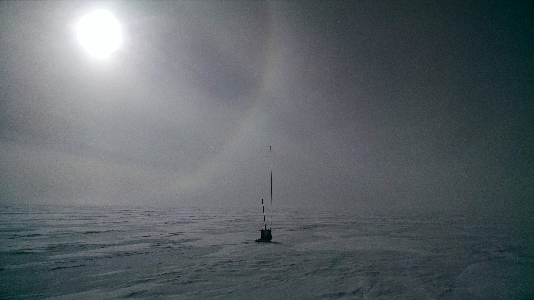

Halo while greenhouse gas sampling near TAWO. –Elissa, 9/06

**General:**

* Nothing to report.

**Significant Weather Observations:**

* 9/05: Ovc Stratus, -SN. -16C, 12kts, Visibility 800m.
* 9/06: Few Stratus, Bkn Cirrostratus, -19C, 13kts, Visibility 1600m. Halo visible at 1145z for several hours
* 9/07: Ovc Stratus, -15C, 4kts, Visibility 4800m. Parhelia at ~2110z. Light snow ~2315z
* 9/08: Few Stratus (on horizon), Sct Altocumulus, Sct Cirrus., -24C, 9kts, Visibility 3200m. Halo from 1115z to at least 1215z.
* 9/09: Bkn Stratus, -16C, 14kts, Visibility 4800m. Becoming foggy ~1800z.
* 9/10: Bkn Stratus, -17C, 9kts, Visibility unlimited. Ice crystals in the air 0950z. Parhelia 0950z. Around 2000z, dense FZFG rolled in.
* 9/11: Bkn Stratus, -17C, 11kts, Visibility 1600m. Foggy in the morning, clearing in the afternoon. Snow in the evening (observed at 2315z)

**Dataman Account:**

* 9/05: Data transfer complete at 0625z.
* 8/06: Data transfer complete at 0628z.
* 8/07: Data transfer complete at 0622z.
* 9/08: Data transfer complete at 0557z.
* 9/09: Data transfer complete at 0607z.
* 9/10: Data transfer complete at 0640z.
* 9/11: Data transfer complete at 0603z.

**MWR:**

* Operating normally.
* 9/08: Cathode Voltage out of tolerance (10), but protocol says this is a known issue.

**SODAR:**

* Operating normally.
* Heavy equipment operating daily for berm construction.

**POSS:**

* Operating normally.

**MMCR:**

* Operating normally.
* Pitch 0.10, roll -0.03 as of 9/11.

**CAPABL:**

* Operating normally.

**MPL:**

* Operating normally.
* VantageVue communication error (17:27) remained present until system was restarted for calibration at 1557z on 9/07, then re-appeared (15:57).
* “Missing calibration files” messages also present throughout week.
* 9/07: Performed AfterPulse Calibration from 1521z-1557z.
* 9/08: Synced computer clock at 1334z.

**VCEIL:**

* Operating normally.

**Hotplate:**

* Off site for repairs since 6/9/2016.

**IceCAM:**

* Operating normally.

**PAERI:**

* Operating normally.

**TSI:**

* Operating normally.
* Due to decreasing sangle of the sun, false low cloud coverage is reported during the early morning and late evening hours, and there are no raw or processed photos from ~0735z-2128z as of 9/11 (time increasing each day).

**IcePIC:**

* 8/XX Slides placed for collection XXXXXz. Images photographed include XXXXXXXX.

**Radiosonde:**

* Twice daily soundings.

**MASC:**

* Offsite for repairs since 5/3/2016.