# ICECAPS Weekly Report

April 10 – April 16, 2017

Hannah James

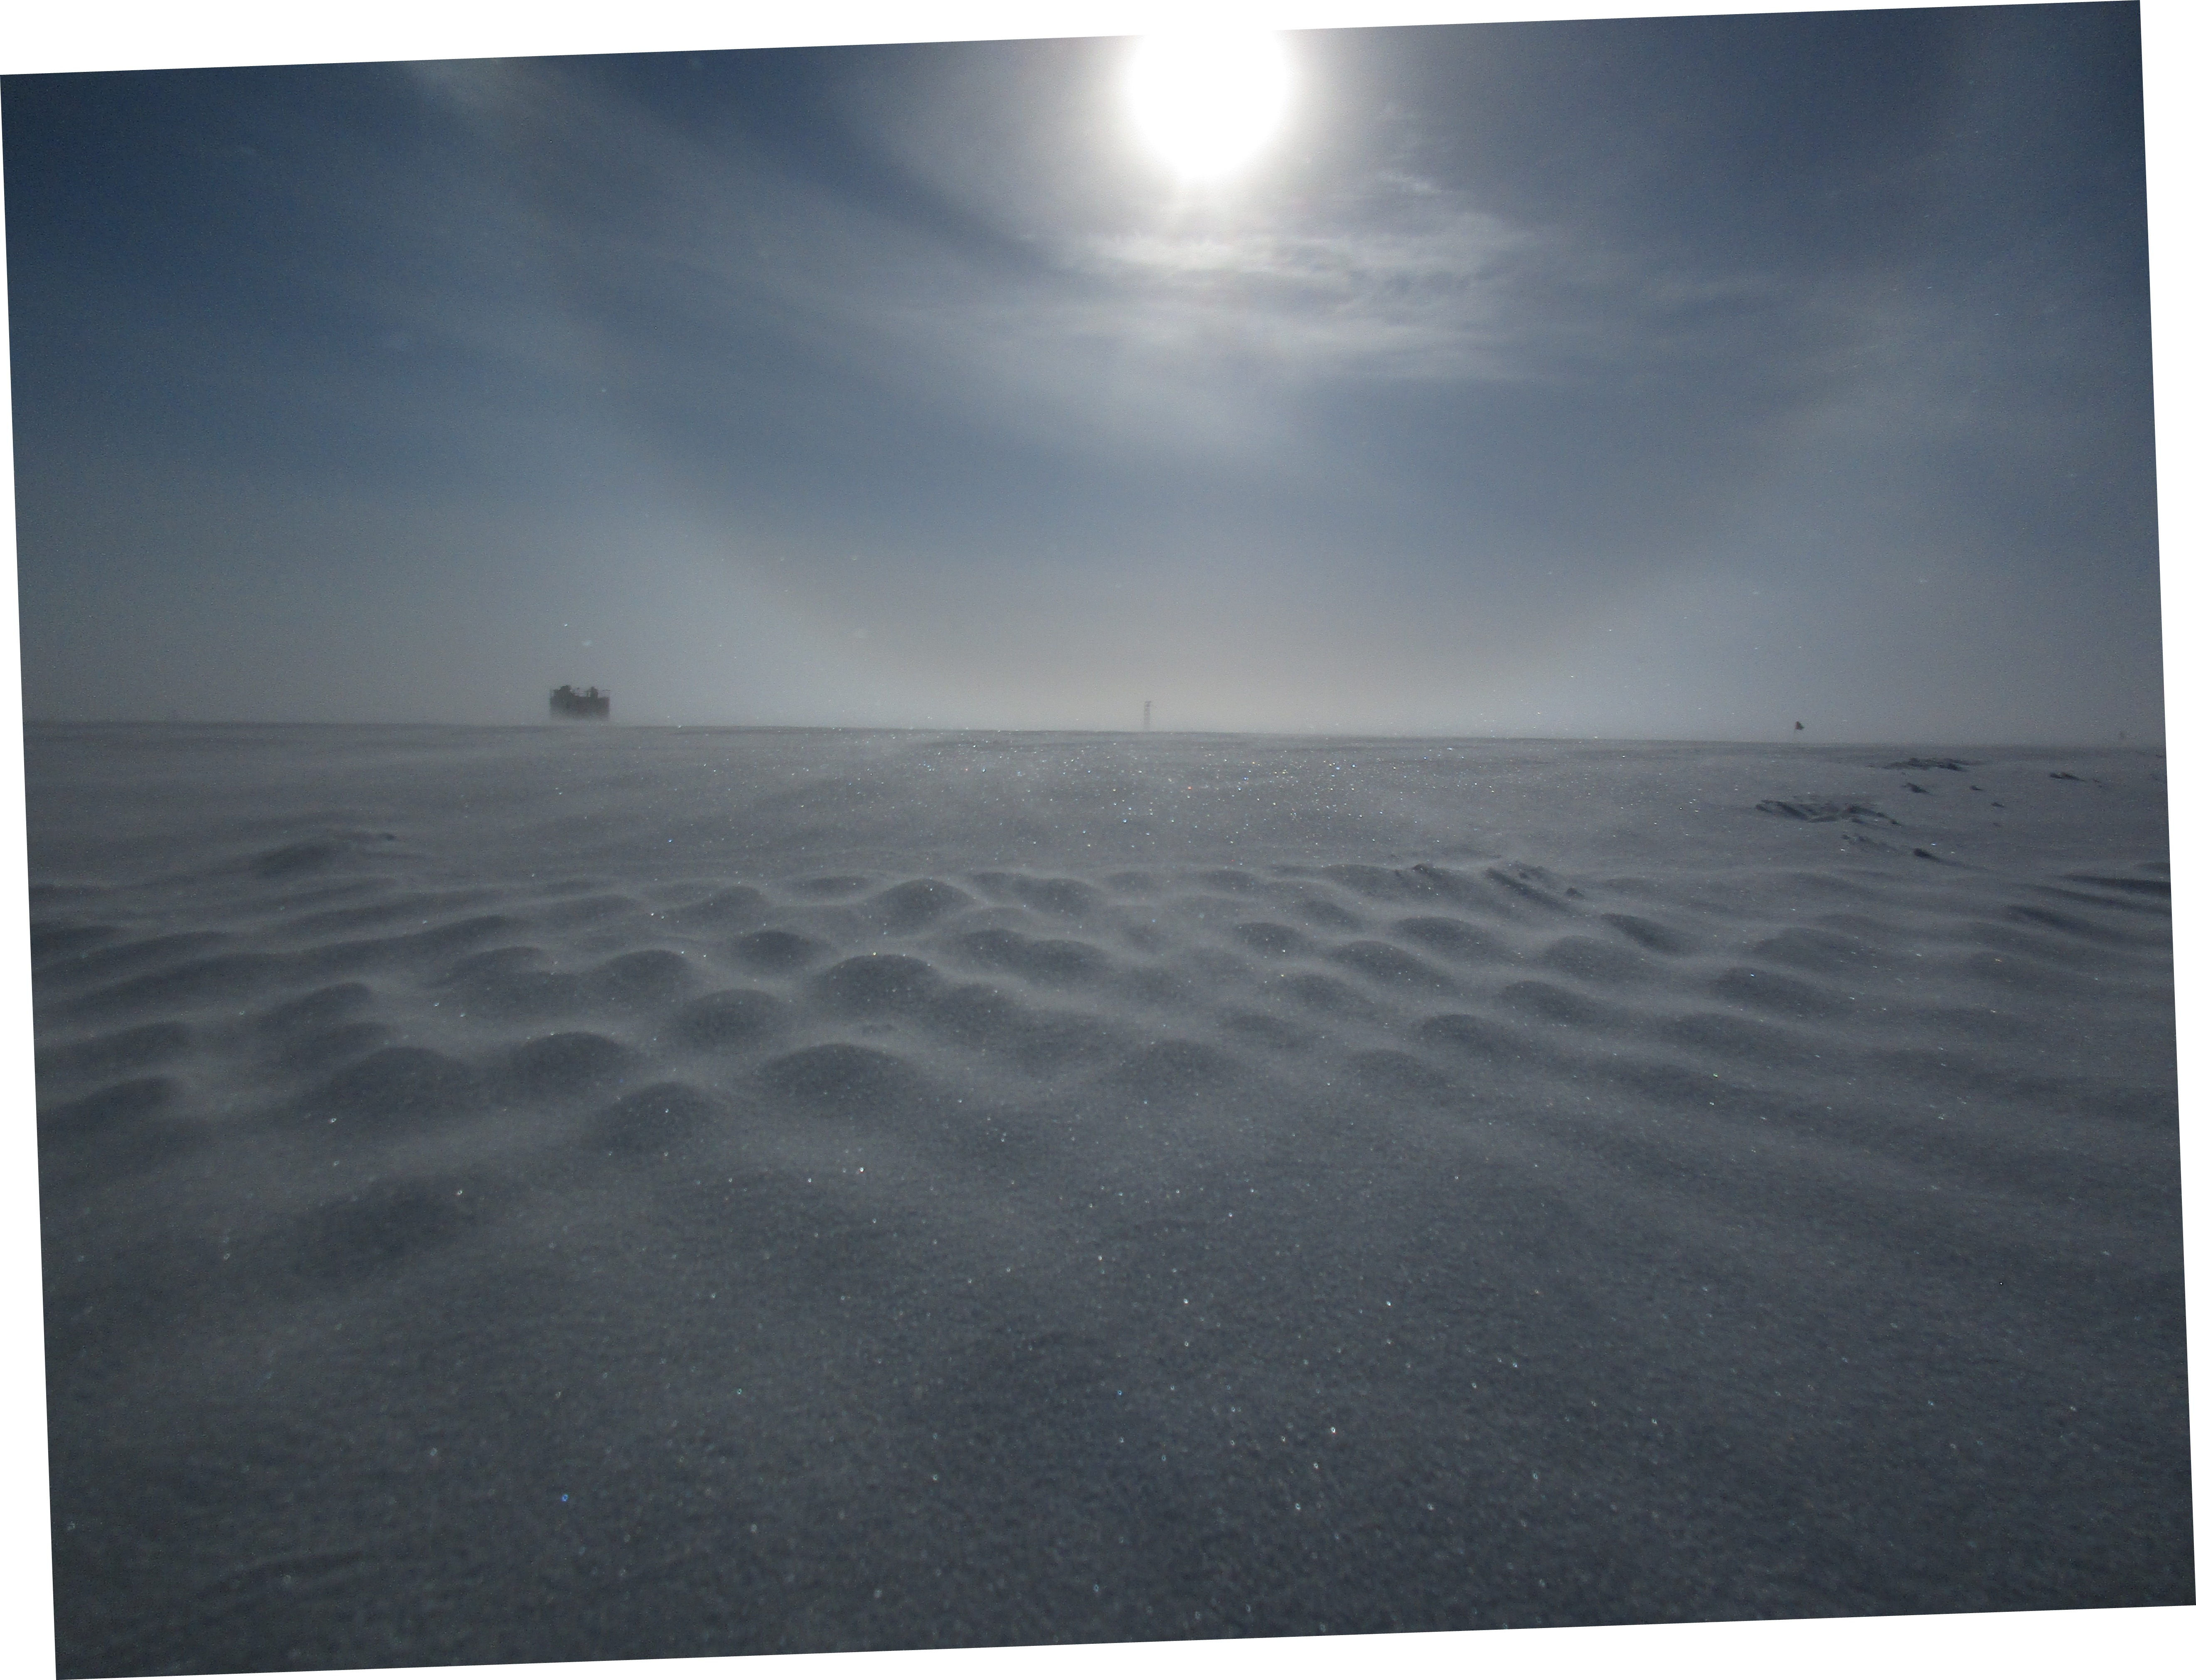

Higher winds at the end of the week formed some beautiful snow drifts. -HJ

**General:**

On April 11, Summit had two planned power outages from 16:09-16:11Z and 16:16-16:18Z for emergency generator testing. The summer season officially began on April 15 with the arrival of a Twin Otter. Summit Station now has an additional mechanic, field coordinator, cargo lead, and station cook.

**Significant Weather Observations:**

* 04-10: Few cirrostratus. -41C, 2 kts.
* 04-11: Fzfg, VV in morning clearing to limited visibility due to ground fog. -33C, 6 kts. 10:45Z- Fogbow.
* 04-12: Br. Few stratus, sct stratocumulus. Lenticular-looking clouds on horizon. -35C, 9 kts.
* 04-13: Br. Bkn cirrostratus. -36C, 6 kts.
* 04-14: Fzfg, drsn, IC. Sct altocumulus, sct cirrostratus. -35C, 12 kts.
* 04-15: Br, drsn, IC. Sct altocumulus, sct cirrus. -30C, 15kts.
* 04-16: Fzfg, IC. Sct stratus, bkn altostratus. -30, 17kts.

**ICECAPS Data Management:**

* 04-10: Data transfer complete 06:07Z.
* 04-11: Data transfer complete 06:21Z.
* 04-12: Data transfer complete 06:00Z.
* 04-13: Data transfer complete 05:55Z.
* 04-14: Data transfer complete 05:58Z. Matt Shupe cleaned up MMCR mount as it was 95% full.
* 04-15: Data transfer incomplete. MMCR files not transferred. spot_check_archive.sh command not able to run fully.
* 04-16: Data transfer complete 09:57Z. All files from 2017-04-14 also successfully transferred.

**MWR:**

* Operating normally.

**SODAR:**

* Operating normally.

**POSS:**

* Operating normally.
* 04-15: Offline 17:36-18:10Z during Dataman reboot.

**MMCR:**

* Operating normally.
* Pitch -0.10, roll -0.22 as of 04-16.
* 04-14: Mount on Dataman 95% full. Matt Shupe removed old files.
* 04-15: Mount link broken, no files transferred.
* 04-16: All files successfully transferred.

**CAPABL:**

* Operating normally.

**MPL:**

* Operating normally.

**VCEIL:**

* Operating normally.

**Hotplate:**

* Offsite for repairs since 2016-06-09.

**IceCAM:**

* Operating normally.

**PAERI:**

* Operating normally.

**TSI:**

* Stored in MSF for winter.

**IcePIC:**

* No images captured this week.

**Radiosonde:**

* Twice daily soundings.
* Ongoing troubleshooting dealing with *.mwx and *.spf files not being grabbed by Dataman. For now, every other day I will manually change the permissions.
* 04-11: Morning balloon not launched due to repeated failed sondes with a reported humidity over 100%. Replacement balloon launched 17:31Z.
* 04-14: The Danish Civil Aviation Authority removed the requirement for parachutes with weather balloon launches. Test mass being recalculated, parachutes will be returned to Littleton this summer.

**MASC:**

* Offsite for repairs since 2016-05-03.