# ICECAPS Weekly Report

April 17 – April 23, 2017

Hannah James

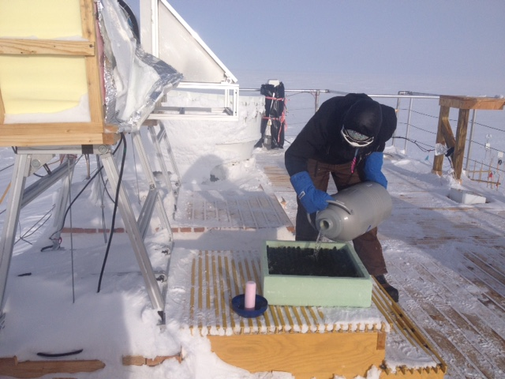

Prepping to calibrate the 150-90 MWR. -AR

**General:**

The summer season is in full swing at Summit. On Friday and Sunday we received C-130 flights bringing in the construction crew, electricians, and PFS employees for seasonal visits. On Friday, April 21, there was an unexpected power outage that lasted from 22:12-22:17Z. All was running well in the MSF after this outage.

**Significant Weather Observations:**

* 04-17: Fzfg, drsn, IC. Sct cirrus, ovc cirrostratus, later in the day blsn, VV200. -30, 18kts. 12:45Z halo.
* 04-18: Br, drsn, IC. Sct altostratus. Ovc stratus in afternoon. -28C, 18kts.
* 04-19: Vcfzfg. Few stratus, few altocumulus, sct cirrus. -33C, 10kts.
* 04-20: Br. Few stratus, bkn altostratus, bkn cirrus. -30C, 10 kts.
* 04-21: Br. Sct cirrostratus. -38C, 6 kts.
* 04-22: Few stratus, sct cirrostratus. -40C, 5 kts. 12:00-cornora.
* 04-23: Few stratus far in the distance, sct cirrocumulus. -39C, 9 kts.

**ICECAPS Data Management:**

* 04-17: Data transfer complete 05:57Z.
* 04-18: Data transfer complete 06:47Z.
* 04-19: Data transfer complete 05:54Z.
* 04-20: Data transfer complete 05:50Z.
* 04-21: Data transfer complete 06:43Z.
* 04-22: Data transfer complete 05:53Z.
* 04-23: Dataman computer screen totally blank. Looking at the InSite data transfer webpage, it appears Dataman transfers were done around 05:50Z.

**MWR:**

* Operating normally.
* 04-19: Message stating “Slave elevation mirror does not respond.” Cleared message, emailed Erik and Dave, message did not return. Dailies passed.
* 04-20: Message stating “Slave elevation mirror does not respond.” Cleared message. Emailed Erik and Dave, they said everything was fine. All other dailies passed.
* 04-21: Error message appeared again, but returned after 2 minutes. Cleared again, and returned.
* 04-22: Discovered that the HATPRO’s scene mirror is not moving. This may be a belt issue, a frozen shaft, or something else… Erik and Dave will be in contact with RPG as to how much diagnostic work we can do at Summit rather than sending it back. 17:40Z- HATPRO’s measurements were stopped, it was powered down. The 150-90 is running on the “summit_version_11_scan_HF” file. HATPRO will be brought inside early next week for diagnostics. Liquid Nitrogen calibration performed on the 150-90. 19:15Z- measurements stopped, 19:48-19:54Z- calibration ran, 20:03Z- measurements resumed.

**SODAR:**

* Operating normally.

**POSS:**

* Operating normally.
* 04-23: Unable to check dailies due to Dataman computer being down.

**MMCR:**

* Operating normally.
* Pitch -0.10, roll -0.22 as of 04-23.
* 04-22: Error log reporting “NetCDF_Mom - Could not read calibration table NetCDF file” and “Level 2 - NetCDF_Mom - Data may be incorrect” on all error logs since yesterday’s 12:30 calibration. All 12:30 calibrations tests pass.
* 04-23: Error log reads same as yesterday. All 12:30 calibrations tests pass.

**CAPABL:**

* Operating normally.

**MPL:**

* Operating normally.

**VCEIL:**

* Operating normally.

**Hotplate:**

* Offsite for repairs since 2016-06-09.

**IceCAM:**

* Operating normally.
* 04-23: Unable to check due to Dataman computer being down.

**PAERI:**

* Operating normally.

**TSI:**

* Stored in MSF for winter.

**IcePIC:**

* 04-19: Slides placed for collection 16:40-17:05Z. Particles photographed include isolated bullets, bullet rosettes, broken bullet rosettes, sheaths, and some radiating plates.

**Radiosonde:**

* Twice daily soundings.
* Ongoing troubleshooting dealing with *.mwx and *.spf files not being grabbed by Dataman. For now, every other day I will manually change the permissions.

**MASC:**

* Offsite for repairs since 2016-05-03.