# ICECAPS Weekly Report

April 3 – April 9, 2017

Hannah James

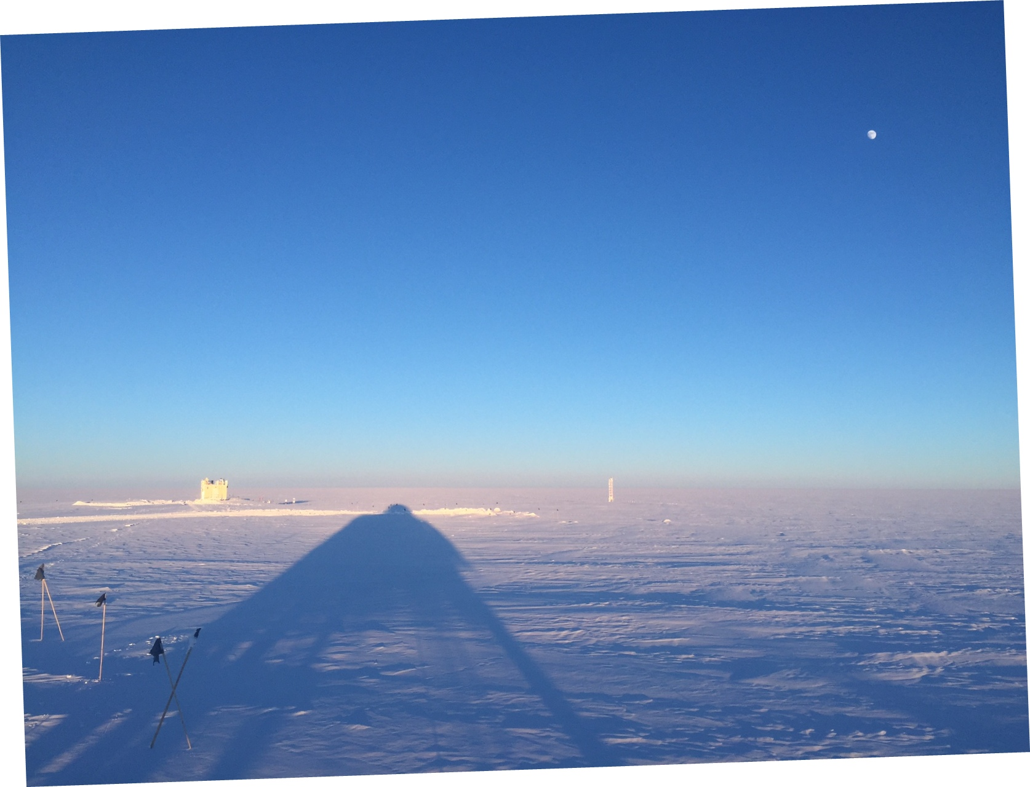

Low sun angles and calm weather provided some beautiful shadows this week -HJ

**General:**

None to report.

**Significant Weather Observations:**

* 04-03: Blsn, -sn. Ovc stratus. -31C, 19 kts.
* 04-04: Ic, vcfg. Sct altostratus, bkn cirrostratus. -33C, 7kts. –Sn in the morning. 11:45Z: Sub-horizon halo. 12:00-13:00Z: Circumzenithal arc, halo, start of parhelic circle.
* 04-05: Few altostratus on horizon. -40C, 5kts. Fata morgana throughout the day.
* 04-06: Few stratus, few cirrostratus. -41C, 0kts. 12:00Z- corona.
* 04-07: Fzfg, skc later in the day. -44C, 12 kts.
* 04-08: Few cirrostratus on the horizon, Skc overhead. -34C, 9 kts.
* 04-09: Sct stratus, very thin, sct cirrostratus on the horizon. -41C, 9 kts.

**ICECAPS Data Management:**

* 04-03: Data transfer complete 05:56Z. CAPABL mount down overnight, remounted 12:45Z.
* 04-04: Data transfer complete 05:44Z. CAPABL mount down overnight, remounted 16:50Z.
* 04-05: Data transfer complete 08:18Z.
* 04-06: Data transfer complete 06:00Z.
* 04-07: Data transfer complete 06:31Z.
* 04-08: Data transfer complete 05:59Z.
* 04-09: Data transfer complete 06:11Z.

**MWR:**

* Operating normally.

**SODAR:**

* Operating normally.
* 04-03: ~1700-1800Z: Heavy equipment operating near MSF to remove large drifts.

**POSS:**

* Operating normally.

**MMCR:**

* Operating normally.
* Pitch -0.10, roll bouncing between -0.11 and -0.22 as of 04-09.

**CAPABL:**

* Operating normally.
* 04-04: CAPABL computer found at login screen after a reported unexpected shutdown with LabView not running. 12:42Z- Per Robert’s request, Licel and Meadowlark were turned off. After Robert performed a Disk Cleanup, it was discovered that there are 250MB of crash dump files. While on the phone with Robert Licel, Meadowlark, the computer, and the motor controllers were power cycled. In APT user, the motors were still enabled and both read 0.0 as a position. We ran LabView using the “FloatingRefLaser2.txt” configuration file. Data looked good, and no alignment was performed. Data was being saved by approximately 16:15Z. For now, CAPABL will run using this configuration file.

**MPL:**

* Operating normally.

**VCEIL:**

* Operating normally.

**Hotplate:**

* Offsite for repairs since 2016-06-09.

**IceCAM:**

* Operating normally.

**PAERI:**

* Operating normally.

**TSI:**

* Stored in MSF for winter.

**IcePIC:**

* No images captured this week.

**Radiosonde:**

* Twice daily soundings.
* Ongoing troubleshooting dealing with *.mwx and *.spf files not being grabbed by Dataman. For now, every other day I will manually change the permissions.
* 04-05: Morning balloon had low RH readings (28-30%) when sonde was placed outside. At first, I suspected this was a sonde failure since the sensor had hit the stand. A second sonde was prepped, but read low as well. MW41 Software was restarted, and still humidity read low. Upon a closer look at weather conditions, it was discovered that the Greenhouse temperature sensor was reading much warmer than TAWO’s, resulting in a RH of ~50%. Due to this inversion, the balloon was launched, albeit late (11:59Z). Von and Matt were notified of the values and a late launch. Matt Shupe verified that the MMCR saw similar conditions, and that due to low winds from the north-northeast that these extremely low humidity values could be real- rare but real.

**MASC:**

* Offsite for repairs since 2016-05-03.