**ICECAPS Weekly Report**

August 14 – 20, 2017

Sam Dorsi

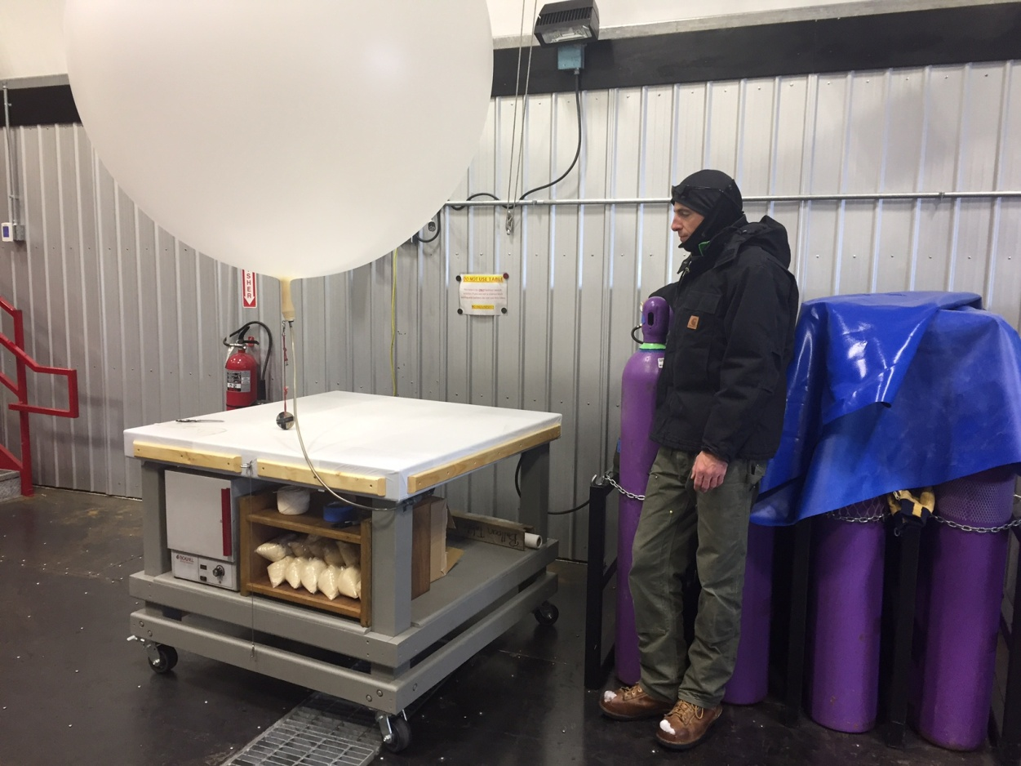

The morning routine is underway at the new SMG balloon preparation space. MG

**General:**

* 08-18: Ryan Neely and Robert Stillwell arrived at Summit.

**Significant Weather Observations:**

* 08-14: Overcast stratus, from 17:45 to 18:30Z observed halos at 22 and 46 degrees, perry arc, parhelic circle, -8C, 13 kts.
* 08-15: Overcast stratus, freezing fog, -13C, 10 kts.
* 08-16: Broken stratus, blowing snow, -11C, 18 kts.
* 08-17: Broken stratus, weak halo at 22 degrees from 11:30Z to 17:00Z, -15C, 8 kts.
* 08-18: Broken altostratus, drifting snow, -21C, 11 kts.
* 08-19: Scattered altostratus, -16C, 4 kts.
* 08-20: Broken altostratus, -18C, 9 kts.

**ICECAPS Data Management:**

* 08-14: Data transfer complete 16:19Z.
* 08-15: Data transfer complete 12:51Z.
* 08-16: Data transfer complete 06:09Z.
* 08-17: Data transfer complete 05:17Z.
* 08-18: Data transfer complete 07:01Z.
* 08-19: Data transfer complete 14:26Z.
* 08-20: Data transfer complete 18:55Z.

**MWR:**

* Operating normally.
* 08-18: Liquid nitrogen arrived at Summit. Calibration started at 17:29Z and completed at 20:00Z.
* 08-19: Calibration continued from 19:45 to 20:39Z.
* 08-20: Calibration continued from 13:35 to 14:27Z.

**SODAR:**

* Operating normally.
* 08-19: Receiver dish cleaned from 12:54 to 13:13Z.

**POSS:**

* 08-14 to 08-20: The log files show a ‘posaccmsod’ message and some truncated messages.
* 08-15: POSS power cycled at 18:51z. Communications errors are still present.
* 08-16: POSS heater bulb replaced 17:37Z. USB temperature logger set up to assess thermostat functionality and enclosure conditions.
* 08-20: Temperature logger observations downloaded and sent to Matt Shupe.

**MMCR:**

* Operating normally.
* 08-14 to 08-15: Log files show calibration table errors.
* 08-16: MMCR rebooted from 15:29 to 15:58Z. Calibration table errors resolved.
* Pitch 0.00 to -0.10, Roll 0.00 to -0.11 as of 08-03. Continuing to monitor Pitch and Roll readings under varying sunshine conditions.

**CAPABL:**

* Operating normally.
* 08-18 to 08-19: Neely and Stillwell performing work on CAPABL.

**MPL:**

* Operating normally.

**VCEIL:**

* Operating normally.

**Hotplate:**

* Operating normally.

**IceCAM:**

* Operating normally.

**PAERI:**

* Operating normally.

**TSI:**

* Operating normally.

**IcePIC:**

* 08-15: Slides placed for collection from 13:29 to 19:09Z. Particles imaged included rimed hexagonal plates, rimed sectored plate, irregulars.

**Radiosonde:**

* Twice daily soundings.
* 08-19: Sounding at 12z rejected due to late entry of surface observations.
* Issue with *.mwx and *.spf file permissions prevents transfer by data management scripts. File permissions are manually changed every 1-2 days.

**MASC:**

* Operating normally.