**ICECAPS Weekly Report**

August 21 – 27, 2017

Sam Dorsi

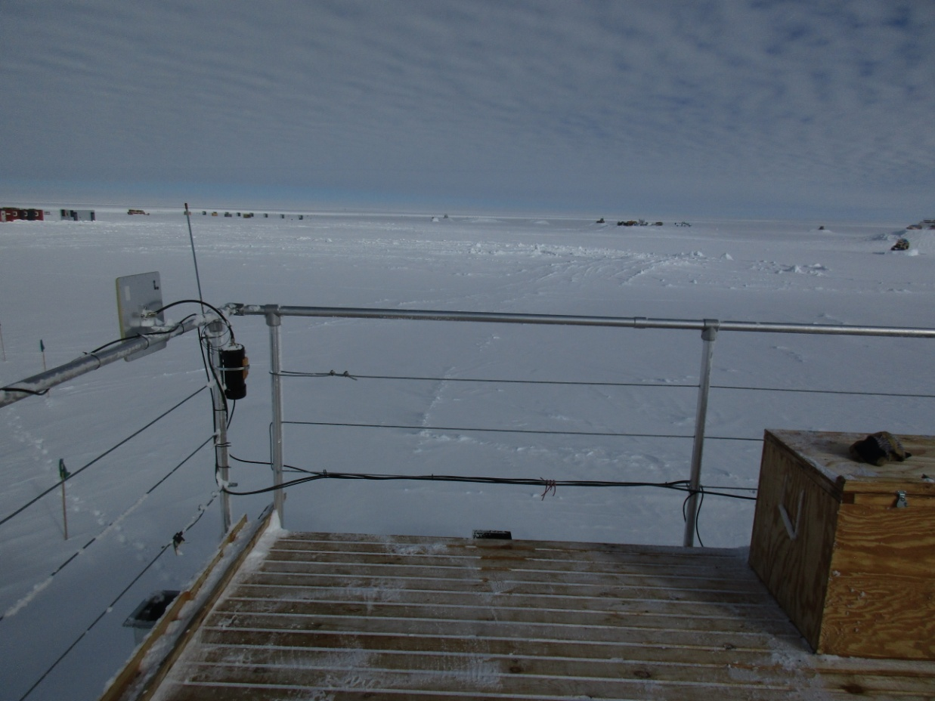

The newly replaced IceCAM cable run is well-protected from damage from snow removal. SWD

**General:**

* 08-24: Ryan Neely and Robert Stillwell depart Summit.

**Significant Weather Observations:**

* 08-21: Overcast stratus, -23C, 10 kts.
* 08-22: Overcast stratus, blowing snow, -14C, 21 kts.
* 08-23: Scattered altostratus, drifting snow, -14C, 14 kts.
* 08-24: Scattered stratocumulus, -19C, 8 kts.
* 08-25: Scattered altocumulus, -25C, 7 kts.
* 08-26: Broken altostratus, -19C, 8 kts.
* 08-27: Clear, -20C, 11 kts.

**ICECAPS Data Management:**

* 08-21: Data transfer complete 12:53Z.
* 08-22: Data transfer complete 16:27Z.
* 08-23: Data transfer complete 15:03Z.
* 08-24: Data transfer complete 17:11Z.
* 08-25: Data transfer complete 06:14Z.
* 08-26: Data transfer complete 06:32Z.
* 08-27: Data transfer complete 05:42Z.

**MWR:**

* Operating normally.
* 08-21: Liquid nitrogen calibration continued from 11:30 to 12:20Z
* 08-22: Liquid nitrogen absolute calibration performed from 13:20 to 13:51Z; but inadequate LN2 remained for internal/external flop measurement.

**SODAR:**

* Operating normally.
* 08-21: Dishes cleaned from 17:53 to 17:58Z.

**POSS:**

* 08-14 to 08-27: The log files show ‘posaccmsod’ and truncated messages.

**MMCR:**

* Operating normally.
* 08-24: Desiccant swap performed at 13:30Z.

**CAPABL:**

* Operating normally.
* 08-21 to 08-24: Neely and Stillwell continuing to perform work on CAPABL.
* 08-21: Installed CAPABL backup computer, and added to ‘LogMeIn’ software.

**MPL:**

* Operating normally.
* 08-21: Afterpulse calibration performed 12:55 to 13:39z.
* 08-21: The inside surface of the MPL roof window was cleaned using optical wipes and methanol. Two passes were performed: the first using non-scratching soft cotton cleaning pads and the second using optical tissues. This cleaning was performed by Neely, Stillwell and Dorsi during the afterpulse calibration (12:55 to 13:39z). Considerable grime was removed from the window. Some slight streaking is still visible, but it was deemed safer to stop at this point.

**VCEIL:**

* Operating normally.

**Hotplate:**

* Operating normally.

**IceCAM:**

* Operating normally.
* 08-25: IceCAM outdoor ethernet cable replaced.

**PAERI:**

* Operating normally.
* 08-23: The PAERI outdoor temperature sensor was relocated from the outside east wall of the enclosure to a shaded, aspirated, physically protected location just above the shelter fan (12:15Z).

**TSI:**

* Operating normally.

**IcePIC:**

* Not collected.

**Radiosonde:**

* Twice daily soundings.
* Issue with *.mwx and *.spf file permissions prevents transfer by data management scripts. File permissions are manually changed every 1-2 days.

**MASC:**

* Operating normally.