**ICECAPS Weekly Report**

August 28 – September 3, 2017

Sam Dorsi

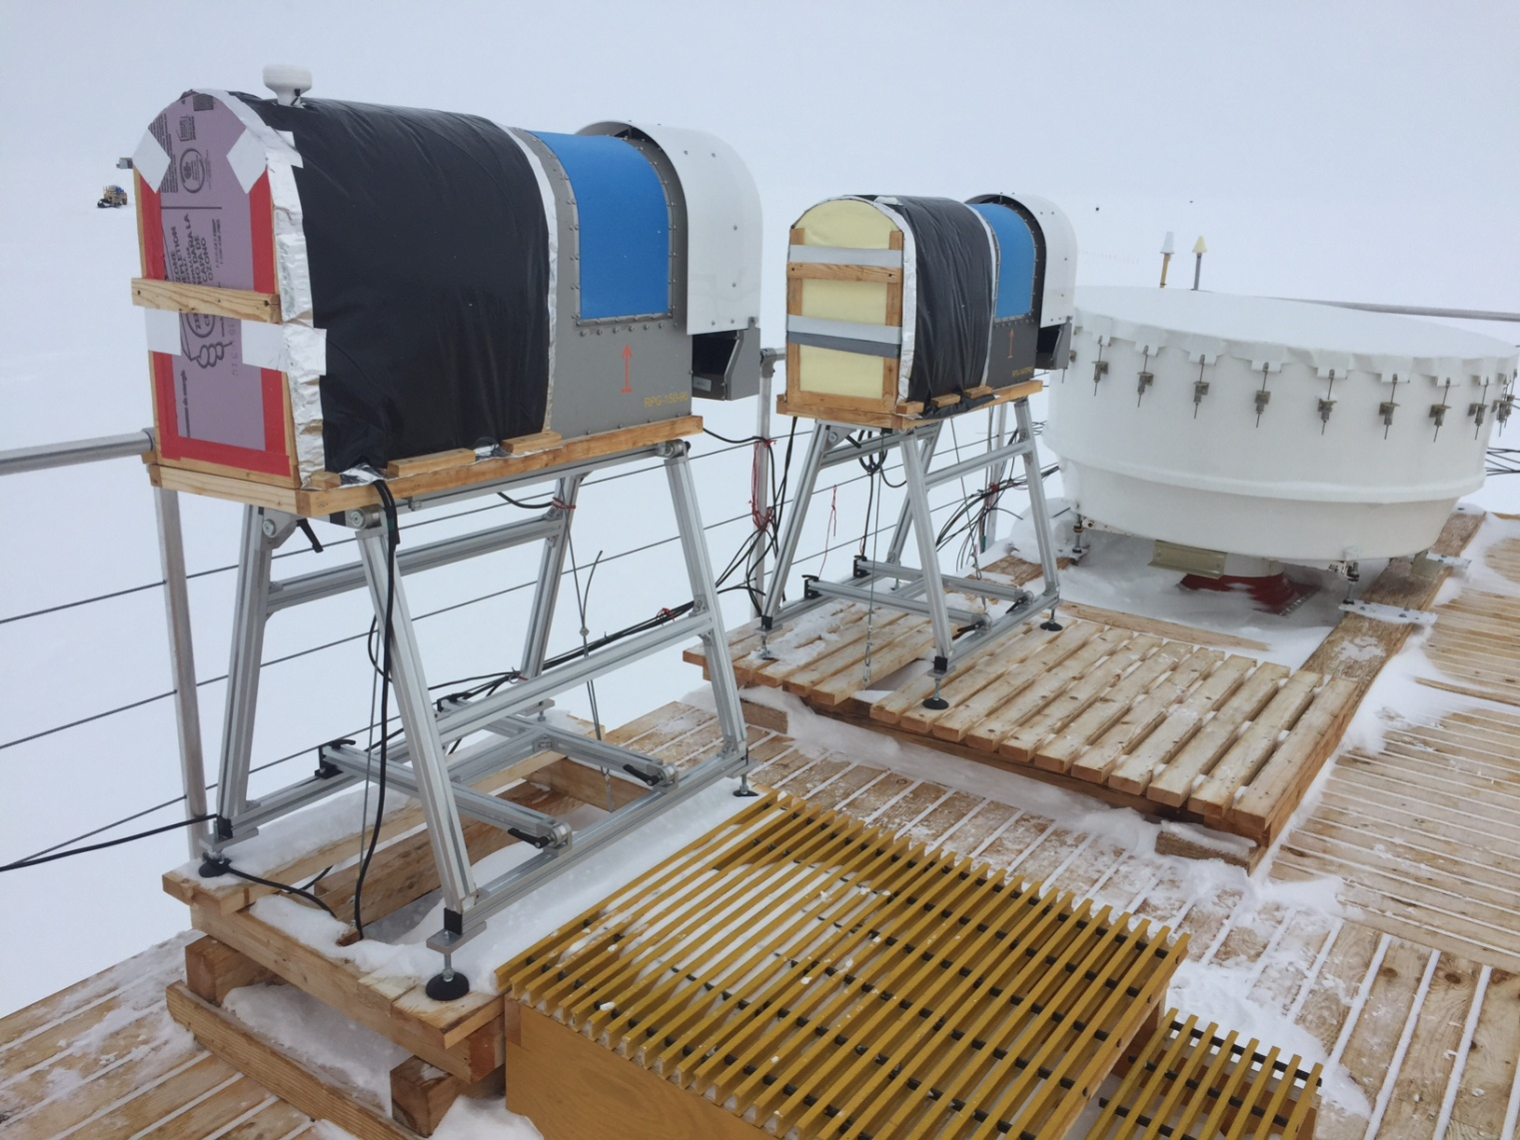

The MWRs sit ready for the winter under new insulated blankets. SWD

**General:**

* None.

**Significant Weather Observations:**

* 08-28: Scattered altocumulus, -17C, 6 kts.
* 08-29: Overcast stratus, drifting snow, -12C, 9 kts.
* 08-30: Broken stratus, -12C, 10 kts.
* 08-31: Broken stratus, -11C, 22 kts.
* 09-01: Overcast stratus, -16C, 12 kts.
* 09-02: Scattered altostratus, -26C, 2 kts.
* 09-03: Freezing fog, -24C, 4 kts.

**ICECAPS Data Management:**

* 08-28: Data transfer complete 05:28Z.
* 08-29: Data transfer complete 05:42Z.
* 08-30: Data transfer complete 05:49Z.
* 08-31: Data transfer complete 06:31Z.
* 09-01: Data transfer complete 05:58Z.
* 09-02: Data transfer complete 06:10Z.
* 09-03: Data transfer complete 05:55Z.

**MWR:**

* Operating normally.
* 09-01: MWR blankets built using new insulation materials. Blankets installed 14:05 to 15:15Z.

**SODAR:**

* Operating normally.
* 09-01: Sodar dishes cleaned from 12:56 to 13:04Z.

**POSS:**

* 08-14 to 08-29: The log files show ‘posaccmsod’ and truncated messages.

**MMCR:**

* Operating normally.
* 08-30: Requested information on MMCR tilt measurements under varying weather conditions for last 2 months sent to Duane.

**CAPABL:**

* Operating normally.

**MPL:**

* Operating normally.
* 09-03: Disk is at 95% utilization; Turner notified.

**VCEIL:**

* Operating normally.

**Hotplate:**

* Operating normally.

**IceCAM:**

* Operating normally.

**PAERI:**

* Operating normally.

**TSI:**

* Operating normally.

**IcePIC:**

* 08-29: Slides placed for collection 11:52 to 13:29Z. Particles photographed are hexagonal plates and irregulars.

**Radiosonde:**

* Twice daily soundings.
* 08-30: Addressed issue with *.mwx and *.spf files that had previously required manual intervention every 1-2 days. The problem was determined to have resulted from the unique handling within Windows 7 of files created while logged into a user account with administrator privileges. These files are now successfully handled by the nightly data aggregation script.

**MASC:**

* Operating normally.