**ICECAPS Weekly Report**

December 11 – December 17, 2017

Hannah James

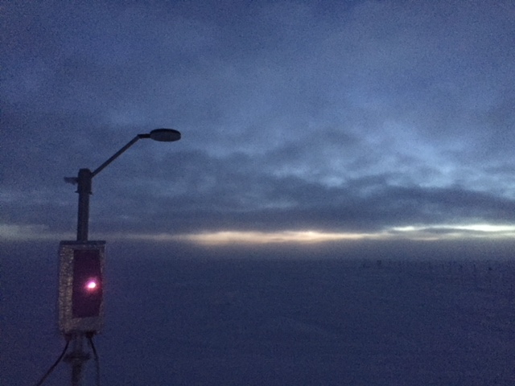

The Hotplate returned to the precipitation suite on Wednesday morning. -HJ

**General:**

* Heavy frost was removed from precipitation suite lines on 12-15. MW41 radiosonde software was successfully updated on 12-16.

**Significant Weather Observations:**

* 12-11: Bkn cirrostratus. -29C, 14 kts. –Sn, vcfzfg, drsn.
* 12-12: Sct stratus, bkn cirrostratus. -34C, 15 kts. Fzfg, drsn.
* 12-13: VV400. -33C, 2 kts. Fzfg.
* 12-14: Bkn altostratus. -33C, 20 kts. Blsn.
* 12-15: Ovc stratus. -35C, 15 kts. Blsn.
* 12-16: Bkn stratus, ovc cirrostratus. -32C, 8 kts. IC.
* 12-17: Ovc stratus. -33C, 9 kts. IC.

**ICECAPS Data Management:**

* 12-11: Data transfer complete 11:27Z.
* 12-12: Data transfer complete 12:39Z.
* 12-13: Data transfer complete 11:34Z.
* 12-14: Data transfer complete 11:07Z.
* 12-15: Data transfer complete 11:21Z.
* 12-16: Data transfer complete 12:08Z.
* 12-17: Data transfer complete 12:08Z.

**MWR:**

* As of 10-28, 150-90 operating in V11_SCAN_HF.MBF. HATPRO remains on and heated until weather conditions allow it to come off the MSF roof.

**SODAR:**

* Operating normally.

**POSS:**

* Operating normally in old software.
* Working with Peter at EC to run new software. POSS offline from time to time while troubleshooting.
* 12-15: ~13:00Z: Removed heavy frost from middle plate.

**MMCR:**

* Operating normally.
* 12-17: “Replace existing "C:\mmcr\labview monitor files\XPower 1 min histories all.txt?" window found with Receiver Cal error running in background. 13:57Z- selected “Replace.” Data collection resumed, daily checks passed. Original .txt file backed up on desktop.

**CAPABL:**

* Operating normally.
* 12-12: 13:30Z- Beam very visible, no rave ice present.
* 12-13: 13:50-14:42Z: Laser turned off for work on roof near output. 13:30Z- Ground fog illuminating beam, no rave ice present.
* 12-14: 13:30Z- Beam visible with blowing snow, no rave ice present.
* 12-15: 13:00Z- Beam visible, small amounts of rave ice present (~1 every 2 seconds). 18:50Z- Beam visible, heavy rave ice present (10/second).
* 12-17: 13:40Z- Beam “sparkling,” small amounts of rave ice present. IcePICs taken, see below (no rave ice photos taken).

**MPL:**

* Operating normally.

**VCEIL:**

* Operating normally.

**Hotplate:**

* Operating normally.
* 12-11: Discovered kink in Cat 5 cable about 5 feet from the instrument end that created a short in line 8. Cut cable, made new terminal, tested outside. Instrument ran for 45 minutes without errors, and collected good data.
* 12-13: Cable re-set outside; Hotplate reinstalled and turned on at 14:38Z. All data streams look good!
* 12-15: Error 85 (Scan failed, input string does not contain data in the expected format) found. Restarted at 13:06Z, daily checks pass. Error 85 found again, cleared at 18:52Z.
* 12-16: Error 85 found again. Restarted 13:22Z.

**IceCAM:**

* Operating normally.

**PAERI:**

* Operating normally.
* 12-15: 18:50Z- cleaned PAERI mirror due to red SW and LW responsivity flags. Flags returned to green status afterwards.

**TSI:**

* In the MSF for winter storage.

**IcePIC:**

* 12-17: Slides placed for collection 13:42-13:45Z. Particles photographed include sheaths, hollow columns, isolated bullets, bullet rosettes, and radiating plates.

**Radiosonde:**

* Twice daily soundings.
* 12-16: Updated MW41 software to Version 2.8.0. Evening balloon launched with new software.

**MASC:**

* Operating normally.