**ICECAPS Weekly Report**

December 18 – December 24, 2017

Hannah James

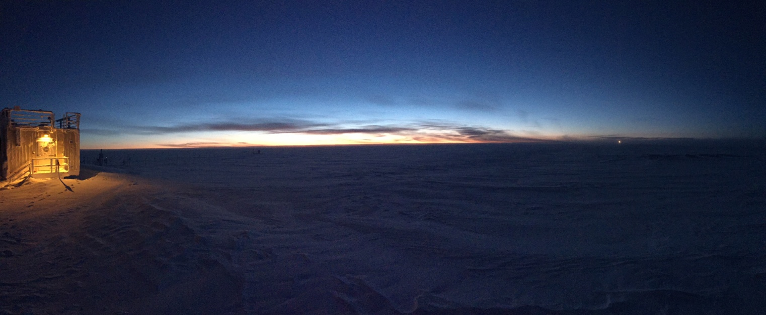

A beautiful, calm day on the eve of Winter Solstice. -HJ

**General:**

* None to report.

**Significant Weather Observations:**

* 12-18: Bkn stratus, bkn cirrus. -33C, 16 kts. IC.
* 12-19: Fewaltostratus, sct cirrus. -44C, 6 kts. IC.
* 12-20: Few cirrus. -50C, 18 kts.
* 12-21: Few cirrostratus in far distance. -48C, 2 kts. Local pollution from generators over MSF at times.
* 12-22: Few cirrostratus in far distance, sky clear overhead. -49C, 17 kts.
* 12-23: Few cirrostratus in far distance, sky clear overhead. -47C, 11 kts.
* 12-24: Sct cirrostratus, bkn cirrus. -46C, 12 kts. Fzfg in early morning, clearing to br.

**ICECAPS Data Management:**

* 12-18: Data transfer complete 11:32Z.
* 12-19: Data transfer complete 11:21Z.
* 12-20: Data transfer complete 11:36Z.
* 12-21: Data transfer complete 11:30Z.
* 12-22: Data transfer complete 10:59Z.
* 12-23: Data transfer complete 11:53Z.
* 12-24: Data transfer complete 11:27Z.

**MWR:**

* As of 10-28, 150-90 operating in V11_SCAN_HF.MBF. HATPRO remains on and heated until weather conditions allow it to come off the MSF roof.

**SODAR:**

* Operating normally.
* 12-18: 15:06-1521Z: SODAR transmitting off while removing snow from dishes.

**POSS:**

* Operating normally in old software.

**MMCR:**

* Operating normally.
* 12-19: Error 7, Receiver Cal Running messages found during daily checks. Clicked “Continue,” normal operations resumed at 13:05Z.
* 12-24: Error 7, Receiver Cal Running messages found during daily checks. Clicked “Continue,” normal operations resumed at 12:44Z.

**CAPABL:**

* Operating normally.
* 12-19: 12-19: 22:42-22:48Z: CAPABL laser turned off to remove snow from window

**MPL:**

* Operating normally.
* 12-19: Aferpulse Calibration performed. MPL not collecting data 17:12-17:33Z. 30m, 30s: 17:14-17:23Z. CopolBkdAvg: 0.000286, CopolBkdStd: 0.000187. 15m, 30s: 17:23-17:31Z. CopolBkdAvg: 0.000246, CopolBkdStd: 0.000271.

**VCEIL:**

* Operating normally.

**Hotplate:**

* Operating normally.

**IceCAM:**

* Operating normally.

**PAERI:**

* Operating normally.
* 12-18: 13:25-14:11Z: PAERI shelter fan inside to remove ice from fan blades.

**TSI:**

* In the MSF for winter storage.

**IcePIC:**

* No images photographed this week.

**Radiosonde:**

* Twice daily soundings.
* 12-20: Sonde terminated 11 minutes after launchdue to "excessive missing data frames.”Software did not register launch until ~10 minutes after launch, surface obs window did not automatically pop up. Surface obs entered ~10 minutes after launch, recalculation occurred. No messages were sent, second launch at 12:06Zcollected data successfully.

**MASC:**

* Operating normally.