**ICECAPS Weekly Report**

December 25 – December 31, 2017

Hannah James

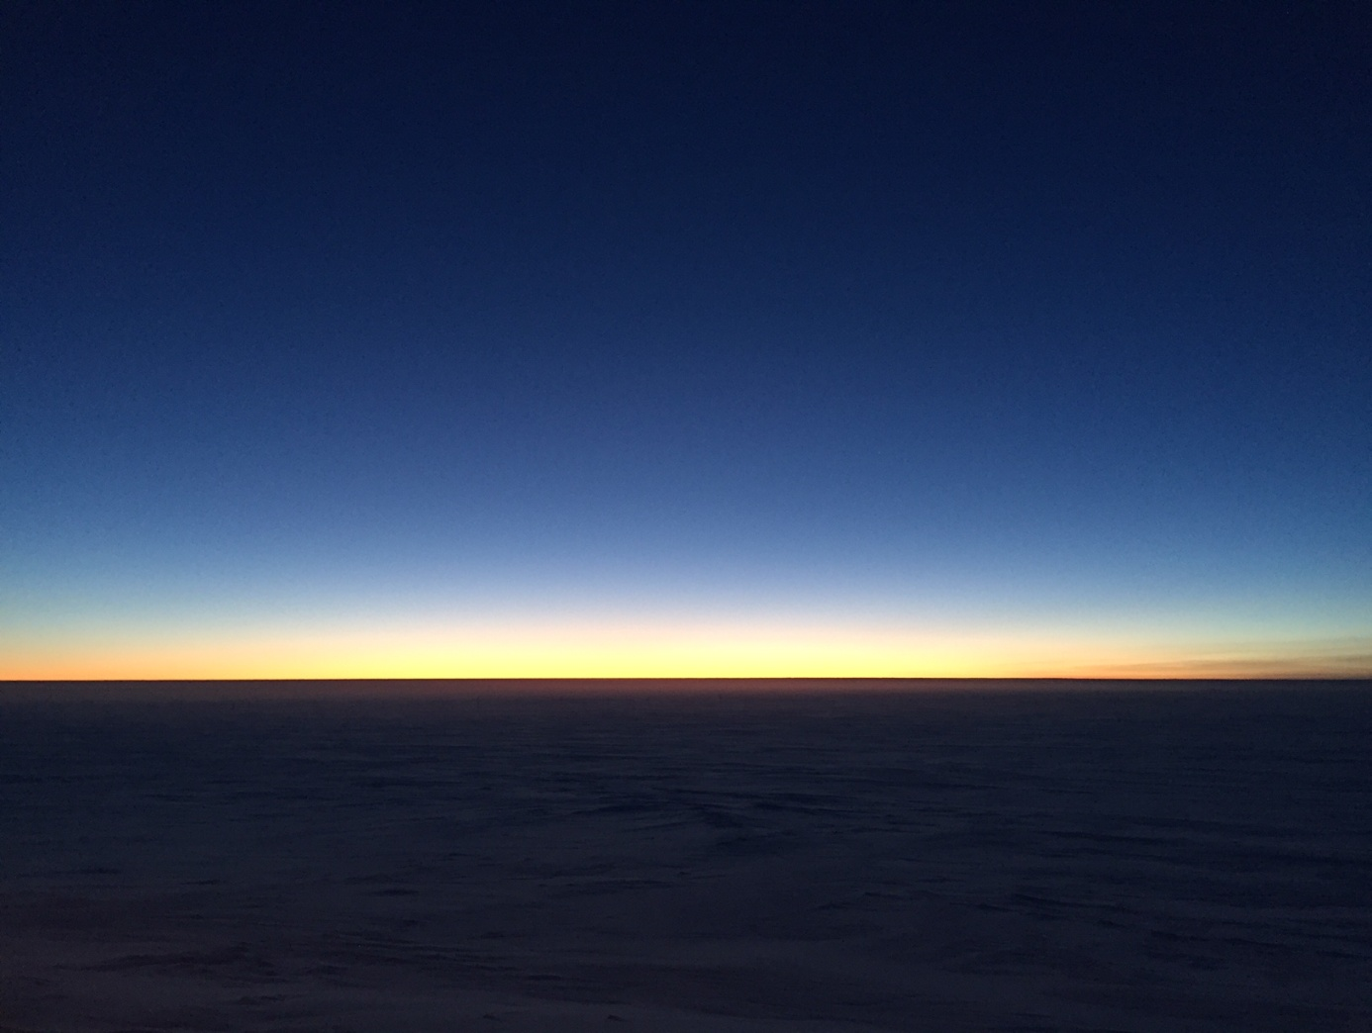

Slowly but surely, light is returning to Summit Station. -HJ

**General:**

* None to report.

**Significant Weather Observations:**

* 12-25: Sct cirrus. -47C, 13 kts. IC.
* 12-26: Few altostratus, sct cirrostratus. -50C, 6 kts. Br.
* 12-27: Few cirrostratus in the distance. -53, 14 kts. IC, br. Fata morgana seen with light on horizon.
* 12-28: Few cirrostratus in distance. -55C, 19 kts. Br. Fata morgana seen with light on horizon.
* 12-29: Sky clear. -56C, 5 kts. Vcfzfg.
* 12-30: Few stratus in far distance, few cirrostratus. -49C, 5 kts. Vcfzfg.
* 12-31: Bkn altostratus, bkn cirrostratus. -50C, 20 kts. Vcfzfg, drsn.

**ICECAPS Data Management:**

* 12-25: Data transfer complete 12:57Z.
* 12-26: Data transfer complete 11:59Z.
* 12-27: Data transfer complete 12:59Z.
* 12-28: Data transfer complete 11:02Z. CAPABL mount down.
* 12-29: Data transfer complete approximately 20:20Z. Connection broken through most of the morning, data transfer didn’t really start until 12:30Z. Celiometer, radiosonde, and CAPABL mounts down.
* 12-30: Data transfer complete 12:38Z.
* 12-31: Data transfer complete 11:38Z.

**MWR:**

* As of 10-28, 150-90 operating in V11_SCAN_HF.MBF. HATPRO remains on and heated until weather conditions allow it to come off the MSF roof.

**SODAR:**

* Operating normally.

**POSS:**

* Operating normally in old software.

**MMCR:**

* Operating normally.
* 12-25: Swapped out desiccant.
* 12-31: “Could not read calibration table NetCDF file” errors appeared on the hour starting at 02:00Z. Reboot started at 14:05Z, three reboots required. Data collection resumed at 14:42Z.

**CAPABL:**

* Operating normally.
* 12-25: 13:39-13:46Z: CAPABL laser turned off to remove snow from window.
* 12-28: CAPABL found with Disk Boot Error. Upon restart with Robert monitoring remotely, motors not found. Power cycled all systems, restarted CAPABL in FloatingRefLaser1 configuration file. Daily checks passed afterwards, system running at ~14:10Z. Mount down overnight.
* 12-29: CAPABL found with Block Diagram open, error line flashing, and LabView paused. Mount down overnight. Robert remotely restarted the system, system running normally by 13:25Z.

**MPL:**

* Operating normally.

**VCEIL:**

* Operating normally.
* 12-29: Mount down overnight.

**Hotplate:**

* Operating normally.
* 12-29: Error 1073807339 found (timeout expired before operation completed). Data collection resumed at 12:34Z.

**IceCAM:**

* Operating normally.

**PAERI:**

* Operating normally.
* 12-28: 13:20Z: Removed snow from scene mirror (introduced by myself accidentally).

**TSI:**

* In the MSF for winter storage.

**IcePIC:**

* No images photographed this week.

**Radiosonde:**

* Twice daily soundings.
* 12-28: Software refusing any input from user while attempting to start morning balloon. Surface obs window was open from the previous evening’s launch with no values (though it was filled and values were accepted the previous night), sonde was stuck at values from 23:23Z and would not terminate. Computer and SPS311 were restarted, and according to the archived values, the previous sonde seemed to fly well and collect good data up to 21km. The morning sonde was launched without problems.
* 12-29: Mount down overnight.

**MASC:**

* Operating normally.