# ICECAPS Weekly Report

December 26, 2016 – January 1, 2017

Sam Dorsi

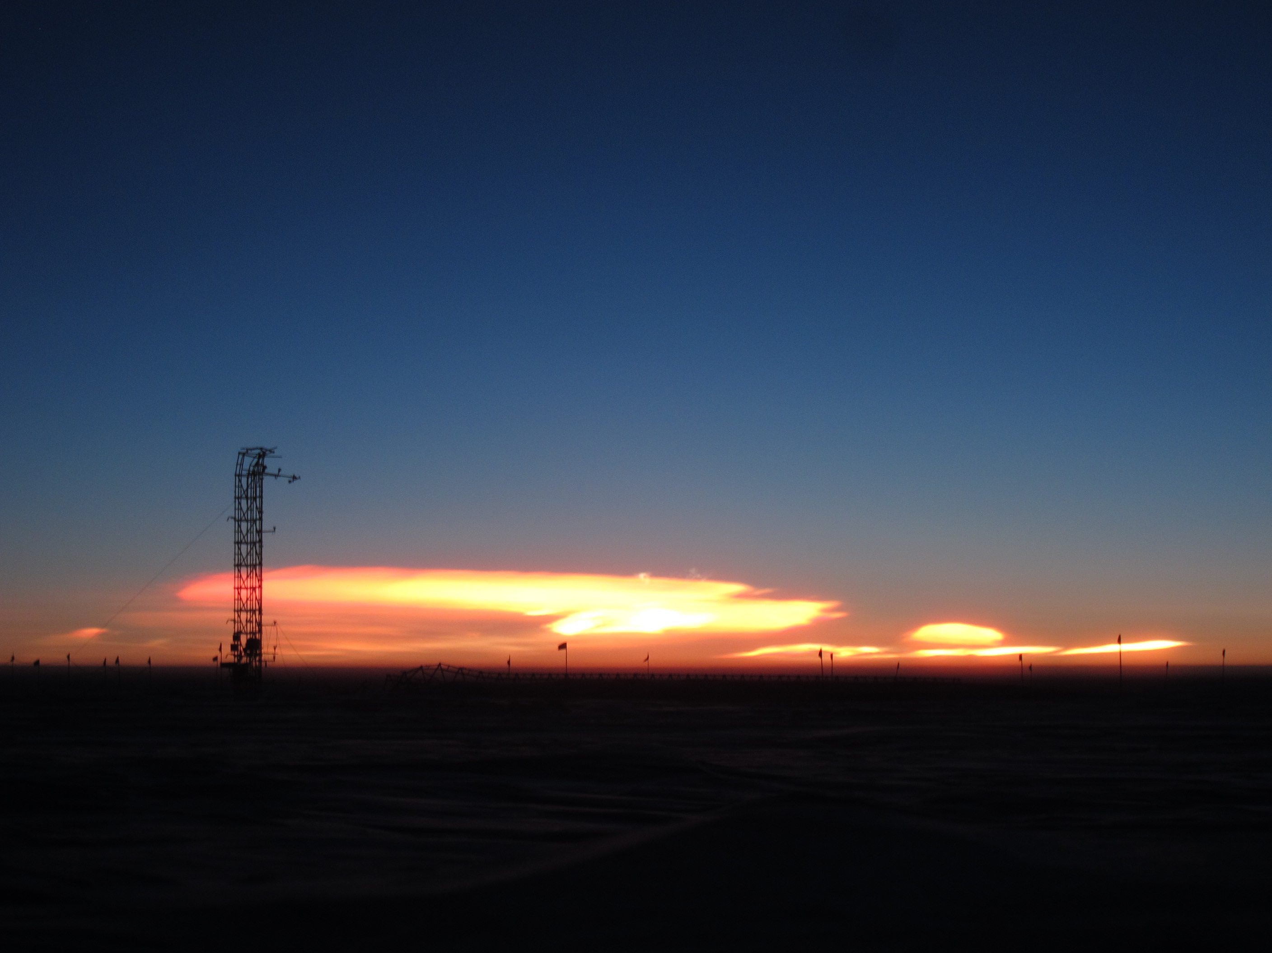

Viewed from MSF, polar stratospheric clouds (12/31) silhouette the damaged 50-Meter Tower. SWD.

General:

* None.

**Significant Weather Observations:**

* 12/26: Broken stratus, freezing fog, drifting snow, -45C, 11 kts.
* 12/27: Blowing snow, -33C, 32 kts. Winds exceeded 50 kts during ~21:00 – 21:30z.
* 12/28: Scattered altostratus, drifting snow, freezing fog, -41C, 16 kts.
* 12/29: Broken stratus, blowing snow, -41C, 25 kts.
* 12/30: Broken stratus, blowing snow, -37C, 20 kts.
* 12/31: Few polar stratospheric clouds to SE from approximately 10:45z – 16:00z, -51C. 8 kts.
* 1/1: Overcast stratus, -26C, 16 kts.

**ICECAPS Data Management:**

* 12/26: Data transfer complete at 17:52z.
* 12/27: Data transfer complete at 12:08z.
* 12/28: Data transfer complete at 11:41z.
* 12/29: Data transfer complete at 11:18z.
* 12/30: Data transfer complete at 11:25z.
* 12/31: Data transfer complete at 12:32z.
* 1/1: Data transfer complete at 12:01z.

**MWR:**

* Operating normally.

**SODAR:**

* Operating normally.
* 12/28: Transmitter and receiver dishes cleared of snow 14:37-14:46z.

**POSS:**

* Operating normally.

**MMCR:**

* Operating normally.
* Pitch 0.22, roll -0.25 as of 1/2.

**CAPABL:**

* Operating normally.

**MPL:**

* Operating normally.
* 12/28: Afterpulse calibration performed 17:38-17:57z.

**VCEIL:**

* Operating normally.

**Hotplate:**

* Offsite for repairs since 6/9/2016.

**IceCAM:**

* Operating normally.

**PAERI:**

* Operating normally.
* 12/27: Scene mirror cleaned at 13:30z and again at 14:47z due to SW/LW Responsivity flags. Strong blowing snow today.
* 12/28: Scene mirror cleaned at 14:27z.

**TSI:**

* Stored in MSF for winter.

**IcePIC:**

* 12/30: Slides placed for collection 13:45 – 13:57z. Particles photographed include isolated bullets, bullet rosettes, hexagonal plates, needles, hollow columns, and irregulars.

**Radiosonde:**

* Twice daily soundings.
* 12/28: Sounding not attempted at 0z due to high winds.

**MASC:**

* Offsite for repairs since 5/3/2016.