**ICECAPS Weekly Report**

December 04 – December 10, 2017

Hannah James

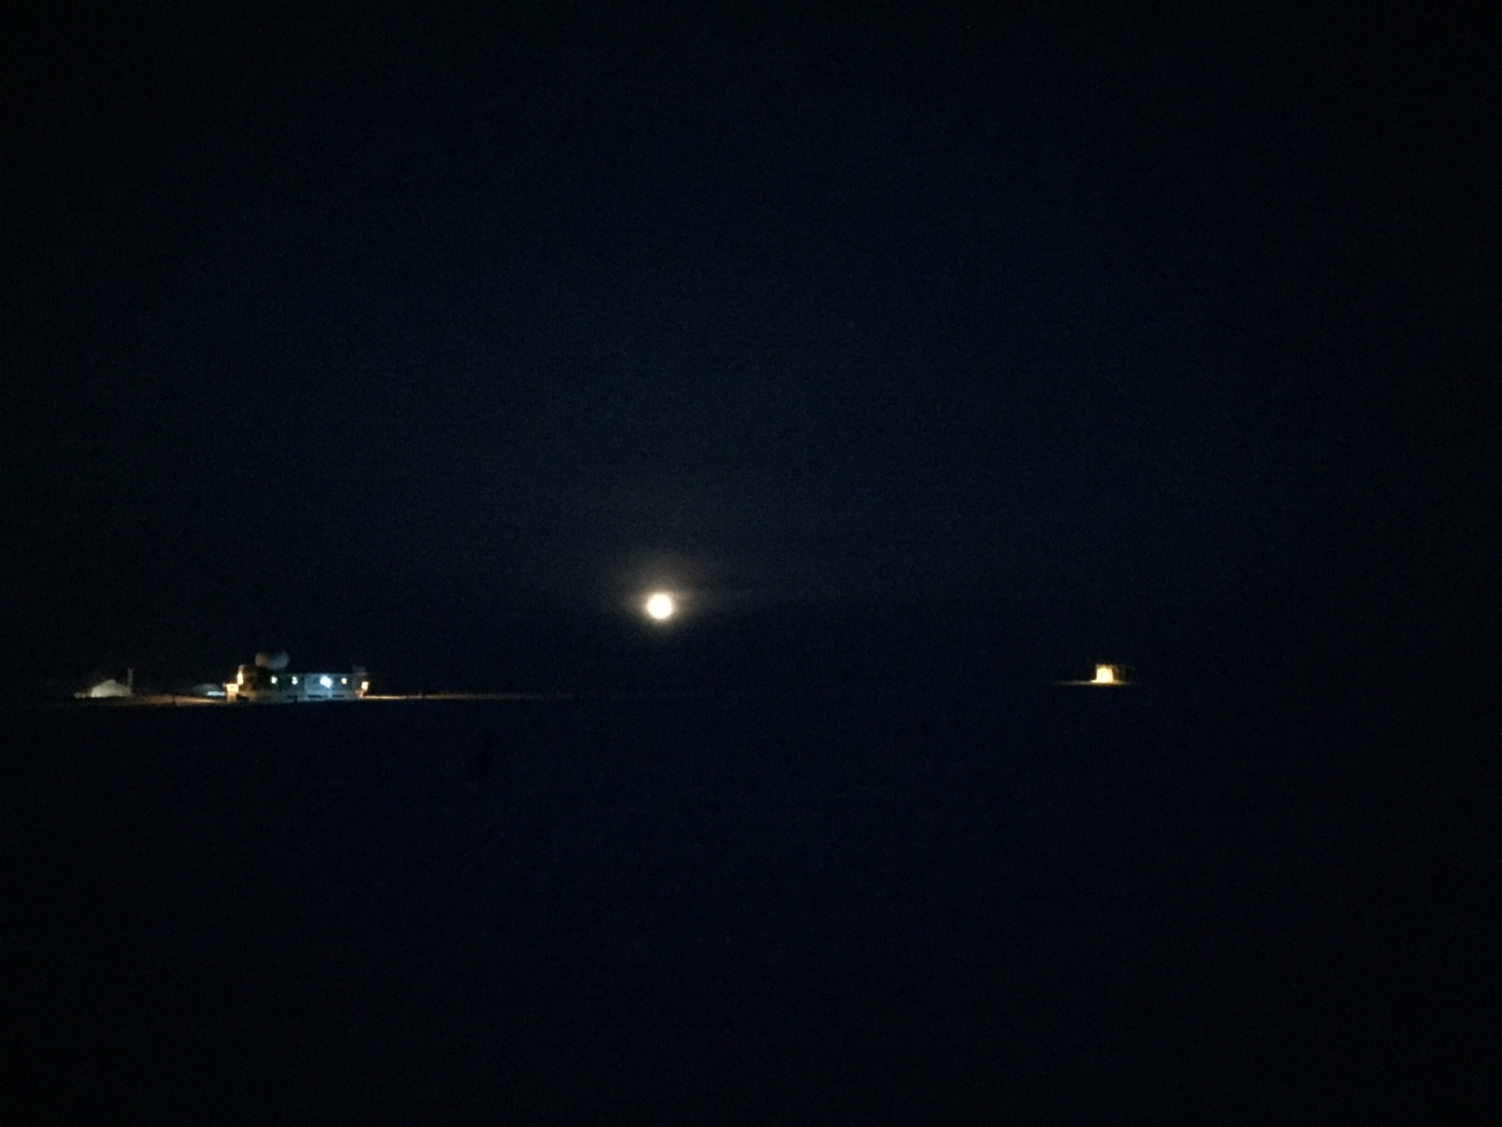A nearly-full moon looks over main station. -HJ

**General:**

* None to report

**Significant Weather Observations:**

* 12-04: Bkn altostratus, bkn cirrostratus. -49C, 9 kts. Br.
* 12-05: Few cirrostratus. -45C, 4 kts. Br.
* 12-06: Sct altostratus, sct cirrostratus. -47C, 11 kts. Vcfzfg. 11:00Z- 22 degree moon halo, parhelia.
* 12-07: Sct cirrostratus, bkn cirrus. -44C, 9 kts. Ic. 11:00Z- 22 degree moon halo.
* 12-08: Bkn stratus. -33C, 12 kts. –Sn, drsn.
* 12-09: Ovc stratus. -23C, 14 kts. –Sn, br, drsn.
* 12-10: Bkn stratus. -22C, 9 kts. –Sn, vcfzfg, drsn.

**ICECAPS Data Management:**

* 12-04: Data transfer complete 11:25Z.
* 12-05: Data transfer complete 11:31Z.
* 12-06: Data transfer complete 10:58Z.
* 12-07: Data transfer complete 11:22Z.
* 12-08: Data transfer complete 11:25Z.
* 12-09: Data transfer complete 12:35Z.
* 12-10: Data transfer complete 10:56Z.

**MWR:**

* As of 10-28, 150-90 operating in V11_SCAN_HF.MBF. HATPRO remains on and heated until weather conditions allow it to come off the MSF roof.

**SODAR:**

* Operating normally.
* 12-07: 13:15-13:35Z: SODAR off while cleaning dishes.

**POSS:**

* Operating normally in old software.
* Working with Peter at EC to run new software. POSS offline from time to time while troubleshooting.

**MMCR:**

* Operating normally.

**CAPABL:**

* Operating normally.
* 12-08: 13:49-15:00Z: Shut down laser for cable work on roof near laser output.

**MPL:**

* Operating normally.

**VCEIL:**

* Operating normally.

**Hotplate:**

* Offline.
* 12-08: Pulled Hotplate cable inside for testing. Line 8 has a short. Cable will be replaced and rerouted.

**IceCAM:**

* Operating normally.

**PAERI:**

* Operating normally.

**TSI:**

* In the MSF for winter storage.

**IcePIC:**

* 12-08: Slides placed for collection 13:20-13:24Z. Particles photographed include bullet rosettes, needles, hexagonal plates, hollow columns, solid columns, and radiating plates, and 2 trigonal ice crystals.

**Radiosonde:**

* Twice daily soundings, with the following exceptions:
* 12-08: RH failure when placed outside. No evening launch (12-09 0Z balloon).
* 12-10: RH failure when placed outside. No morning launch (12-10 12Z balloon).

**MASC:**

* Operating normally.