# ICECAPS Weekly Report

February 13 – 19, 2017

Sam Dorsi and Hannah James

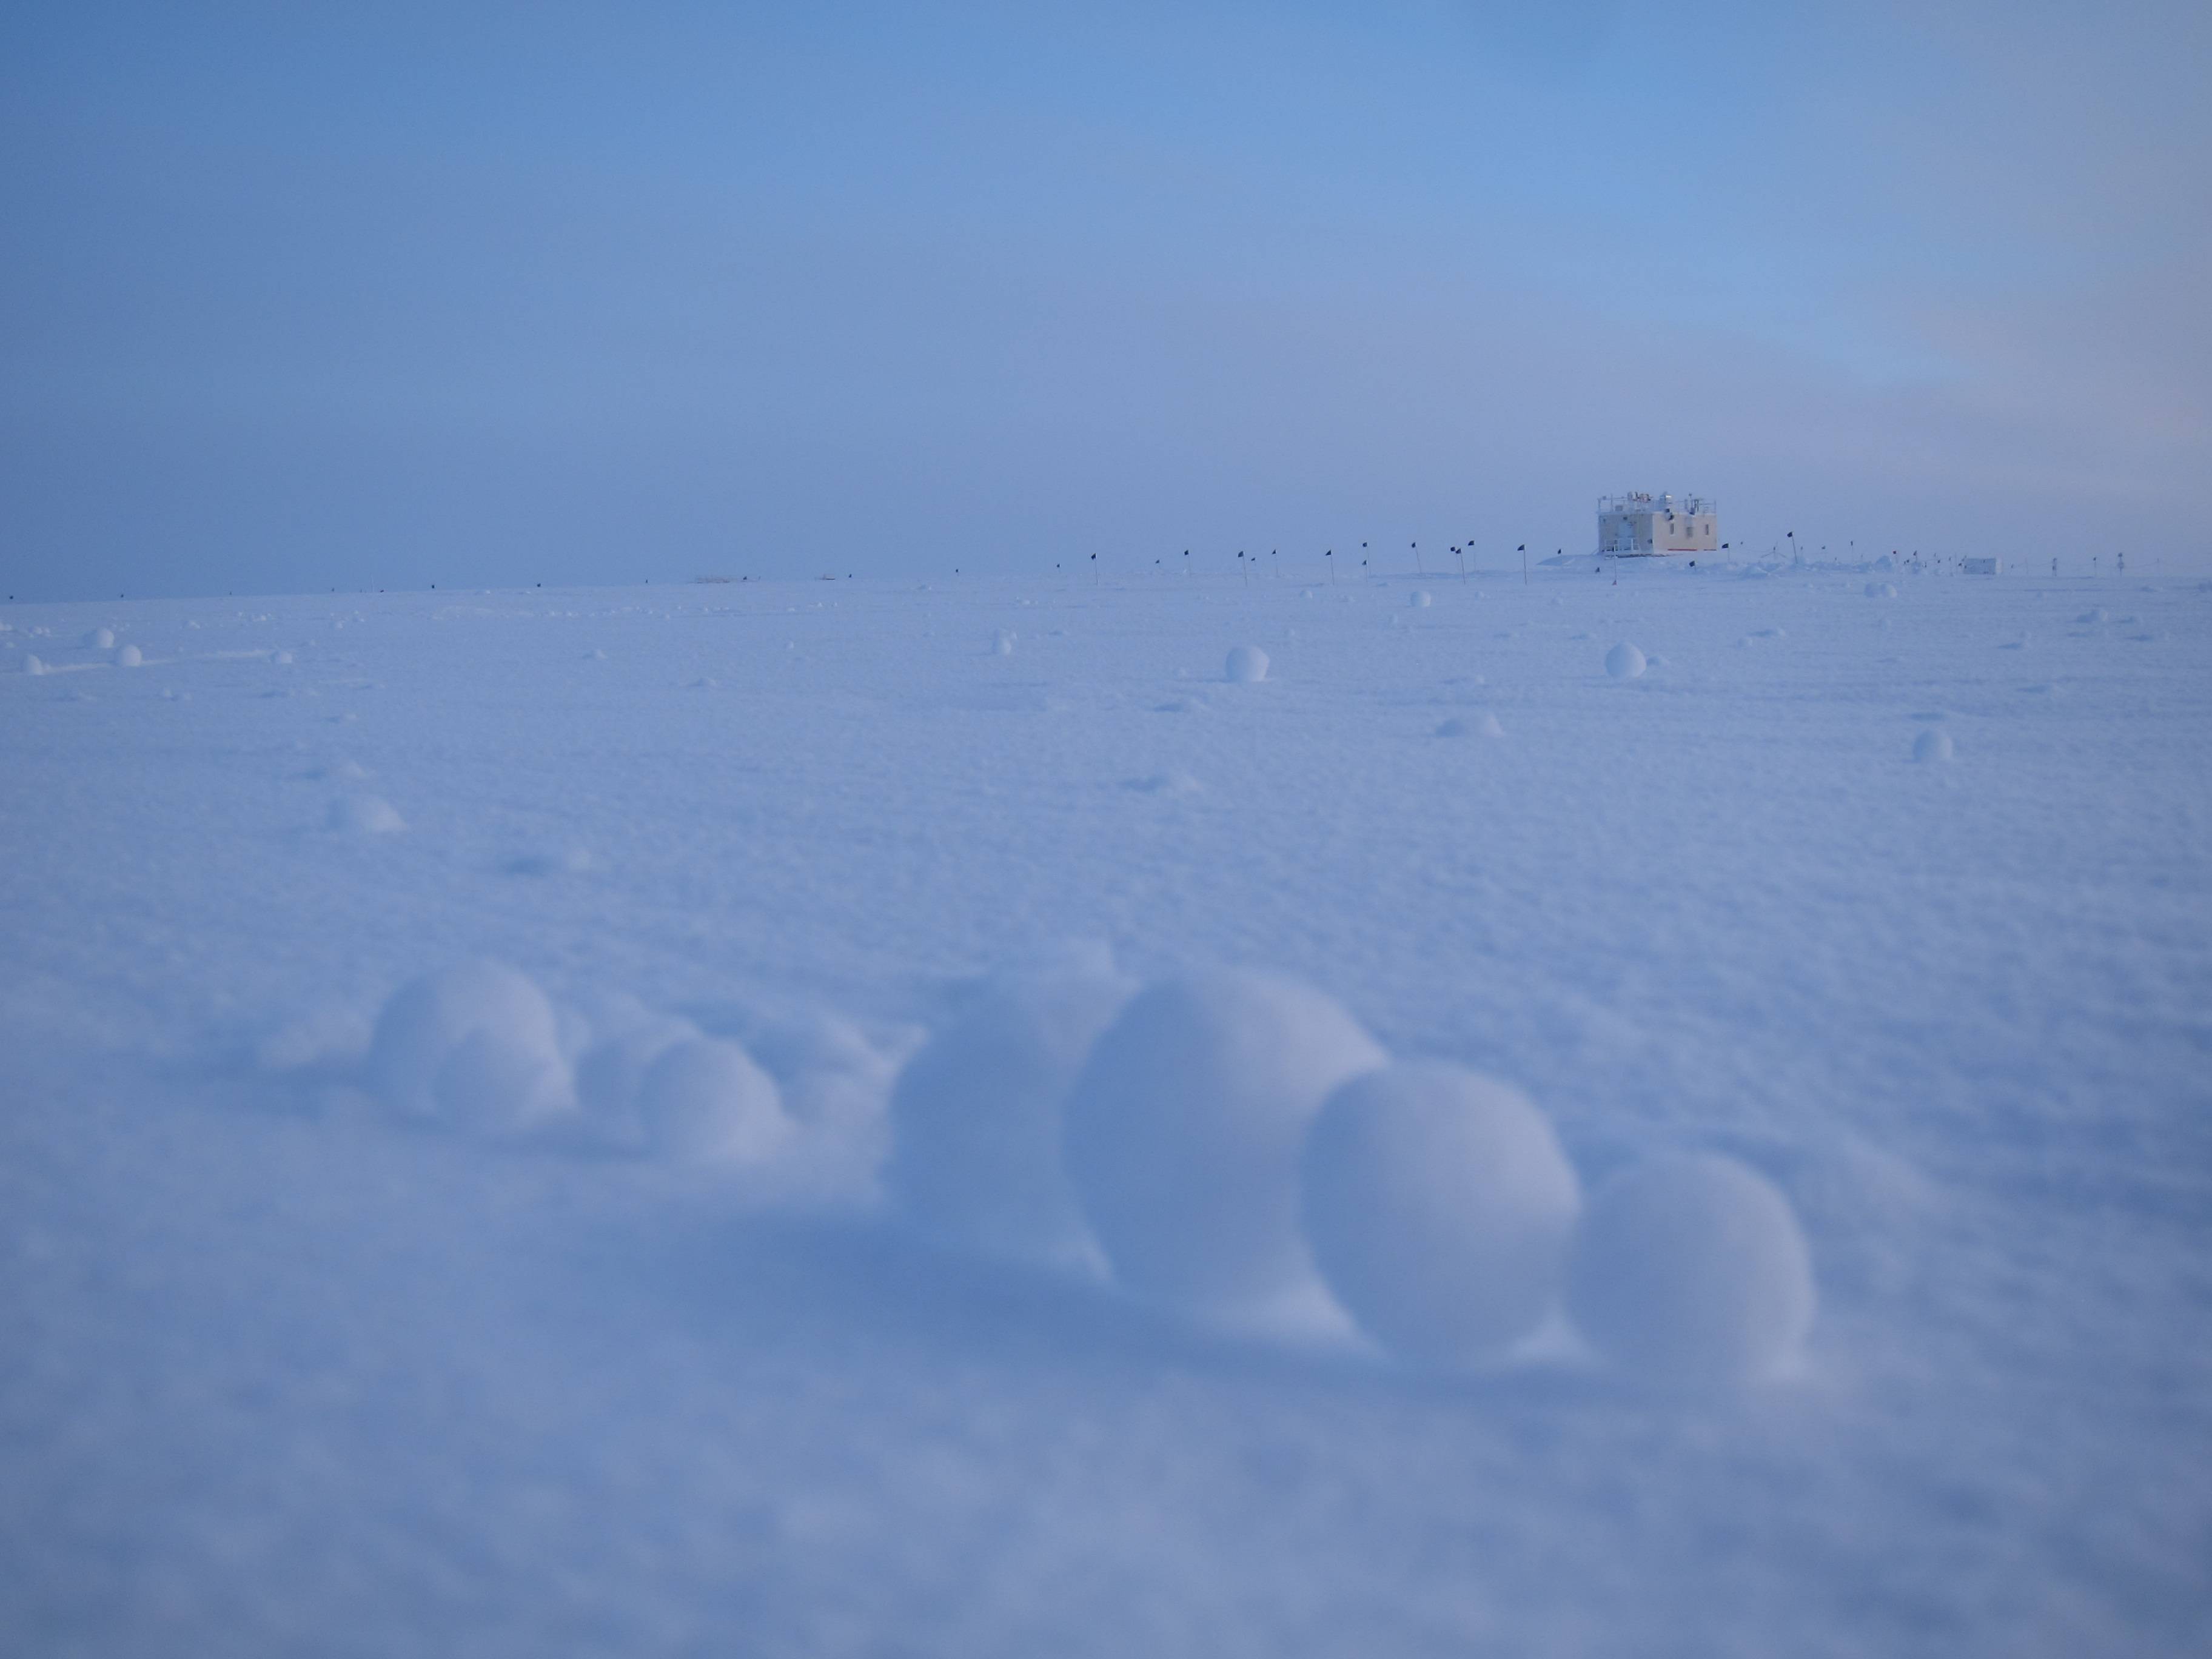

Clusters of yukimarimo gather on the outskirts of camp (2/16). SWD.

**General:**

* 2/16: The spring crew, and incoming ICECAPS tech Hannah James, arrive on station.

**Significant Weather Observations:**

* 2/13: Few stratus, scattered altostratus, drifting snow, -37C, 18 kts.
* 2/14: Overcast stratus, blowing snow, -28C, 18 kts.
* 2/15: Scattered stratus, -40C, 13 kts.
* 2/16: Few stratus, -50C, 12 kts. Yukimarimo of 1-3 cm were noticed at ~23:30z. Away from station, the concentration was approximately 2 spheres/m2. The snow surface was characterized by a fine popcorn-like roughened texture.
* 2/17: Scattered stratus, -42C, 10 kts.
* 2/18: Few stratus, -46C, 12 kts.
* 2/19: Clear, -47C, 9 kts.

**ICECAPS Data Management:**

* 2/13: Data transfer complete at 11:17z.
* 2/14: Data transfer complete at 13:44z.
* 2/15: Data transfer complete at 12:39z.
* 2/16: Data transfer complete at 12:09z.
* 2/17: Data transfer complete at 14:38z.
* 2/18: Data transfer complete at 14:04z.
* 2/19: Data transfer complete at 12:03z.

**MWR:**

* Operating normally.

**SODAR:**

* Operating normally.
* 2/14: The SODAR ceased receiving data at 14:23z.
* 2/15: The previous afternoon’s outage was discovered at 13:25z. The timing of failure is coincident with electrical issues experienced on the hairdryer used to defrost the ceilometer. On consultation with NOAA engineer Scott Abbott, a failed AC fuse was found in the SODAR Interface unit. The 2 A fuse (5 mm x 20 mm) was replaced with a 3.15 A fuse from the SOB (current ratings up to 5 A were reported by Abbott as acceptable in this device). Normal operations resumed at 23:32z.
* 2/15: Cleaned snow out of transmitter and receiver dishes 13:45-13:53z.

**POSS:**

* Operating normally.

**MMCR:**

* Operating normally.
* Pitch -0.01, roll -0.11 as of 2/13.
* 2/19: Desiccant cartridges were changed at 17:52z.

**CAPABL:**

* Operating normally.
* 2/13: Opened Laser 1 head, inspected for presence of water, and removed flash lamp. A small amount of water (~1 mL) was released at the time of removal; this water ran down the flash lamp body and was not caught in the laser head.
* 2/14: Opened and inspected Laser 1 head for moisture; found none. Switched to Laser 1 for primary operations at 17:04z.

**MPL:**

* Operating normally.

**VCEIL:**

* Operating normally.
* 2/13: Ice on the ceilometer window has been greatly reduced in the last 24 hours, as a drainage channel has allowed the melt water to move away from the window. A hairdryer was used to melt ice on the window, but outdoor temperatures were too cold for this to be effective.
* 2/14: With temperatures having warmed to -30°C, the hairdryer was used successfully to clear the window, while additional ice around the periphery was mechanically removed. The ceilometer resumed normal operation at 14:25z.

**Hotplate:**

* Offsite for repairs since 6/9/2016.

**IceCAM:**

* Operating normally.

**PAERI:**

* Operating normally.

**TSI:**

* Stored in MSF for winter.

**IcePIC:**

* 2/13: Slides placed for collection 14:42 – 15:03z. Particles photographed include needles, solid columns, hollow columns, hexagonal plates, trigonal ice.
* 2/13: IcePIC equipment moved inside to defrost. Objective lens cleaned.

**Radiosonde:**

* Twice daily soundings.

**MASC:**

* Offsite for repairs since 5/3/2016.