# ICECAPS Weekly Report

February 20 – 26, 2017

Sam Dorsi and Hannah James

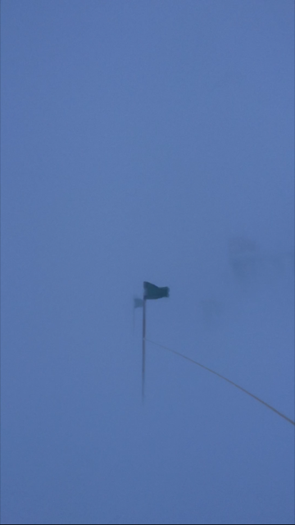

Low visibility all week limited photo opportunities. -HJ

**General:**

A planned emergency generator swap caused two brief power outages on 21 February between 17:02-17:04Z and 17:15-17:17Z. High winds on station limited travel around station throughout the week. The ventilation system in the MSF was found packed with snow on 26 Feb 2017, and caused some high humidity and condensation issues on the interior of the lidar windows. Windows were thawed and clear of frost by the next morning.

**Significant Weather Observations:**

* 02-20: Broken stratocumulus, -34C, 6 kts.
* 02-21: Few stratus, -54C, 12 kts.
* 02-22: Blsn, -48C, 19 kts.
* 02-23: Bkn altocumulus. Blsn, -40C, 24 kts.
* 02-24: Blsn, -37C, 28 kts.
* 02-25: Blsn, -30C, 45 kts. No clouds visible.
* 02-26: Blsn, -30, 24 kts. No clouds visible.

**ICECAPS Data Management:**

* 02-20: Data transfer complete at 12:46z.
* 02-21: Data transfer complete at 13:09z.
* 02-22: Data transfer complete at 15:39z.
* 02-23: Data transfer complete at 11:56z.
* 02-24: Data transfer complete at 12:58z.
* 02-25: Data transfer complete at 12:59z.
* 02-26: Data transfer complete at 12:46z.

**MWR:**

* Operating normally.
* 02-26: Communication error found, computer clock 23 hours off. Software reboot 15:13-15:19Z, normal data collection resumed.

**SODAR:**

* Operating normally.
* 02-26: Signal suggests that SODAR is packed with snow. When winds die down, dishes will be cleaned out.

**POSS:**

* Operating normally.

**MMCR:**

* Operating normally.
* Pitch -0.01, roll -0.11 as of 02-13.

**CAPABL:**

* Operating normally.
* 02-23: CAPABL laser 1 found not firing. Contacted Neely and Robert, restarted, but no beam was firing from the output. Laser head 1cover was opened, and water was found both on the cover and at the top of the laser head. Laser head 1 was left open to dry, and data collection resumed with Laser head 2. CAPABL will continue to run on Laser 2, with the exception of flash lamp changes, until Laser 1 is repaired offsite, then returned to Summit this summer.
* 02-26: Interior window iced up, data collection stopped 14:16-15:30Z. Replaced Laser head 1 cover.

**MPL:**

* Operating normally.
* 02-26: Ice found on interior of window. Shutdown laser at 15:56Z, placed additional fan at the base of the lidar to thaw window. Operation was resumed 02-27 12:35Z.

**VCEIL:**

* Operating normally.
* 02-20: Ceilometer computer discovered unresponsive. Logged out of user account, logged back in, and restarted data collection. This appears to have resolved the issue. Data files from the previous 24 hours are present and of normal size.
* 02-26: Ceilometer packed full of snow and ice. “Window contaminated” status reported. Removed as much as possible by hand, will remove more when winds die down.

**Hotplate:**

* Offsite for repairs since 2016-6-9.

**IceCAM:**

* Operating normally.

**PAERI:**

* Operating normally.

**TSI:**

* Stored in MSF for winter.

**IcePIC:**

* Due to high winds, no images were captured this week.

**Radiosonde:**

* Twice daily soundings.
* 02-20: Sounding at 0Z exhibited humidity check failure with readings great than 105%. No sounding launched.
* 02-20: MW41 software updated to version 2.5. By necessity the MRP111 embedded computer in the SPS311 was also updated.
* 02-25: Due to high winds, no balloons were launched
* 02-26: Due to high winds and high drifting at the SOB, no morning balloon was launched. Evening balloon failed due to high winds.

**MASC:**

* Offsite for repairs since 2016-05-03.