# ICECAPS Weekly Report

February 27 – March 5, 2017

Hannah James

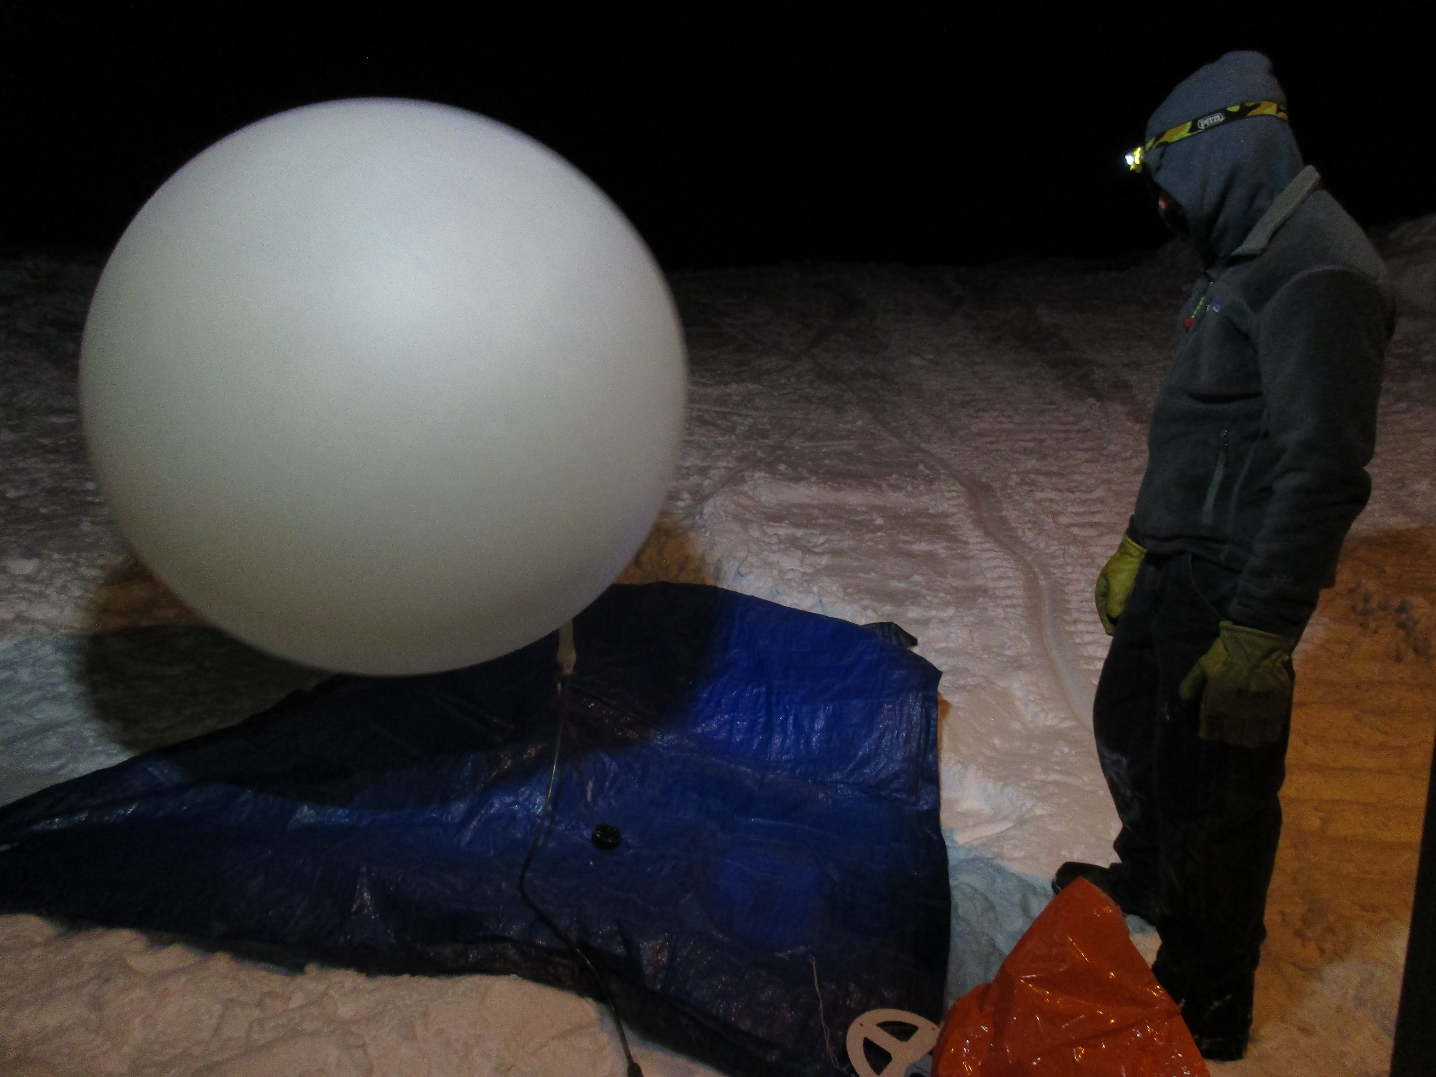

Radiosonde balloons were inflated outside for the majority of the week due to the SOB grarage door failure. -HJ

**General:**

After five days of weather delays, the winter crew departed station on Tuesday afternoon.

**Significant Weather Observations:**

* 02-27: Blsn, -25C, 30 kts.
* 02-28: Drsn, Ovc stratus. -23C, 15 kts.
* 03-01: Few cirrus. -33C, 15 kts.
* 03-02: Fzfg, IC. -29C, 17 kts. 11:00-1700Z: halo
* 03-03: Drsn, Br, IC. -37C, 14 kts. 11:00-15:00Z: halo
* 03-04: Br. -43C, 8 kts.
* 03-05: Br on the horizon. Sct cirrocumulus, sct cirrus. -39C, 10 kts.

**ICECAPS Data Management:**

* 02-27: Data transfer complete 17:24Z.
* 02-28: Data transfer complete 12:16Z.
* 03-01: Data transfer complete 11:28Z.
* 03-02: Data transfer complete 10:52Z.
* 03-03: Data transfer complete 10:42Z.
* 03-04: Data transfer complete 14:17Z.
* 03-05: Data transfer complete 11:22Z.

**MWR:**

* Operating normally.

**SODAR:**

* Operating normally.
* 02-27: Signal suggests that SODAR is packed with snow. When winds die down, dishes will be cleaned out.
* 02-28: Cleaned out SODAR dish 13:40-13:59Z. Layer of hard packed snow remains accumulated in the transceiver dish.

**POSS:**

* Operating normally.

**MMCR:**

* Operating normally.
* Pitch 0.00, roll -0.11 as of 03-05.
* 03-05: NetCDF_Mom and NetCDF_Spec errors appeared on hourly logs starting at 0300Z. Rebooted radar starting at 16:51Z, radar back online at 17:38Z.

**CAPABL:**

* Operating normally.

**MPL:**

* Operating normally.
* 02-27: After interior window defrost, operation was resumed at 12:35Z.
* 02-28: Monthly afterpulse calibration performed 19:28- 19:44Z. 30m, 30sec results: Copol BkdAvg- 0.000285, Copol BkdStd: 0.000200. 15m, 30sec results: Copol BkdAvg- 0.000257, Copol BkdStd: 0.000260.
* 03-01: Discovered that I forgot to check “Save data” after yesterday’s afterpulse calibration. Data missing from 19:28Z on 02-28 through 12:41 03-01.

**VCEIL:**

* Operating normally.
* 02-27: Ceilometer packed full of snow and ice. “Window contaminated” status reported. Removed as much as possible by hand, will remove more when winds die down.
* 02-28: Ice remains on lens, but is slowly melting out. “Window contaminated” status reported.
* 03-01: Window contaminated message cleared from status, window still iced.
* 03-03: Bottom 10% of lens remains covered with ice.
* 03-04: Ceilometer clear of ice.

**Hotplate:**

* Offsite for repairs since 2016-6-9.

**IceCAM:**

* Operating normally.

**PAERI:**

* Operating normally.
* “Encoder scene confirm” flag has remained yellow since 2017-02-24. Von is aware of this and states that the data is not being compromised.

**TSI:**

* Stored in MSF for winter.

**IcePIC:**

* 03-03: Slides placed for collection 12:40-13:25Z. Particles photographed include needles, hexagonal plates, graupel, and irregulars.

**Radiosonde:**

* Twice daily soundings.
* 02-28: Due to garage door failure, balloons are being inflated outside until further notice.
* 03-03: Garage door fixed, balloons inflated inside.
* Ongoing troubleshooting dealing with *.mwx and *.spf files not being grabbed by Dataman.

**MASC:**

* Offsite for repairs since 2016-05-03.