# ICECAPS Weekly Report

February 6 – 12, 2017

Sam Dorsi

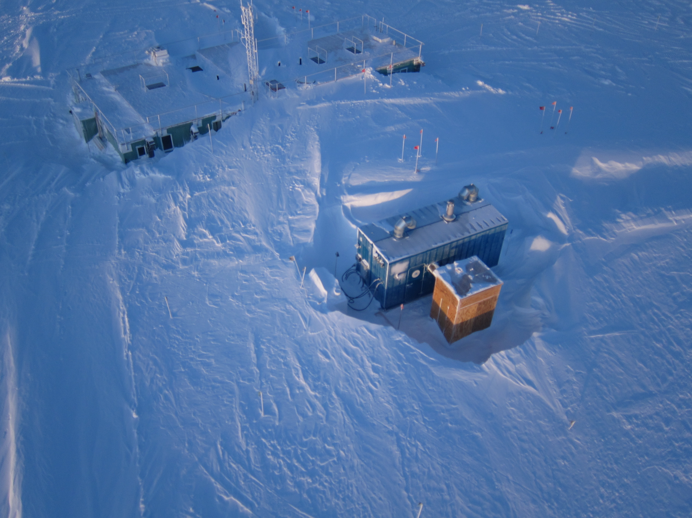

Snow drifts rise around the Green House and microturbine buildings. SWD.

**General:**

* None.

**Significant Weather Observations:**

* 2/6: Broken stratus, -32C, 10 kts.
* 2/7: Overcast stratus, blowing snow, -27C, 21 kts.
* 2/8: Blowing snow, -22C, 34 kts.
* 2/9: Blowing snow, -27C, 23 kts.
* 2/10: Blowing snow, -27C, 18 kts.
* 2/11: Blowing snow, -22C, 45 kts.
* 2/12: Overcast stratus, drifting snow, -22C, 16 kts.

**ICECAPS Data Management:**

* 2/6: Data transfer complete at 19:51z.
* 2/7: Data transfer complete at 20:24z.
* 2/8: Data transfer complete at 19:47z.
* 2/9: Data transfer complete at 16:43z.
* 2/10: Data transfer complete at 11:25z.
* 2/11: Data transfer complete at 11:54z.
* 2/12: Data transfer complete at 11:09z.

**MWR:**

* Operating normally.

**SODAR:**

* Operating normally.
* 2/9: Cleaned snow out of transmitter and receiver dishes 13:44-13:57z.
* 2/12: Cleaned snow out of transmitter and receiver dishes 12:43-12:53z.

**POSS:**

* Operating normally.

**MMCR:**

* Operating normally.
* Pitch -0.01, roll -0.11 as of 2/13.

**CAPABL:**

* Operating normally.
* 2/8: Disconnected water lines to Laser 1 at 12:55z.
* 2/9: In removing Laser 1 flash lamp (12:44z), discovered moisture in laser head. System will be left to dry, and a longer-term leak test performed.
* 2/10: Cleaned and reinstalled flash lamp, sealed laser head, and reconnected coolant lines. Powered on coolant pumps at 14:14z.
* 2/12: Opened Laser 1 head to inspect for presence of water; found none, resealed laser head (12:10z).

**MPL:**

* Operating normally.

**VCEIL:**

* Operating normally.
* 2/10: Status message contained note ‘window contaminated’. Window was brushed free of snow at 12:48z, which cleared the error. Hard ice remains covering a portion of the window.
* 2/11: Amid unusually high temperatures during wind event, standing water was found on window surface. This water was held in place by a thick rim of ice; where possible, ice was mechanically removed from window and water was allowed to drain ~22:30z.
* 2/12: Continued efforts to carefully remove ice from window 12:58z.

**Hotplate:**

* Offsite for repairs since 6/9/2016.

**IceCAM:**

* Operating normally.
* 2/9: The IceCAM mount broke during powerful winds overnight, leaving the camera unit dangling from the ethernet cable. Upon discovery, the camera was temporarily secured to prevent damage.
* 2/10: A new wooden mount was built for the IceCAM and installed on the roof. This should provide the same field of view and better resilience in the wind.
* 2/12: IceCAM lost network connection during wind event. Restored by moving from port 20 to port 16. I have a dark suspicion this is the start of the same degradation that was observed with the previous network switch.

**PAERI:**

* Operating normally.
* 2/11: Scene mirror cleaned ~22:15z.
* 2/12: PAERI shelter fan swapped (#3 out, #1 in) at 13:30 to 13:51z.

**TSI:**

* Stored in MSF for winter.

**IcePIC:**

* 2/6: Slides placed for collection 13:14-13:26z. Particles photographed include hollow columns, bullet rosettes, needles and irregulars.

**Radiosonde:**

* Twice daily soundings.
* 2/8: Radiosonde at 0z failed in high winds. Radiosonde at 12z not attempted due to unsafe high winds.
* 2/9: Radiosonde at 0z not attempted due to unsafe high winds.
* 2/11: Radiosonde at 12z failed in high winds.

**MASC:**

* Offsite for repairs since 5/3/2016.