# ICECAPS Weekly Report

January 16 – January 22, 2017

Sam Dorsi

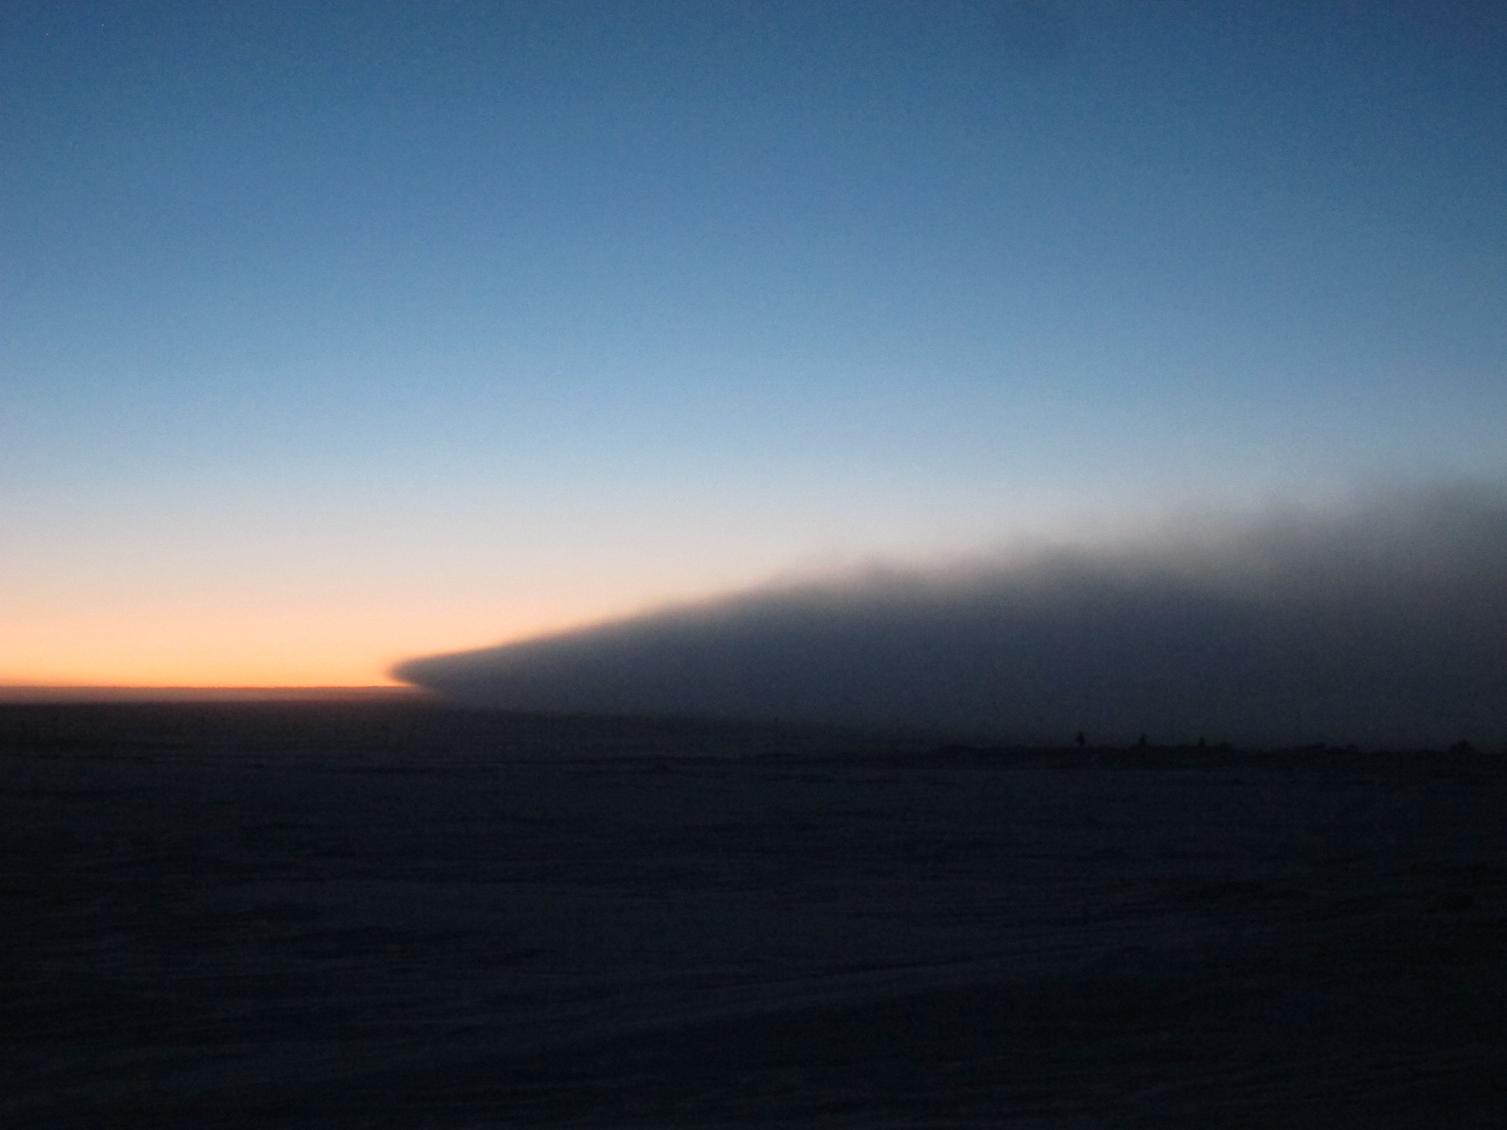

The generator exhaust plume moves along a stratum a meter above the surface. SWD.

**General:**

* 1/16: Power outage for generator swap at 13:01z.
* 1/20: Raised and repaired bamboo flags on precipitation suite cable run.

**Significant Weather Observations:**

* 1/16: Overcast stratus, blowing snow, -45C, 21 kts.
* 1/17: Broken stratus, -50C, 12 kts.
* 1/18: Few stratus, -55C, 16 kts.
* 1/19: Blowing snow, -35C, 27 kts.
* 1/20: Overcast stratus, -33C, 16 kts.
* 1/21: Broken stratus, blowing snow, -32C, 20 kts.
* 1/22: Broken stratus, drifting snow, -38C, 14 kts.

**ICECAPS Data Management:**

* 1/16: Data transfer complete at 12:15z.
* 1/17: Data transfer complete at 13:46z.
* 1/18: Data transfer complete at 14:08z.
* 1/19: Data transfer complete at 12:15z.
* 1/20: Data transfer complete at 11:27z.
* 1/21: Data transfer complete at 11:03z.
* 1/22: Data transfer complete at 12:36z.

**MWR:**

* Operating normally.

**SODAR:**

* Operating normally.
* 1/21: Cleaned snow out of transmitter and receiver dishes 13:44z to 13:54z.

**POSS:**

* Operating normally.

**MMCR:**

* Operating normally.
* Pitch 0.00, roll -0.05 as of 1/23.
* 1/18 – 1/21: Calibration table error appears in logs.
* 1/21: To address ‘Piraq Hardware’ error, the MMCR was rebooted from 12:20z to 14:01z.

**CAPABL:**

* Operating normally.
* 1/17: Laser 1 head was sealed at 12:55z and cooling water was run for one hour. Turned off Q-Switch then powered on laser, leaving it to run for another hour in ‘simmer’ mode. At the completion of this power-on test, the laser was powered off. The head was then reopened and examined for any traces of water. None were detected. Laser 1 was resealed and powered on: the laser successfully fired, and was left to operate for 24 hours as a trial. Aside from these tests, normal operations continue on Laser 2.

**MPL:**

* Operating normally.

**VCEIL:**

* Operating normally.

**Hotplate:**

* Offsite for repairs since 6/9/2016.

**IceCAM:**

* Operating normally.
* 1/22: Swapped port on network switch due to connectivity issue (12:25z).

**PAERI:**

* Operating normally.

**TSI:**

* Stored in MSF for winter.

**IcePIC:**

* 1/16: Slides placed for collection 14:35-14:56z. Particles photographed include needles and irregulars.

**Radiosonde:**

* Twice daily soundings.
* 1/19: Radiosondes at 0z and 12z failed amid high winds.

**MASC:**

* Offsite for repairs since 5/3/2016.