# ICECAPS Weekly Report

January 2 – January 8, 2017

Sam Dorsi

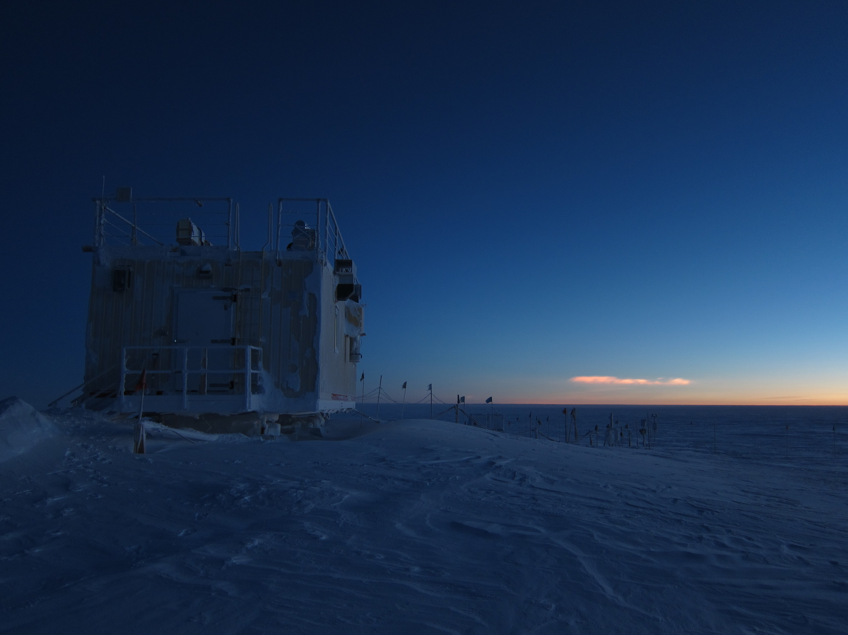

A cluster of polar stratospheric clouds glow in the eastern sky (1/3). SWD.

General:

* 1/5 – 1/6: Minor building weatherization: sealing gaps around windows and doorways.

**Significant Weather Observations:**

* 1/2: Overcast stratus, blowing snow, -32C, 25 kts.
* 1/3: Few polar stratospheric clouds to ESE (~10:30 to 14:30z), -52C, 3 kts.
* 1/4: Broken stratus, drifting snow, -27C, 16 kts.
* 1/5: Overcast stratus, blowing snow, -27C, 19 kts.
* 1/6: Broken stratus, blowing snow, -36C, 17 kts.
* 1/7: Overcast stratus, blowing snow, -31C, 20 kts.
* 1/8: Few stratus, -51C, 4 kts.

**ICECAPS Data Management:**

* 1/2: Data transfer complete at 11:52z.
* 1/3: Data transfer complete at 18:35z.
* 1/4: Data transfer complete at 10:30z.
* 1/5: Data transfer complete at 13:39z.
* 1/6: Data transfer complete at 15:33z.
* 1/7: Data transfer complete at 11:13z.
* 1/8: Data transfer complete at 10:15z.

**MWR:**

* Operating normally.

**SODAR:**

* Operating normally.
* 1/2: Transmitter and receiver dishes cleared of snow 14:23-14:31z.
* 1/6: Transmitter and receiver dishes cleared of snow 13:26-13:41z.

**POSS:**

* Operating normally.

**MMCR:**

* Operating normally.
* Pitch 0.22, roll -0.25 as of 1/2.
* 1/3: “Open File” error cleared 12:21z.
* 1/8: “Open File” error cleared 11:29z.

**CAPABL:**

* Operating normally.
* 1/3: Performed swap of Laser 1 flash lamp (12:55 – 17:10z). This swap has a diagnostic function, as we believe the earlier Laser 1 dropout was caused by either 1) a premature flash lamp failure or 2) a Q-Switch board failure. The lamp replacement did not appear to resolve the Laser 1 issue; this may indicate the need for a Q-Switch board replacement. Alignment of both automatic and manually adjusted mirrors was necessary after power-cycling the motors. During power-off, the USB power strip was replaced, as requested by Robert—this will help in avoiding motor controller power cycling.

**MPL:**

* Operating normally.

**VCEIL:**

* Operating normally.

**Hotplate:**

* Offsite for repairs since 6/9/2016.

**IceCAM:**

* Operating normally.
* 1/3: Captured a few grainy images of PSCs in the morning!

**PAERI:**

* Operating normally.

**TSI:**

* Stored in MSF for winter.

**IcePIC:**

* 1/2: Slides placed for collection 14:23 – 14:37z. Particles photographed include hexagonal plates, bullet rosettes, needles and irregulars.

**Radiosonde:**

* Twice daily soundings.
* 1/2: Sounding failed at 12z due to high winds.

**MASC:**

* Offsite for repairs since 5/3/2016.