# ICECAPS Weekly Report

January 23 – January 29, 2017

Sam Dorsi

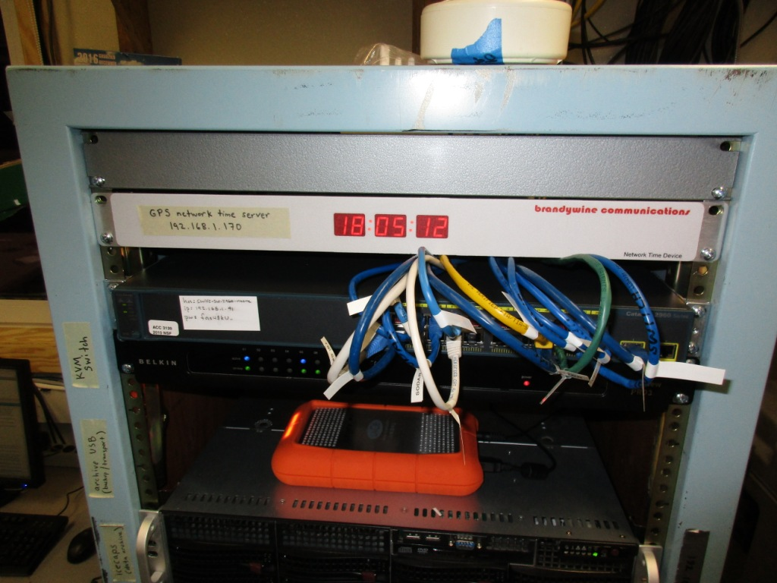

The newly installed MSF network switch is populated with individually labeled cables. SWD.

**General:**

* 1/24: The MSF network switch was swapped from 17:35 to 17:53z, resulting in an 18-minute outage. The previous unit had been steadily failing and the replacement was installed to avoid a less-controlled outage at a future date.

**Significant Weather Observations:**

* 1/23: Scattered stratocumulus, -36C, 14 kts.
* 1/24: Scattered stratus, -31C, 15 kts.
* 1/25: Scattered stratocumulus, -31C, 12 kts.
* 1/26: Few stratus, -52C, 9 kts.
* 1/27: Few stratus, -58C, 5 kts.
* 1/28: Few stratus, -50C, 12 kts.
* 1/29: Overcast stratus, -29C, 18 kts.

**ICECAPS Data Management:**

* 1/23: Data transfer complete at 11:14z.
* 1/24: Data transfer complete at 13:32z.
* 1/25: Data transfer complete at 13:39z.
* 1/26: Data transfer complete at 18:41z.
* 1/27: Data transfer complete at 10:42z.
* 1/28: Data transfer complete at 19:25z.
* 1/29: Data transfer complete at 20:37z.

**MWR:**

* Operating normally.

**SODAR:**

* Operating normally.
* 1/29: Cleaned snow out of transmitter and receiver dishes 12:16-12:29z.

**POSS:**

* Operating normally.

**MMCR:**

* Operating normally.
* Pitch 0.00, roll -0.05 as of 1/23.

**CAPABL:**

* Operating normally.
* 1/25: System was discovered displaying a startup error (‘disk boot failure’) identical to the event on 12/15. In coordination with Robert, the system was rebooted, but LabView repeatedly crashed upon running the instrument script (‘illegal memory access’). The full system was power-cycled, including the mirror controllers: this committed us to a realignment step. Initial alignment was sufficiently poor that standard signal-peaking alignment techniques were unsuccessful. Further alignment efforts failed and were called off due to the late hour.
* 1/26: Diagnostics continued with Robert. The projected beam shape on window was inspected and found slightly truncated along one edge, suggesting an issue with first-stage mirror alignment. Wider-ranging manual alignment attempts of first stage mirror were performed; this successfully restored the full signal, with the upper-right knob on kinematic mount requiring 1.7 rotations! System resumed normal operation.

**MPL:**

* Operating normally.
* 1/30: Monthly afterpulse calibration performed 16:35 – 16:56z.

**VCEIL:**

* Operating normally.

**Hotplate:**

* Offsite for repairs since 6/9/2016.

**IceCAM:**

* Operating normally.

**PAERI:**

* Operating normally.

**TSI:**

* Stored in MSF for winter.

**IcePIC:**

* 1/27: Slides placed for collection 13:23-13:57z. Particles photographed include isolated bullets, bullet rosettes and radiating plates. Slides were frosted while carrying the -50C slides to the IcePic shed in my liner-gloved hands, but particles are still fully discernible.

**Radiosonde:**

* Twice daily soundings.

**MASC:**

* Offsite for repairs since 5/3/2016.