# ICECAPS Weekly Report

January 30 – February 5, 2017

Sam Dorsi

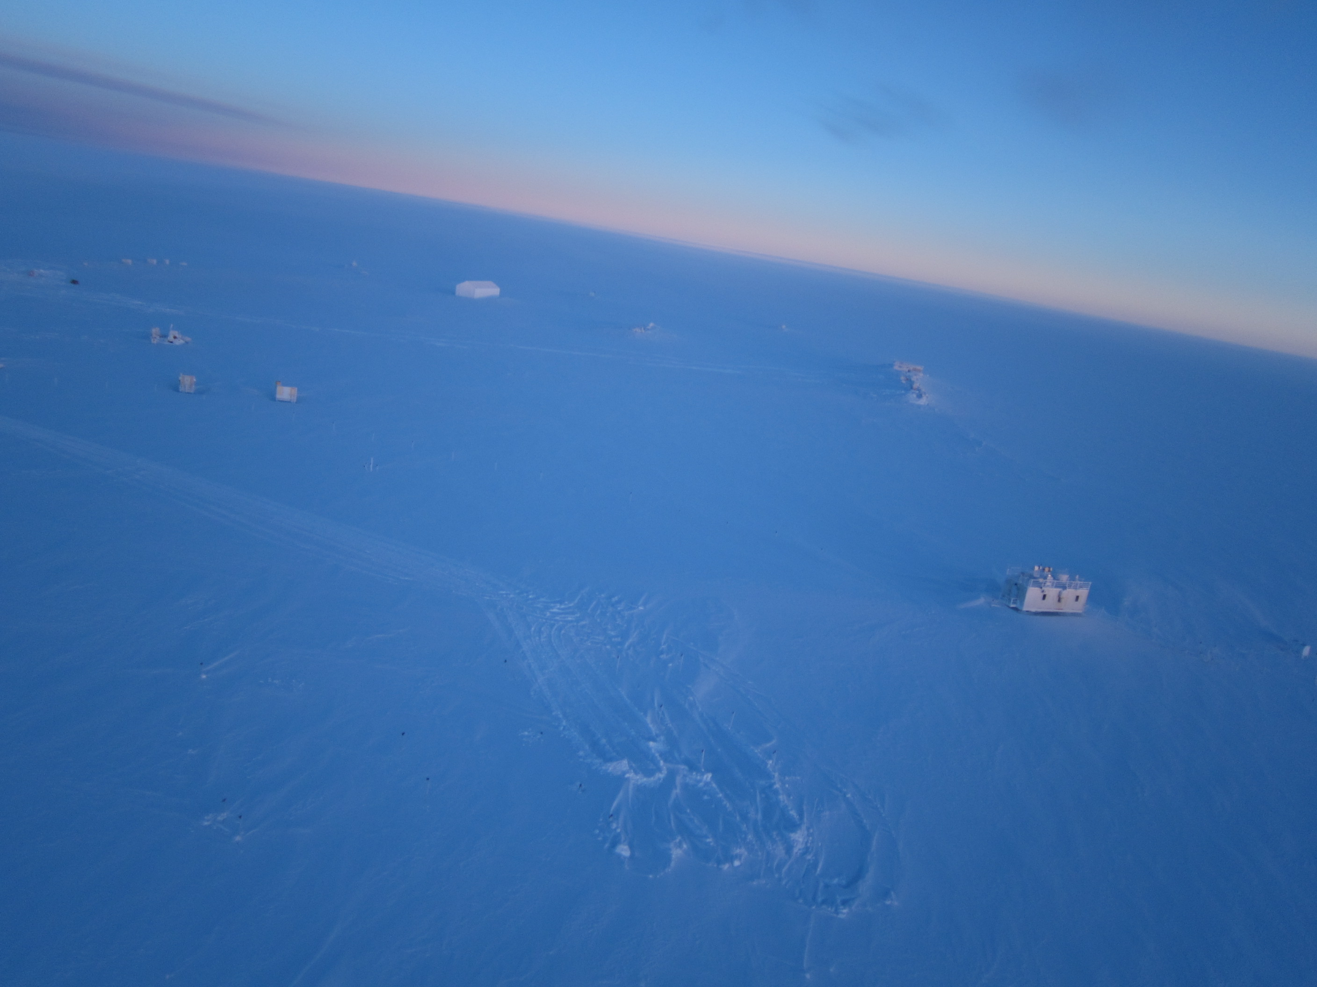

A kite-borne camera offers an aerial perspective on the MSF and outlying facilities. SWD.

**General:**

* None.

**Significant Weather Observations:**

* 1/30: Overcast stratus, -31C, 9 kts.
* 1/31: Scattered stratus, -35C, 10 kts.
* 2/1: Few stratus, -40C, 7 kts.
* 2/2: Scattered stratus, -40C, 12 kts.
* 2/3: Scattered stratus, -37C, 4 kts.
* 2/4: Broken altostratus, -31C, 19 kts.
* 2/5: Few altostratus, -38C, 9 kts.

**ICECAPS Data Management:**

* 1/30: Data transfer complete at 20:10z.
* 1/31: Data transfer complete at 21:39z.
* 2/1: Data transfer complete at 21:34z.
* 2/2: Data transfer complete at 18:17z.
* 2/3: Data transfer complete at 19:21z.
* 2/4: Data transfer complete at 19:29z.
* 2/5: Data transfer complete at 19:40z.

**MWR:**

* Operating normally.

**SODAR:**

* Operating normally.
* 2/4: Cleaned snow out of transmitter and receiver dishes 14:22-14:28z.

**POSS:**

* Operating normally.

**MMCR:**

* Operating normally.
* Pitch -0.09, roll -0.10 as of 2/5.

**CAPABL:**

* Operating normally.

**MPL:**

* Operating normally.
* 1/30: Monthly afterpulse calibration performed 16:35 – 16:56z.

**VCEIL:**

* Operating normally.

**Hotplate:**

* Offsite for repairs since 6/9/2016.

**IceCAM:**

* Operating normally.

**PAERI:**

* Operating normally.
* 1/31: Removed shelter fan housing, replaced fan with a used/rebuilt fan, and reinstalled (19:45z). Rebuilt the newly removed fan for future swap.

**TSI:**

* Stored in MSF for winter.

**IcePIC:**

* 2/2: Slides placed for collection 12:45-13:03z. Particles photographed include solid columns, isolated bullets, radiating plates, irregulars and rimed particles.

**Radiosonde:**

* Twice daily soundings.

**MASC:**

* Offsite for repairs since 5/3/2016.