# ICECAPS Weekly Report

January 9 – January 15, 2017

Sam Dorsi

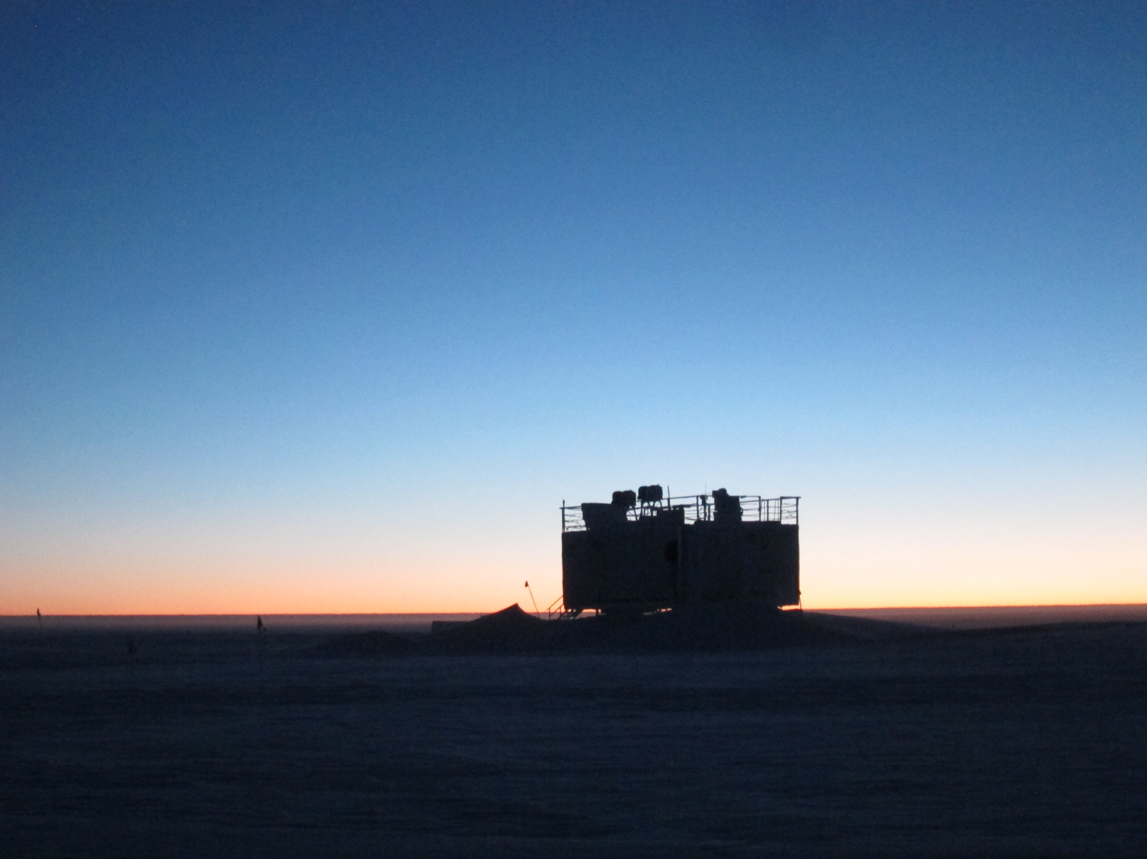

With the sun returning, the sky grows ever brighter behind the MSF. SWD.

**General:**

* 1/9: Unplanned power outage from 23:07z to 23:08z.
* 1/10: Planned outages for generator swap from 12:09z to 12:10z, and again from 19:16z to 19:17z.
* 1/11-12: Network outage occurred ~22:00z to ~13:00z.
* 1/13: Planned outages from 12:47z to 12:48z, and from 14:43z to 14:45z.
* 1/13: MSF structure was re-leveled 17:15z – 18:00z. Pitch was changed from 0.33° to 0.01°, and roll changed from -0.27° to 0.00° (MMCR 1-hour averages).

**Significant Weather Observations:**

* 1/9: Clear, -50C, 14 kts.
* 1/10: Few stratus, -47C, 6 kts.
* 1/11: Scattered stratus, -52C, 6 kts.
* 1/12: Few stratus, -50C, 12 kts.
* 1/13: Broken stratus, -40C, 14 kts.
* 1/14: Scattered altostratus, -42C, 15 kts.
* 1/15: Blowing snow, -23C, 29 kts.

**ICECAPS Data Management:**

* 1/9: Data transfer complete at 12:23z.
* 1/10: Data transfer complete at 11:43z.
* 1/11: Data transfer complete at 11:28z.
* 1/12: Data transfer complete at 23:43z. Transfer was manually restarted after partial completion due to outage.
* 1/13: Data transfer complete at 15:57z.
* 1/14: Data transfer complete at 12:42z.
* 1/15: Data transfer complete at 11:37z.

**MWR:**

* Operating normally.

**SODAR:**

* Operating normally.

**POSS:**

* Operating normally.

**MMCR:**

* Operating normally.
* Pitch 0.33, roll -0.25 as of 1/9.
* Pitch 0.00, roll 0.00 as of 1/13.

**CAPABL:**

* Operating normally.
* 1/10: Laser 1 was fully powered down and its head unit was opened and inspected at 17:45z. Inspection revealed condensed water on many interior surfaces. An attempt was made to identify leaks by operating the cooling water pump with the head open; however, no leaks were apparent. Head was left open to dry.
* 1/11: Confirmed visually that Laser 1 head was dry, then powered water pump and examined for leaks inside laser head over the course of 2 hours. No leaks were detected.
* 1/12: Instrument was discovered in an error state (19:30z), with the .vi block diagram shown instead of the real-time display. Laser 2 was firing as normal, but the Licel was not triggering and the shot counter was not incrementing. LabView was shutdown, the Licel power-cycled, and the vi reopened. The system resumed normal operations at 22:23z.

**MPL:**

* Operating normally.

**VCEIL:**

* Operating normally.

**Hotplate:**

* Offsite for repairs since 6/9/2016.

**IceCAM:**

* Operating normally.

**PAERI:**

* Operating normally.
* 1/12: Throughout the day, PAERI exhibit cold-related status flags.

**TSI:**

* Stored in MSF for winter.

**IcePIC:**

* 1/13: Slides placed for collection 13:10 to 13:26z. Particles photographed include columns, hexagonal plates, bullet rosettes and needles, possible triangular ice, possible rimed particles.

**Radiosonde:**

* Twice daily soundings.

**MASC:**

* Offsite for repairs since 5/3/2016.